
INDUSTRY REPORT
Soybean Farming in the US
Jan 2026

About

IBISWorld
IBISWorld specializes in industry research with coverage on thousands of global industries. Our comprehensive data and in-depth analysis help businesses of all types gain quick and actionable insights on industries around the world. Busy professionals can spend less time researching and preparing for meetings, and more time focused on making strategic business decisions.

Table Of Contents | Standard

1. About 4
Codes 4
Definition 4
Related Terms 4
What's Included 5
Related Industries 5
Additional Resources 5
2. At a Glance 6
Key Takeaways 6
Products and Services 7
Major Players 8
Key External Drivers 9
Industry Structure 9
SWOT 10
Executive Summary 10
3. Performance 11
Highlights 11
Key Takeaways 11
Performance Snapshot 12
Outlook 21
Life Cycle 24
4. Products and Markets 25
Key Takeaways 25
Products and Services 25
Major Markets 29
International Trade 32
Imports 35
Exports 37
5. Geographic Breakdown 38
Key Takeaways 38
Business Locations 39
6. Competitive Forces 44
Key Takeaways 44
Concentration 44
Barriers to Entry 45
Substitutes 47
Buyer & Supplier Power 48
7. Companies 51
8. External Environment 52
Key Takeaways 52
External Drivers 52
Regulation & Policy 55
Assistance 57
9. Financial Benchmarks 59
Key Takeaways 59
Cost Structure 59
Financial Ratios 63
Valuation Multiples 69
Key Ratios 70
10. Key Statistics 71
Industry Data 71

1. About
https://my.ibisworld.com/us/en/industry/11111/about

Codes
NAICS 2017 - USA | 11111
NAICS 2017 - USA | 111110
NAICS 2022 - USA | 11111
NAICS 2022 - USA | 111110

Definition
Farms in this industry grow soybeans as their main crop. Soybeans are most often used in livestock feeds and vegetable oils, with a small but growing proportion being used in biofuel production. Establishments that sell soybean seeds to US farmers for growing crops are also included.

Related Terms

SOYBEAN MEAL
The solid protein left over after the oil is removed from soybeans.

HERBICIDE
A substance used to destroy unwanted plants and weeds, while leaving a desired crop relatively unharmed.

BUSHEL
A unit of mass. A bushel of soybeans equates to 56 pounds or 25.4 kilograms.

BIOFUEL
Also called agrifuel or biodiesel. A fuel consisting of or derived from dead biological material, usually plants.

YIELD
The number of soybeans produced per acre of land. For soybeans, this is measured in bushels per acre.

GENETICALLY MODIFIED (GM)
A technique whereby specific changes are introduced into a plant's or animal's DNA by genetic engineering techniques. The most common modified foods include soybean, corn and canola.

ASIAN SOYBEAN RUST
A disease caused by airborne fungi, which kills soybeans. It was discovered in US crops in 2004.

What's Included
- Soybean oil
- Soybean meal
- Soybean hulls

Related Industries

Industries in the Same Sector
- Competitors:
  - Corn Farming in the US
  - Wheat, Barley & Sorghum Farming in the US
  - Hay & Crop Farming in the US
- Complementors:
  - Corn, Wheat & Soybean Wholesaling in the US
  - Fertilizer Manufacturing in the US
  - Tractors & Agricultural Machinery Manufacturing in the US

International Industries
- Global Oil & Gas Exploration & Production
- Soybean Farming in Canada
- Grain Growing in Australia
- Grain Growing in New Zealand
- Cereals, Leguminous Crops & Oilseed Growing in the UK
- Geflügelhaltung
- Legume Growing in China

Additional Resources
- National Agriculture Statistics Service
- US International Trade Commission
- USDA Economic Research Service
- US Department of Agriculture
- American Soybean Association

2. At a Glance
https://my.ibisworld.com/us/en/industry/11111/at-a-glance
Revenue  $45.7bn  ’21-’26 ↓ 4.7 %  ’26-’31 ↑ 1.3 % | Employees  60,940  ’21-’26 ↓ 11.1 %  ’26-’31 ↓ 1.0 % | Businesses  59,466  ’21-’26 ↓ 11.0 %  ’26-’31 ↓ 3.5 %
Profit  $7.6bn  ’21-’26 ↓ 0.2 % | Profit Margin  16.7%  ’21-’26 ↑ 3.4 pp | Wages  $567.1m  ’21-’26 ↓ 2.4 %  ’26-’31 ↓ 0.6 %

Key Takeaways

Performance
- Surging biofuel demand is giving soybean farmers new opportunities, but they're struggling with low prices and strong global stocks. Many are boosting yields to offset these challenges and stabilize income.
- Climate change will add volatility to yields and force farmers to reassess production practices. As the impacts of extreme seasons and weather events limit production, prices will also rise, helping revenue to continue to increase, though farmers will also face higher operating costs.
- US soybean exports are under pressure as Brazil ramps up production and China cuts its imports. Farmers are diversifying markets to sustain their trade volume, emphasizing quality and sustainability to stay competitive.

Products and Markets
- Refineries need soybean oil for biodiesel. Biofuel production has grown as supply chain disruptions at home and abroad have increased gas and diesel prices.
- Health concerns are challenging soybeans in the edible oil market. Consumers are spending a premium on oils they see as healthier and avoiding seed oils.

Products and Services
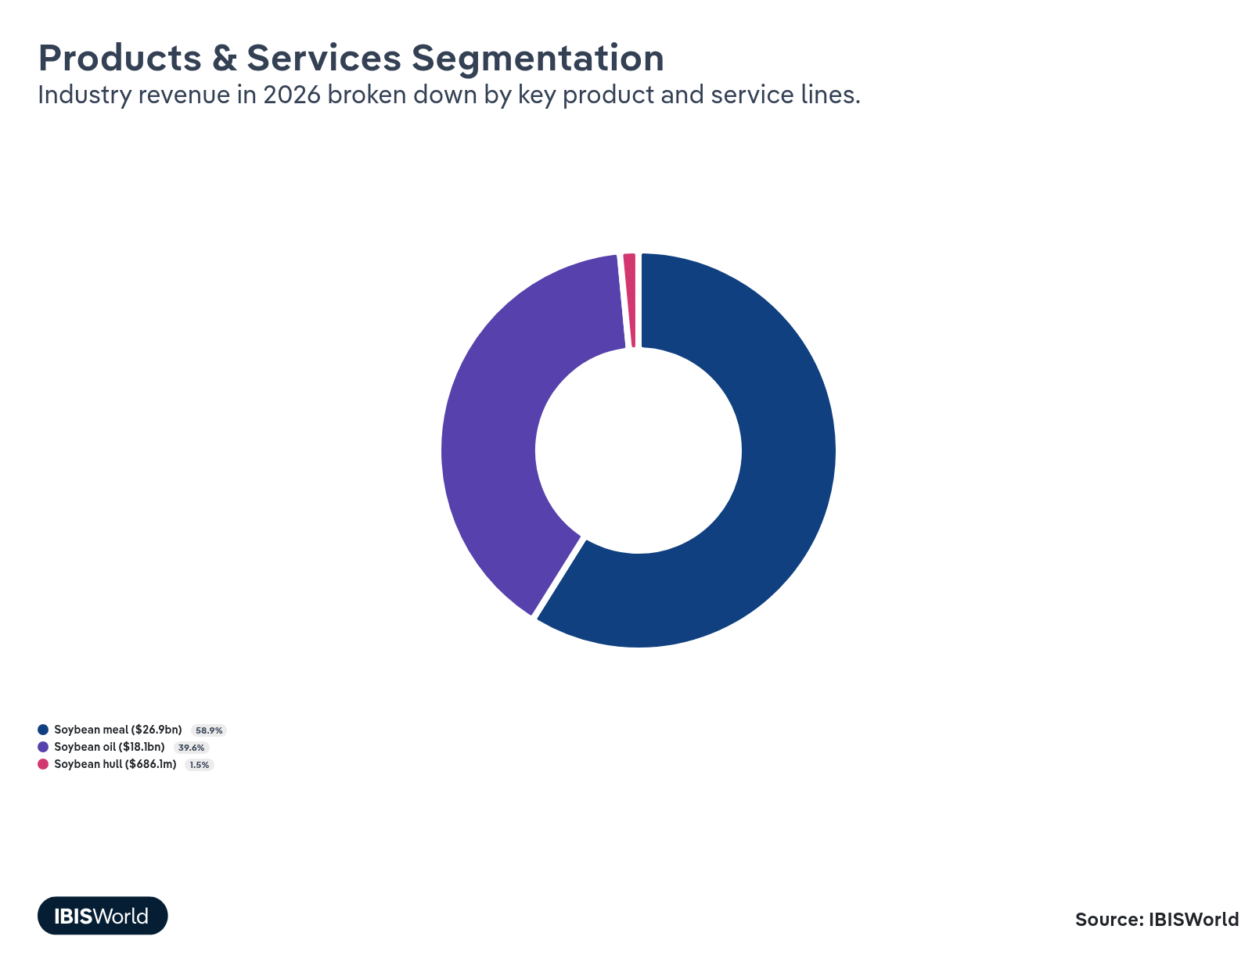

Major Players
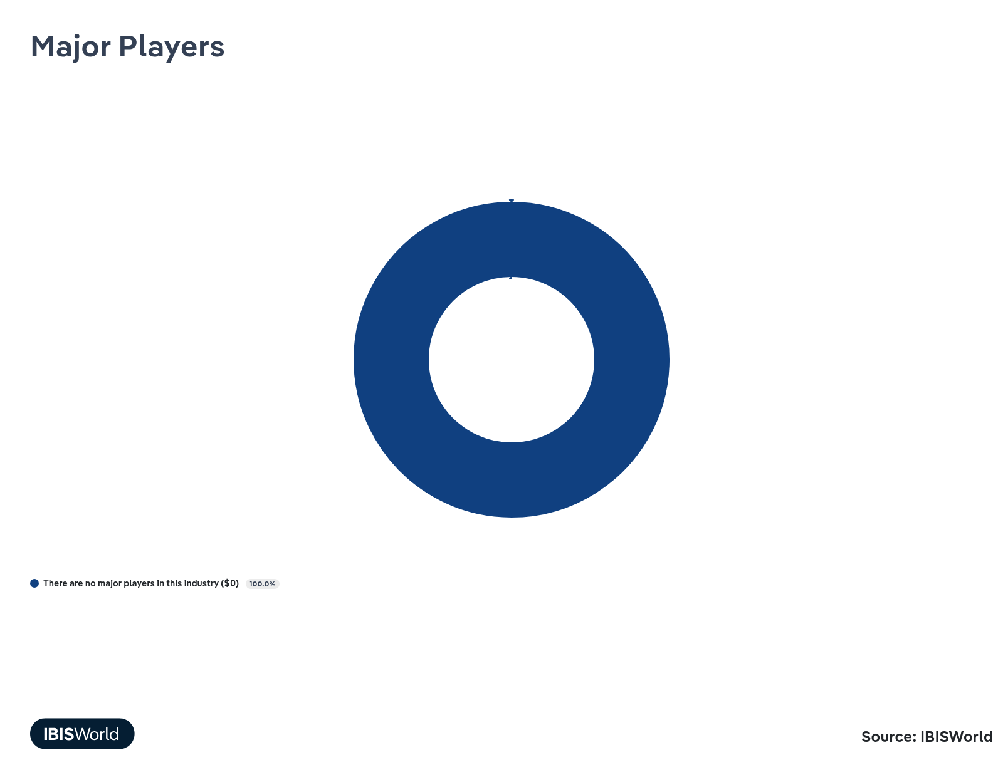

Key External Drivers
Key External Drivers | Impact
Demand from organic chemical manufacturing | Positive
World price of soybeans | Positive
Trade-weighted index | Negative
Subsidies for soybean farming | Positive

Industry Structure
Characteristic | Level | Trend
Concentration | Low
Barriers To Entry | High | Steady
Regulation and Policy | Moderate | Steady
Life Cycle | Growth
Revenue Volatility | High
Assistance | Moderate | Steady
Competition | Moderate | Increasing
Innovation | Low

SWOT
Strengths  High & Steady Barriers to Entry  Growth Life Cycle Stage  Low Imports  High Profit vs. Sector Average  Low Customer Class Concentration  High Revenue per Employee | Weaknesses  High Volatility  High Product/Service Concentration  High Capital Requirements | Opportunities  High Revenue Growth (2020-2025)  High Revenue Growth (2025-2030)  Trade-weighted index | Threats  Low Revenue Growth (2005-2025)  Low Outlier Growth  Low Performance Drivers  World price of soybeans

Executive Summary

Soy to the world: While domestic sales struggle due to decreased soybean prices, exports have faced further pressure as international competition grows
The US soybean farming industry has navigated significant changes in the current period, with soybean prices determining the initial rise and recent decline in industry performance. These prices have been influenced by several key factors, including the growing demand for biofuels and mixed consumer perceptions regarding soy products. The demand for soybean oil in biofuel production has surged due to supportive policies like the Renewable Fuel Standard and rising crude oil prices, creating a lucrative market for soybean producers. However, subsequent drops in fertilizer and crude oil prices, paired with record-high soybean production, have sharply dropped soybean prices, bringing revenue and profit down with them as farmers struggle to balance costs with lower incomes. Industry revenue has shrunk at a CAGR of 4.7% since 2021, with an increase of 3.2% in 2026, reaching an estimated $45.7 billion.
US soybean exports are facing mounting challenges due to competitive pressures abroad and quickly evolving trade policy. Brazil’s increased production and improved export infrastructure have strengthened its position as a major supplier, particularly to China, which is reducing its reliance on US soybeans. This shift threatens US exports and compels American farmers to reassess their strategies, focusing on market diversification and emphasizing quality and sustainability to remain competitive. Trade tensions throughout 2025, such as those affecting key markets like the EU, Canada and China, have further complicated trade, impacting US farmers' access and pricing power in these vital markets.
After three years of declines, global soybean prices are forecast to begin to rise through the rest of 2026 as domestic supplies tighten and export markets are revitalized. As climate change impacts crop yields through extreme weather and pest challenges, and as world supplies become more limited in the coming years, prices will be pushed further upward alongside rising global demand. Subsidies will continue to play a vital role in supporting farmer incomes amid these fluctuations, providing some stability to an otherwise highly volatile industry. Over the next five years, the industry is expected to grow at a CAGR of 1.3%, with revenues reaching $48.7 billion by the end of 2031.

3. Performance
https://my.ibisworld.com/us/en/industry/11111/performance

Highlights
Revenue  $45.7bn  2021-26 CAGR ↓ 4.7 %  2026-31 CAGR ↑ 1.3 % | Employees  60,940  2021-26 CAGR ↓ 11.1 %  2026-31 CAGR ↓ 1.0 % | Businesses  59,466  2021-26 CAGR ↓ 11.0 %  2026-31 CAGR ↓ 3.5 %
Profit  $7.6bn  2021-26 CAGR ↓ 0.2 % | Profit Margin  16.7%  2021-26 CAGR ↑ 3.4 pp

Key Takeaways
- Surging biofuel demand is giving soybean farmers new opportunities, but they're struggling with low prices and strong global stocks. Many are boosting yields to offset these challenges and stabilize income.
- Climate change will add volatility to yields and force farmers to reassess production practices. As the impacts of extreme seasons and weather events limit production, prices will also rise, helping revenue to continue to increase, though farmers will also face higher operating costs.
- US soybean exports are under pressure as Brazil ramps up production and China cuts its imports. Farmers are diversifying markets to sustain their trade volume, emphasizing quality and sustainability to stay competitive.

Performance Snapshot
Revenue: | ↓ 2021-26 Revenue CAGR -4.7%
Revenue  $45.7bn  ’21-’26 ↓ 4.7 %  ’26-’31 ↑ 1.3 % | 2026 Revenue Growth  ↑ 3.2 % | Revenue Volatility  High
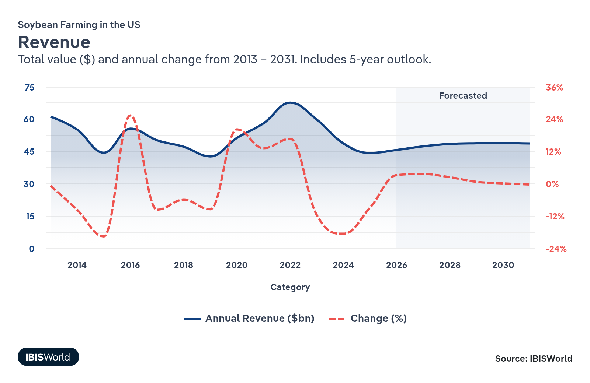
Employees: | ↓ 2021-26 Employees CAGR -11.1%
Employees  60,940  ’21-’26 ↓ 11.1 %  ’26-’31 ↓ 1.0 % | Employees per Business  1  ’21-’26 ↓ 0.2 %  ’26-’31 ↑ 2.6 % | Revenue per Employee  $751k  ’21-’26 ↑ 7.3 %  ’26-’31 ↑ 2.3 %
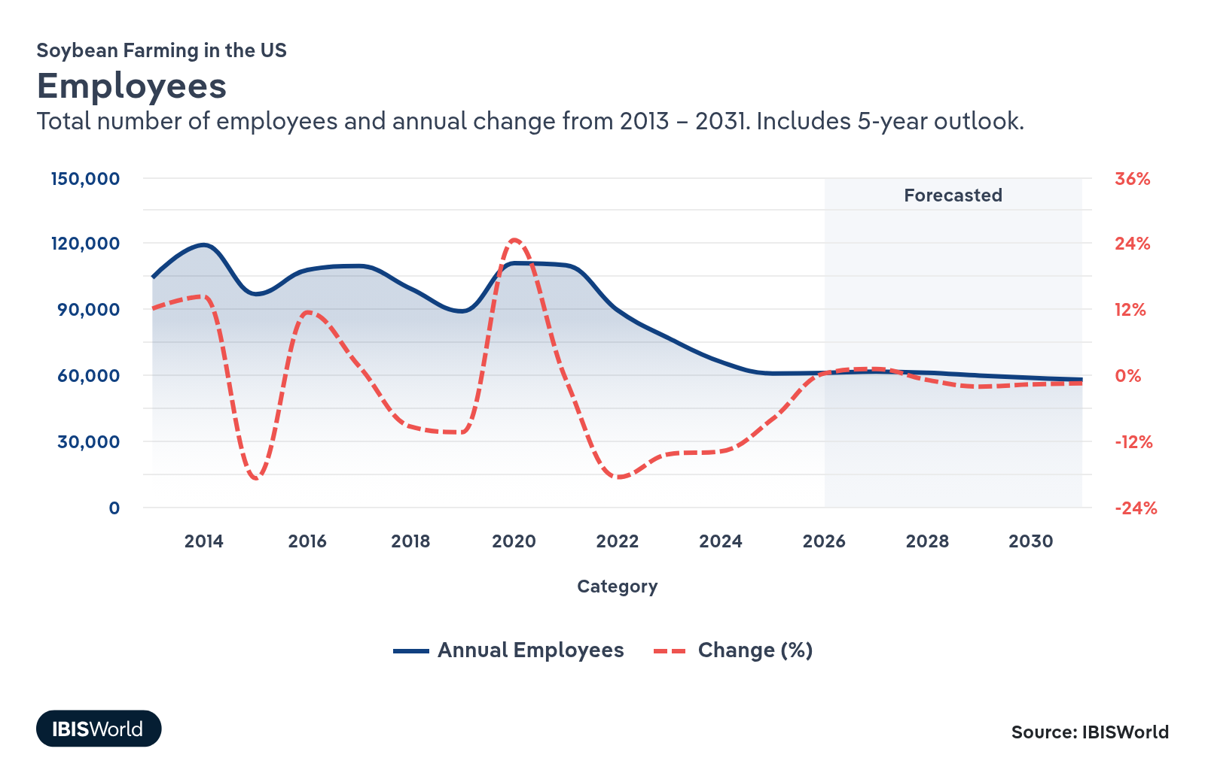
Businesses: | ↓ 2021-26 Business CAGR -11.0%
Businesses  59,466  ’21-’26 ↓ 11.0 %  ’26-’31 ↓ 3.5 % | Employees per Business  1  ’21-’26 ↓ 0.2 %  ’26-’31 ↑ 2.6 % | Revenue per Business  $769.2k  ’21-’26 ↑ 7.1 %  ’26-’31 ↑ 5.0 %
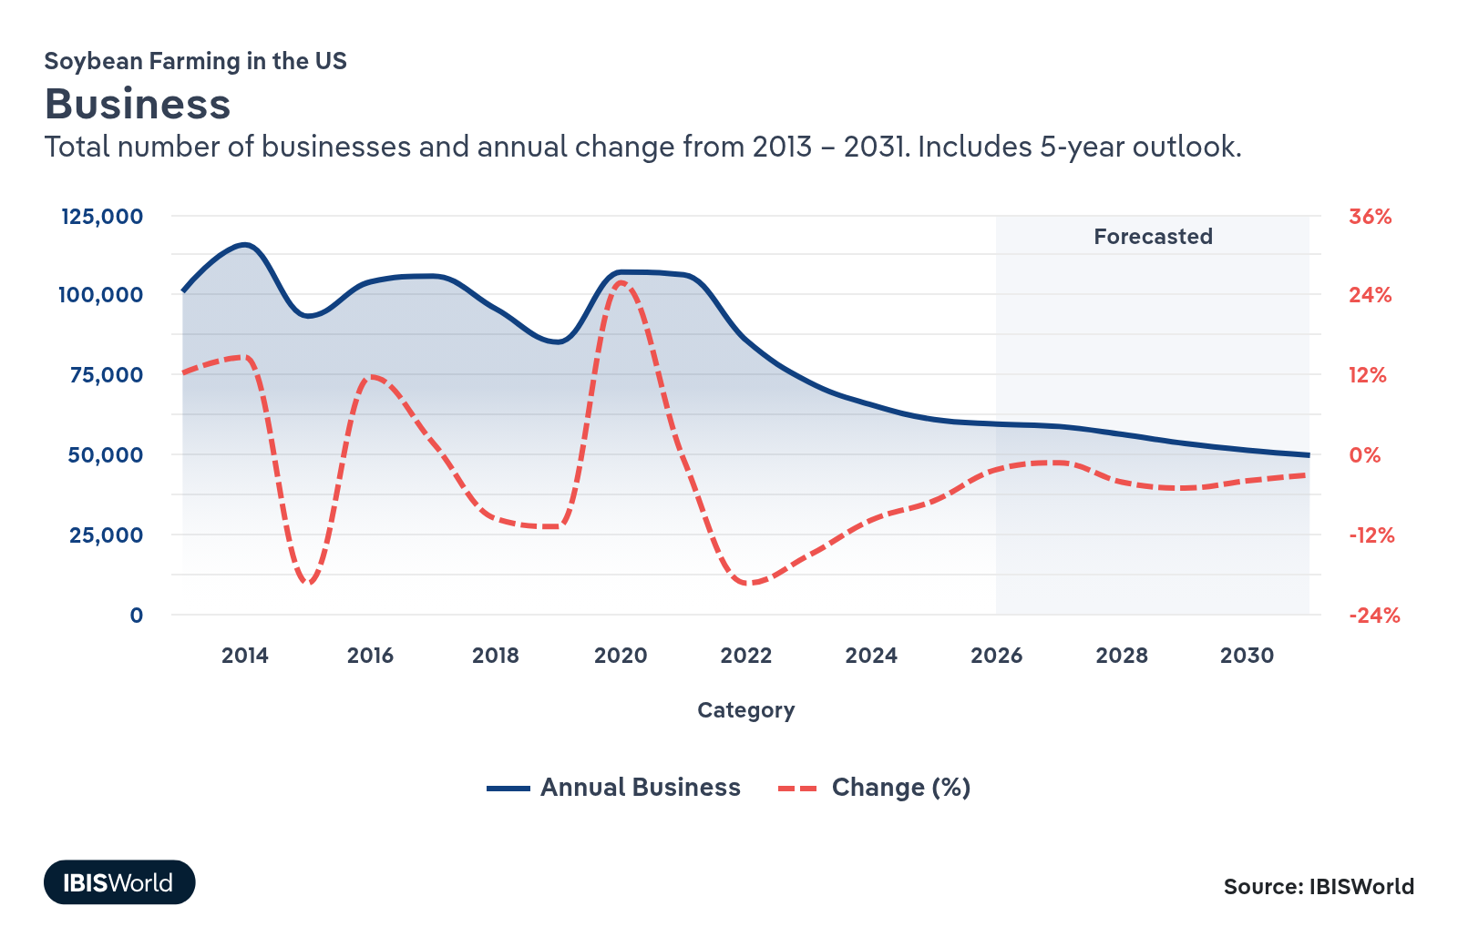
Profit: | ↓ 2021-26 Profit CAGR -0.2%
Total Profit  $7.6bn  ’21-’26 ↓ 0.2 % | Profit Margin  16.7%  ’21-’26 ↑ 3.4 pp | Profit per Business  $128.4k
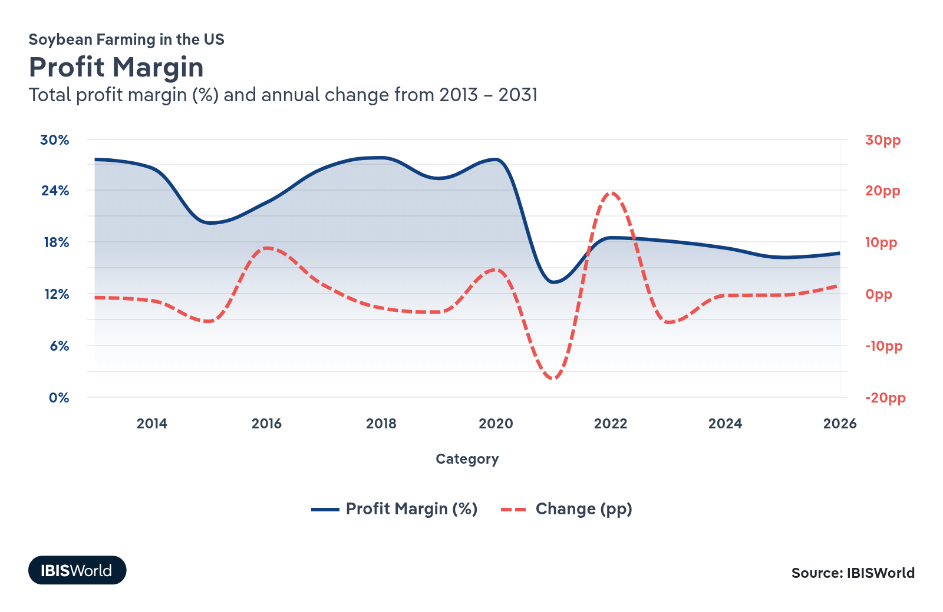
Current Performance
Current Performance

What's driving current industry performance?

Surging biofuel demand boosts soybean oil production and farmer opportunities
- According to the USDA's December 2025 World Agricultural Supply and Demand Estimates (WASDE), a forecasted 52.3% of soybean oil production in the US will go into biofuels in the 2025/26 marketing year (MY), up from 43.7% in 2024/25 and 37.9% in 2020/21. This is largely due to supportive state and federal policies such as the Renewable Fuel Standard (RFS) program, which mandates the use of a specified level of renewable fuels, such as those produced from soybean oil.
- At the same time, benchmark crude oil prices have fallen at an estimated compound annual rate of 4.6% since 2021, narrowing the purely cost-based advantage of some biofuels relative to fossil diesel. This can discourage discretionary blending on price alone, but low-carbon fuel standards, tax credits and corporate decarbonization targets still create strong policy and reputational incentives for refiners to use soybean oil and other bio-feedstocks.
- Domestic production of soy-based biofuels has elevated soybean oil production from 27.1 billion pounds in the 2023/24 MY to reach an estimated 30.2 billion pounds in the 2025/26 MY, as measured by the USDA. This growth is in line with overall global production increases over the current period, growing to an estimated 141.22 million metric tons in the 2025/26 MY, an increase of 10.3% from 2022/23 production.
- As the biofuel industry grows, soybean farmers can stabilize their revenues and boost profit by partnering with biofuel producers. With soybean prices dropping, these producers are incorporating more soy into their operations and looking to secure long-term contracts. This creates a steady demand for soy, helping farmers benefit from the increasing focus on renewable energy while ensuring consistent income even amid market fluctuations.

Yield gains help soybean farmers survive a world awash in cheap soybeans
- Soybean farmers are in a challenging spot as they grapple with falling prices and rising production. Through 2023, global soybean prices reported by the St. Louis Fed dropped by 13.3%, in large part because some countries that were not as severely hit by adverse events like droughts and wildfires have ramped up their output. This increased global supply pushed prices down further through 2024, and they have remained suppressed despite small gains in 2025, influenced also by a rise in oil production that lowered energy and agricultural operation costs.
- US soybean yields dipped in 2022 but have since recovered and pushed higher. The USDA now pegs the national soybean yield at 50.6 bushels per acre in 2024/25, forecast to rise to 53.0 bushels per acre in 2025/26, helped by improved genetics, better agronomy and generally favorable weather across key producing states. Precision agriculture tools, variable-rate input use and refined planting windows are helping many growers squeeze more bushels out of roughly stable acreage, offsetting some of the price weakness.​
- Higher yields offer a silver lining by providing farmers with more volume to sell, which helps cushion the impact of lower prices on revenue. This yield-driven resilience is crucial in a volatile market, enabling farmers to continue investing in their operations and sustainability initiatives.
- The rise in global soybean stocks presents its own set of challenges. Although US ending stocks have tightened between the 2023/24 and 2025/26 MYs, the USDA's December 2025 WASDE report shows world ending stocks growing by 6.0% in that same timeframe. While extra supply offers stability and flexibility in addressing shortages, it also suppresses prices, posing risks to farmer incomes. The resulting market saturation can increase storage costs and heighten trade competition, potentially leading to strained international trade relationships. More limited ending stocks in 2025/26 represent part of the upward pressure on soybean prices during the season.
- Farmers are looking to adapt to major market shifts with such strategies as those highlighted by Michigan State University: Selecting high-yield, pest-resistant soybean varieties can boost yields without extra costs. Reducing input costs through no-till practices and applying fertilizers based on soil tests can save money. Early planting and timely harvests maximize yields while minimizing costs. Smart storage and marketing strategies, such as forward contracts, can help secure better prices.

Mixed health perceptions of soy influence consumer demand patterns
- Public perceptions about soy's health effects are a significant influence on demand for food-grade beans. Recent clinical and epidemiologic reviews suggest that, for most people, moderate soy intake has neutral or beneficial effects on several health outcomes. A 2025 narrative review in Nutrients reports that post-diagnosis soy isoflavone intake from foods is associated with lower breast cancer recurrence and possibly reduced mortality, while randomized trials show no adverse effects on breast density or markers of cell proliferation. Regular soy intake is also associated with lower cardiovascular risk and all-cause mortality.
- Despite many positive health claims, public perceptions remain mixed, with ongoing concerns about breast cancer, hormones and thyroid function. Mayo Clinic summaries from 2025, however, cite no meaningful negative impact of soy in these areas. Stanford Medicine's 2025 analysis of seed oils, including soy, also notes that although there have been public worries in recent years about the health impacts of these products, the unsaturated fats in seed oils are generally associated with better cardiovascular outcomes than saturated fats.
- These mixed perceptions lead to divided consumer attitudes towards soy. While some view it as a healthful alternative to red meat, others avoid it due to health concerns. The complexity and variability in soy research contribute to consumer hesitancy and have limited potential growth in some soy product markets, including protein powder, tofu and soy milk. This division impacts how manufacturers and marketers position soy products, hindering full market potential.
- Soy farmers can take proactive steps to adapt to these evolving consumer perceptions and market demands. They can engage in sustainable farming practices that enhance the nutritional profile and environmental credentials of soybeans, appealing to health-conscious and eco-aware consumers. Collaborating with researchers and nutrition experts can help farmers stay informed about the latest scientific findings and address public concerns through transparent communication. Engaging directly with consumer groups through farmers’ markets or educational campaigns can help demystify soy and build trust with end consumers.

China and Brazil's soybean strategies are shaking up export demand for US soy
- Big changes are underway in the global soybean market, with Brazil ramping up production and China reevaluating where it buys and how much it needs. Brazil’s crop agency, CONAB, now projects the country’s 2025/26 soybean harvest at 177.6 million metric tons, a record, supported by expanding acreage, improved logistics and a competitive currency. The USDA forecasts similarly robust Brazilian output and higher exports in 2025/26, continuing a trend of steady increases in recent years, reinforcing Brazil’s role as the dominant supplier to China, the world’s largest soybean buyer.​
- Meanwhile, China is making moves to reduce its reliance on US soybeans. A Reuters report shows that US soybeans' share of China's imports dropped to 18.0% in 2024, a significant fall from 40.0% in 2016. The Associated Press's 2025 report on the subject notes that the US's share now sits at 21.0%. These shifts pose a real challenge for US soybean farmers. China is still a crucial customer. US agricultural soybean exports to the region dropped from $17.9 billion in 2022 to $12.6 billion in 2024, and the country put a temporary halt to US purchases during 2025 tariff tensions, both of which severely disrupted farmers' core revenue sources.
- Part of China's strategy involves ramping up imports from Brazil, aligning with its goal to boost self-sufficiency in agriculture. By approving gene-edited crops and setting up soil conservation laws, China is beefing up domestic production. China is also experimenting with alternative animal feed ingredients, like wheat and rice, to decrease reliance on soybeans.
- After unstable demand, as noted by the University of Illinois' analysis in 2025, a new deal between Washington and Beijing commits China to buy at least 25 million metric tons of US soybeans annually through 2028. Farmer groups and industry associations played a large role in pressing for this framework and will continue to lobby for trade policies and dispute-resolution mechanisms that preserve China as a viable outlet while also protecting access to other key markets, giving growers more predictable demand and a stronger negotiating position in future trade talks.​

What influences industry volatility?

Unpredictable weather patterns can disrupt soybean harvests
- Soybean farming, like other agricultural sectors, is increasingly vulnerable to unpredictable weather patterns. Severe events such as droughts and storms can significantly disrupt harvests, impacting yields and farmer livelihoods.
- With climate change driving a rise in the frequency and intensity of these adverse weather conditions, the volatility and risk associated with soybean farming are mounting. To mitigate these risks, the federal government dispenses soybean subsidies to help protect farmers against financial losses.

Biofuel policy links soybean prices to volatile energy markets
- Renewable fuel mandates, like the Inflation Reduction Act’s biofuel incentives, tie soybean oil prices to energy markets. Soybean oil demand for biofuels is projected by the USDA to hit 15.5 billion pounds in 2025/26, up from 8.9 billion pounds over the 2020/21 season. However, energy price swings, such as crude oil’s 41.5% price drop since 2022, directly impact soybean revenue.
- A 2024 Kansas City Fed study found that, since the Renewable Fuel Standard was enacted, a 1.0% change in oil prices has typically been associated with a 0.6% change in corn prices, reflecting a much stronger linkage between energy and corn markets. Soybeans risk similar volatility under expanded biodiesel policies. This interdependence makes soybean revenue more volatile than less energy-linked sectors like wheat.

Trade policy and exchange rates determine revenue
- US soybean farmers heavily rely on exports, particularly to China. However, global trade policies, tariffs and China's efforts to reduce its import dependence pose significant challenges.
- Exchange rate volatility further complicates pricing and profitability abroad. Fluctuations in the value of the dollar can drive soybean exports up and down dramatically and make imports more or less attractive to domestic buyers. The appreciation of the dollar in recent years, for example, has made the US dollar more expensive on the world market and less competitive with other countries' supplies.
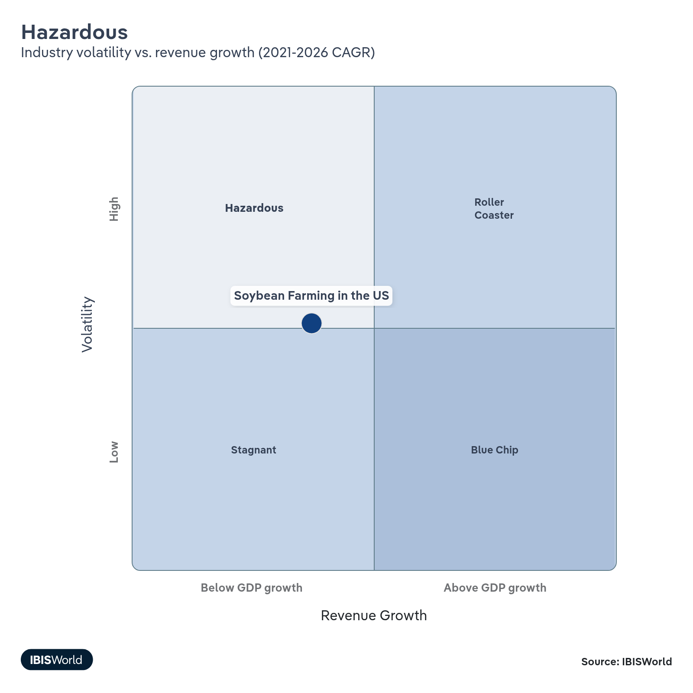

How do successful businesses overcome volatility?
Manage exchange rates for product sales
With exports making up a considerable share of the soybean market, entering into contracts to insulate against the risk of price fluctuations is essential.
Take advantage of government subsidies and other grants
Government assistance payments can improve farmer income in good and bad times. See the Industry Assistance section for details regarding specific programs.
Outlook | ↑ 2026-31 Revenue CAGR +1.3%

What's driving the industry outlook?

Strong soybean yields and prices will point the industry back towards growth
- The USDA’s 2025 long-term crop projections show US soybean acreage holding relatively steady through the outlook period, while yields are expected to grow by 4.7% between 2026 and 2031. In the same period, the stocks-to-use ratio is projected to drop sharply, as consumption catches up with, or even outpaces, supply growth while crush and export demand expand. Soybean prices are forecast to strengthen at a CAGR of 1.7% through 2031, suggesting a gradual recovery from the steep price declines seen in the current period rather than a return to the extreme highs of 2022.​
- Stable acreage with rising yields and falling stocks-to-use means productivity, not land expansion, does most of the work in meeting future demand. For farmers, that points to a market where efficiency and cost control matter as much as raw bushels, and where tighter stock levels offer more price support but also increase sensitivity to weather shocks and policy changes. Gradual price recovery will improve revenue prospects, but profit will still hinge on managing input costs.​
- US soybean stocks are estimated in the USDA's 2025 WASDE report to have already begun tightening for the 2025/26 season, contracting from 9.32 to 8.61 to 7.89 million metric tons in the 2023/24, 2024/25 and 2025/26 MYs, respectively. As this supply pressure continues to push domestic prices up, farmers are selling into domestic crush markets — where basis and demand are supported by biofuels and feed — while treating export channels as a secondary outlet in a still-crowded global market.

Climate change will challenge US soybean farming with extreme weather and pest threats
- Climate change is expected to significantly impact US soybean farming in the coming years. According to a 2024 USDA Economic Research Service study, soybean yields are projected to decrease by 3.0% by 2036 compared to 2016 levels due to climate-related factors. This decline varies regionally, with some states experiencing more severe impacts than others. While climate change will increase the cost and volatility of operations, its restriction on supplies will also uplift soybean prices.
- While some areas might benefit from extended growing periods, others face challenges like increased irrigation and fertilizer needs and disease threats. Heavy rainfall can erode soil quality, and air pollution can reduce crop resilience. Extreme weather events, including wildfires, droughts and storms, threaten crop stability and may increase production costs.
- The evolving climate also brings expanded pest threats and disrupts pollination timing, both critical for soybean yields. These pressures demand a focus on soil management, efficient pesticide application, resilient crop varieties and innovative farming practices to maintain productivity.
- Regional variations in climate impact are significant. For example, according to USDA forecasts, North and South Dakota, Kansas and Nebraska could experience sharp declines in soybean yields of as high as 43.4% through 2036 compared to 2016, while Midwestern states such as Illinois, Missouri, Iowa and Wisconsin might see slight gains of 1.2%.
- As operating expenses increase for soybean farmers seeking to maintain yields in the face of climate challenges, adopting precision agriculture techniques will become essential. Research from Michigan State University in 2025 highlights how precision agriculture can help farmers limit their use of core agricultural inputs, such as agrochemicals, seeds, fuel and oil. For example, variable-rate fertilizer application based on soil analysis and crop health data allows farmers to apply nutrients only where and when they're needed most. This approach not only reduces input costs but also minimizes environmental impacts from excess fertilizer runoff.

Diversified export growth is reshaping soybean farmers’ global opportunities
- The USDA's 2025 Long-Term Projections forecast a continued rebound in US soybean exports following current period dips, showing 6.6% growth from 2025/26 to the end of the 2030/31 season. This increase reflects a recovery to levels experienced prior to recent downturns, supported by strong global demand.
- Emerging markets are becoming a more important growth engine for US soy exports as buyers in Latin America, North Africa, the Middle East and Southeast Asia ramp up meal imports for expanding livestock and aquaculture sectors. This shift is partly a strategic response to years of trade tension and demand concentration in China, with exporters now motivated to prioritize a broader customer base despite recent soybean purchase agreements from China.
- For US soybean farmers, future export performance will look less like a boom back to high, China-driven levels and more like slow, diversified growth layered on top of strong domestic crush demand. Exporters and grower groups are leaning into market-development work – including feed trials, sustainability certifications and identity-preserved programs – to lock in business with a wider range of buyers, while farmers who can hit specific quality or sustainability specs are positioning themselves to capture premiums in these emerging, more diversified export channels.​

Subsidies will help to keep soybean farmers afloat
- Soybean producers are heading into the outlook period with stubbornly high costs: USDA estimates put 2026 soybean production costs at $678.25 per acre, up from $658.06 dollars in 2025. Labor is a significant pressure point, as overall farm labor expenses and hourly wages continue to trend higher and growers struggle to secure experienced workers, pushing many operations to lean more on temporary foreign labor programs that often come with premium wage rates and added compliance costs.​
- Against this backdrop, federal support is crucial to stabilizing farms' balance sheets. The 2018 Farm Bill has been extended through the 2025/26 crop year, keeping Agriculture Risk Coverage and Price Loss Coverage and conservation programs intact while Congress works toward a new package that could permanently raise reference prices and tweak commodity supports for oilseeds. The USDA’s 2025 farm income forecasts show direct government payments rebounding sharply on the back of disaster aid, supplemental bridge payments and bolstered safety-net outlays, even as market-based income from crops softens.​
- For soybean operations, these supports are increasingly the difference between treading water and slipping under. A stronger floor under revenue makes it safer to forward-contract, refinance equipment and commit to multi-year input and land leases, rather than constantly reacting to price dips and cost spikes. Lenders also lean on these predictable programs when sizing operating credit, effectively turning federal policy into a quiet guarantor of day-to-day solvency for many growers.
- Farmers, industry associations and cooperatives are engaging in advocacy to ensure continued support from USDA programs. Farms can also align their business strategies with these subsidized resources and continue adopting sustainable practices to improve yield efficiency.
Life Cycle | Growth

Why is the industry growing?

Contribution to GDP
Despite its maturity, the soybean farming industry in the US has seen a declining contribution to GDP in recent years due largely to its strong volatility and the crop price drops in 2023 that have reversed the industry growth seen early in the current period.

Market Saturation
The market for soybean farming in the US is largely saturated, but there remains room for growth, particularly in niche markets like organic soybeans and climate-resistant varieties, as well as soy-based plastics. Outside of these markets, however, soy is well-entrenched as a staple food product and biofuel input. Farmers can grow their market by looking outside of these traditional use cases and partnering with innovative processors to explore new possibilities.

Innovation
Innovation in US soybean farming is moderate, focusing on developing products such as GMOs, organic variants and climate-resistant seeds. These advancements can open new markets and provide more high-value product offerings. Government funding supporting the development of sustainable agriculture techniques and producing organic products has bolstered innovation in these segments.

Consolidation
Consolidation in the soybean farming industry has been low and consistent, characterized by gradual acquisitions and partnerships rather than aggressive mergers. This steady consolidation reflects a stable competitive landscape, allowing farmers to optimize operations and manage resources effectively without drastic industry changes.

Technology and Systems
The integration of advanced technology and systems, such as precision agriculture and data-driven decision-making tools, has been focused on improving existing soybean farming operations rather than opening new doors. These technologies increase efficiency, optimize resource use and reduce environmental footprints, boosting productivity and ensuring the sustainability of soybean cultivation.

4. Products and Markets
https://my.ibisworld.com/us/en/industry/11111/products-and-markets
Largest Market  $26.9bn  Soybean meal | Product Innovation  Low

Key Takeaways
- Refineries need soybean oil for biodiesel. Biofuel production has grown as supply chain disruptions at home and abroad have increased gas and diesel prices.
- Health concerns are challenging soybeans in the edible oil market. Consumers are spending a premium on oils they see as healthier and avoiding seed oils.

Products and Services
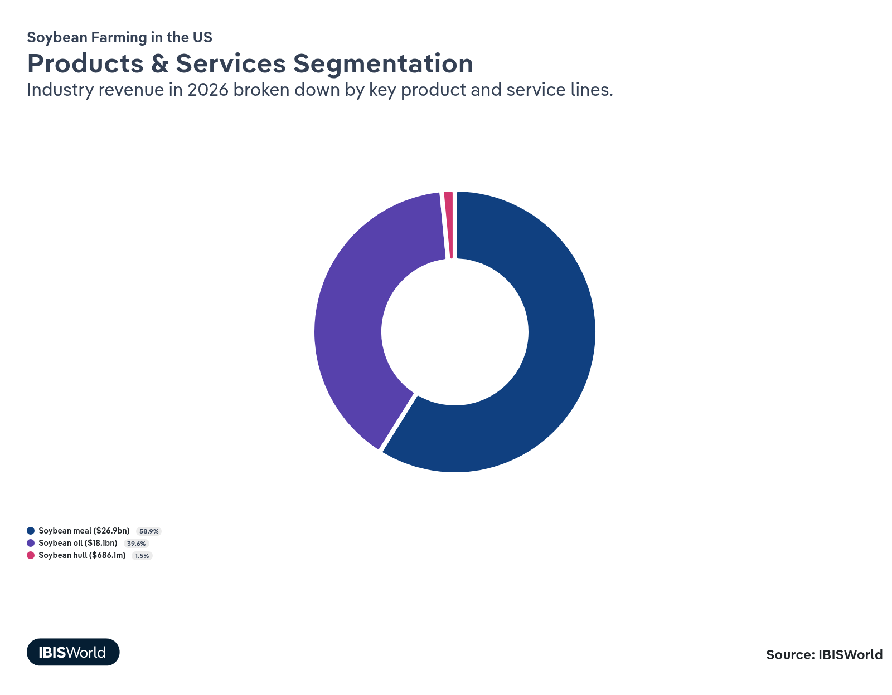

How are the industry’s products and services performing?

Production of soybean meal grows alongside the livestock industry
- Soybean meal includes ground soybeans that have had their oil extracted and are mainly used for animal feed. The USDA reports that soybean crush is expected to reach a record high of 2.56 billion bushels in the marketing year 2025/26. This production growth makes US soybean meal well-positioned to meet growing domestic and international demand, supporting the expansion of the livestock and poultry sectors.
- Domestic disappearance, which refers to the total amount of soybean meal consumed within the US for purposes like feeding livestock, is forecast to increase by 2.2% between the 2024/25 and 2025/26 seasons. This growth mirrors the expected rise in pork and poultry production.
- Competitively priced at $300.0 per short ton for 2025/26, down from $384.1 in the 2023/24 season and at a similar level to the 2024/25 season, soybean meal offers a budget-friendly option for feed manufacturers, further boosting its domestic relevance. Though the price of soybean oil has also dropped, the price of soybean meal has declined more quickly, preventing its share of industry revenue from growing more dramatically.

Heightened biofuel production drives soybean oil sales
- Soybean oil is a versatile product derived from soybeans. It is used extensively as a feedstock in biofuel production and as an ingredient in food, feed and industrial products.
- US soybean oil production is estimated to reach 30.2 billion pounds in the marketing year 2025/26, up from 31.2 billion pounds the previous year. This increase has been driven by expanded domestic soybean oil demand, particularly as a biofuel feedstock.
- Domestic US soybean oil consumption is on the rise, fueled by biofuel production, which alone is estimated to have used 13.5 billion pounds in 2024/25. Growth has been tempered by the use of lower carbon-intensity feedstocks. As production rises, soybean oil prices are pushed down, but overall increased demand has boosted revenue share from this product segment. The use of soybean oil in human food products has also been limited by health concerns surrounding seed oils.

Soybean hulls maintain small share of soybean revenue
- Soybean hulls are the fibrous outer coating of soybeans, produced as a byproduct during the extraction of soybean meal and oil, and are primarily used as a nutritious component in animal feed.
- Although soybean hulls represent a small fraction of overall soybean revenue, their consistent market presence highlights their value, especially in the livestock feed industry. Their fibrous content makes them an excellent feed additive, enhancing the fiber intake of animals and supporting digestive health.
- The stability in soybean hull sales reflects their ongoing demand in feed formulations. They offer an economical alternative to other feed ingredients, especially in cost-sensitive industries such as cattle and sheep farming, where fiber is essential. This allows producers to optimize feed costs while maintaining nutritional value.

What are innovations in industry products and services?

High-oleic soybeans and biotechnology drive agricultural innovation and consumer benefits
- High-oleic acid soybean varieties are an advanced breed of soybeans that offer enhanced oil quality with a longer shelf life, making them optimal for both food and industrial uses.
- The adoption of high-oleic soybean varieties represents opportunities for growers to increase the marketability and value of their crops. These varieties respond to consumer demands for better-quality oils, potentially capturing a greater share in food markets and expanding into industrial uses like biodiesel and biodegradable products.
- Biotechnology innovations in soybeans, such as genetic modifications optimizing oil composition, play a crucial role in creating plant varieties with higher yield potential and disease resistance while reducing the need for chemical inputs. This contributes to increased profit and sustainability for farmers, aligning agricultural practices with evolving environmental standards.

Regenerative and precision farming revolutionize sustainability and efficiency in soybean production
- Regenerative farming revitalizes soil health through practices like crop rotation and cover cropping, bolstering long-term agricultural sustainability.
- Within soybean cultivation, these practices improve soil quality and yield, offering resilience against climatic challenges while supporting biodiversity and reducing carbon footprints.
- Precision farming uses technologies like GPS to optimize farm inputs, ensuring efficient use of resources and boosting production gains.
- Together, these methods promote transparency and sustainability, helping farmers meet consumer preferences for responsibly grown food while maintaining industry profitability.
What products or services do successful businesses offer?
Invest in research and development
By investing in R&D, soy farmers can improve crop yields, enhance disease resistance and reduce environmental impacts, which helps maintain competitiveness and address the evolving demands of the agricultural sector.
Secure access to high-quality inputs
Accessing high-quality seeds and nutrients ensures optimal plant growth and productivity. This helps soy farmers to produce higher yields and meet market quality standards, ultimately contributing to business success.

Major Markets
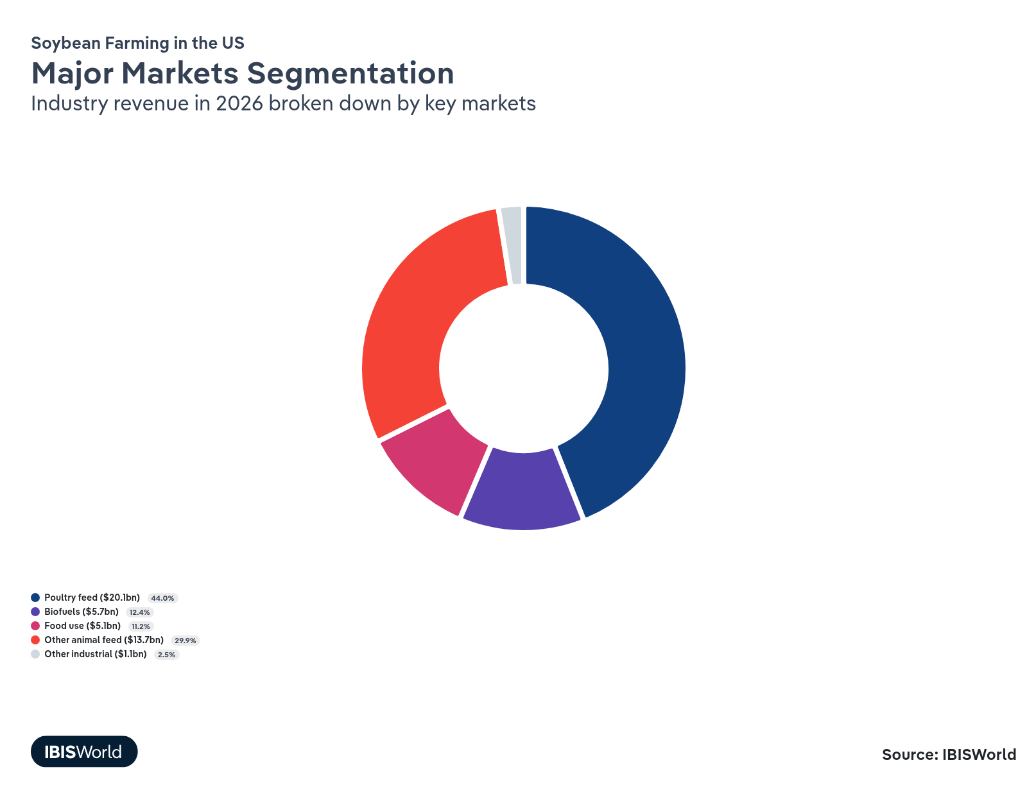

What’s influencing demand from the industry’s markets?

The soybean market has been bolstered by robust poultry feed demand
- The demand for poultry feed has remained resilient, with integrators steadily expanding or maintaining flocks to meet strong consumer preferences for chicken and other white meats. This persistence in poultry production supports heavy, ongoing use of soybean meal in broiler and layer rations, keeping US domestic soybean meal disappearance on a modest growth path rather than allowing any major pullback.​
- Strong US soybean crops in the current period have helped keep soybean meal relatively affordable for poultry producers, even as labor, energy and housing costs remain elevated. Meal prices have eased from their sharp peaks in 2022, easing feed-cost pressure for chicken companies while still underpinning solid demand for soybeans from crushers and feed manufacturers who serve the poultry sector.​

Resilient hog, dairy and beef herds quietly anchor soybean demand
- Beyond poultry, hog, dairy and beef producers continue to rely on soybean meal as a core high-protein ingredient, even as those sectors navigate volatile profit, disease concerns and shifting export demand for meat. Soybean-based feeds provide a relatively predictable nutritional foundation, giving producers some stability on the feed side when hog prices, milk checks or cattle basis fluctuate from year to year.
- China remains the largest single importer of US soybeans for crushing into animal feed, but its import growth has slowed, and competition from Brazil has intensified. After a period of sharp import cuts, a 2025 understanding committed China to sizeable – but still reduced – US purchases compared with pre-trade-war peaks, reinforcing the need for US farmers and exporters to cultivate other feed markets abroad to sustain overall soybean demand.

Soybean biofuels propel growth through sustainability and energy demand
- Soybeans are a key feedstock in the production of biodiesel, offering a renewable energy source that complements efforts to reduce carbon emissions and reliance on fossil fuels.
- Rising biofuel demand aligns with federal and state low-carbon fuel policies, though growth has been choppy as refiners chase lower-carbon-intensity feedstocks like used cooking oil and tallow to maximize credits. Even so, updated carbon-intensity modeling from Argonne National Laboratory in 2025 lowered soy biodiesel’s carbon intensity score, strengthening its environmental credentials and keeping it in the mix for fleet decarbonization.

Organic and plant-based soybean foods capture growing consumer demand for health and sustainability
- Soybeans are increasingly used in human food products, offering a rich source of protein and essential nutrients that cater to health-conscious consumers seeking alternative protein sources. The soybean industry is well-positioned to capitalize on these dietary shifts by increasing product offerings and enhancing the value chain.
- The demand for soybean-based foods, such as tofu, soy milk and plant-based meat alternatives, is on the rise as consumers become more focused on sustainable and environmentally friendly food options. This trend aligns with the growing interest in reducing carbon footprints and adopting plant-based diets.
- The premium pricing of organic soybean foods, driven by consumer demand for natural and sustainable products, offers substantial revenue opportunities for producers, as these items cater to a growing segment willing to invest in higher-quality, environmentally friendly options.

Industrial uses expand soy’s role beyond food and fuel
- Soybeans support a growing portfolio of industrial products that use soy products as renewable substitutes for petroleum-based inputs. Key applications include biobased lubricants, hydraulic fluids, solvents, coatings, inks, adhesives and foams, where soy-derived components improve biodegradability and help users meet internal sustainability goals or procurement standards for bio-based content.
- In the lubricant and coatings space, soy-based esters and resins are gaining ground in niches like chainsaw oils, metalworking fluids, concrete release agents and traffic paints, where performance is comparable and environmental regulations or worker-safety concerns favor less toxic, low-volatile organic compound (VOC) formulations. Public-sector purchasing policies and corporate ESG commitments are encouraging wider trials of soy-based products in municipal fleets, construction and manufacturing, which gradually deepens industrial demand for soybean oil even when biofuel markets are volatile.​

International Trade
Total Imports  $391.3m  ’21-’26 ↓ 4.3 %  ’26-’31 ↑ 1.1 % | Total Exports  $29.3bn  ’21-’26 ↓ 2.0 %  ’26-’31 ↑ 1.3 % | Trade Balance  Net Exporter  ↑ Surplus: $28.9bn

International Trade Imports
International Trade Imports
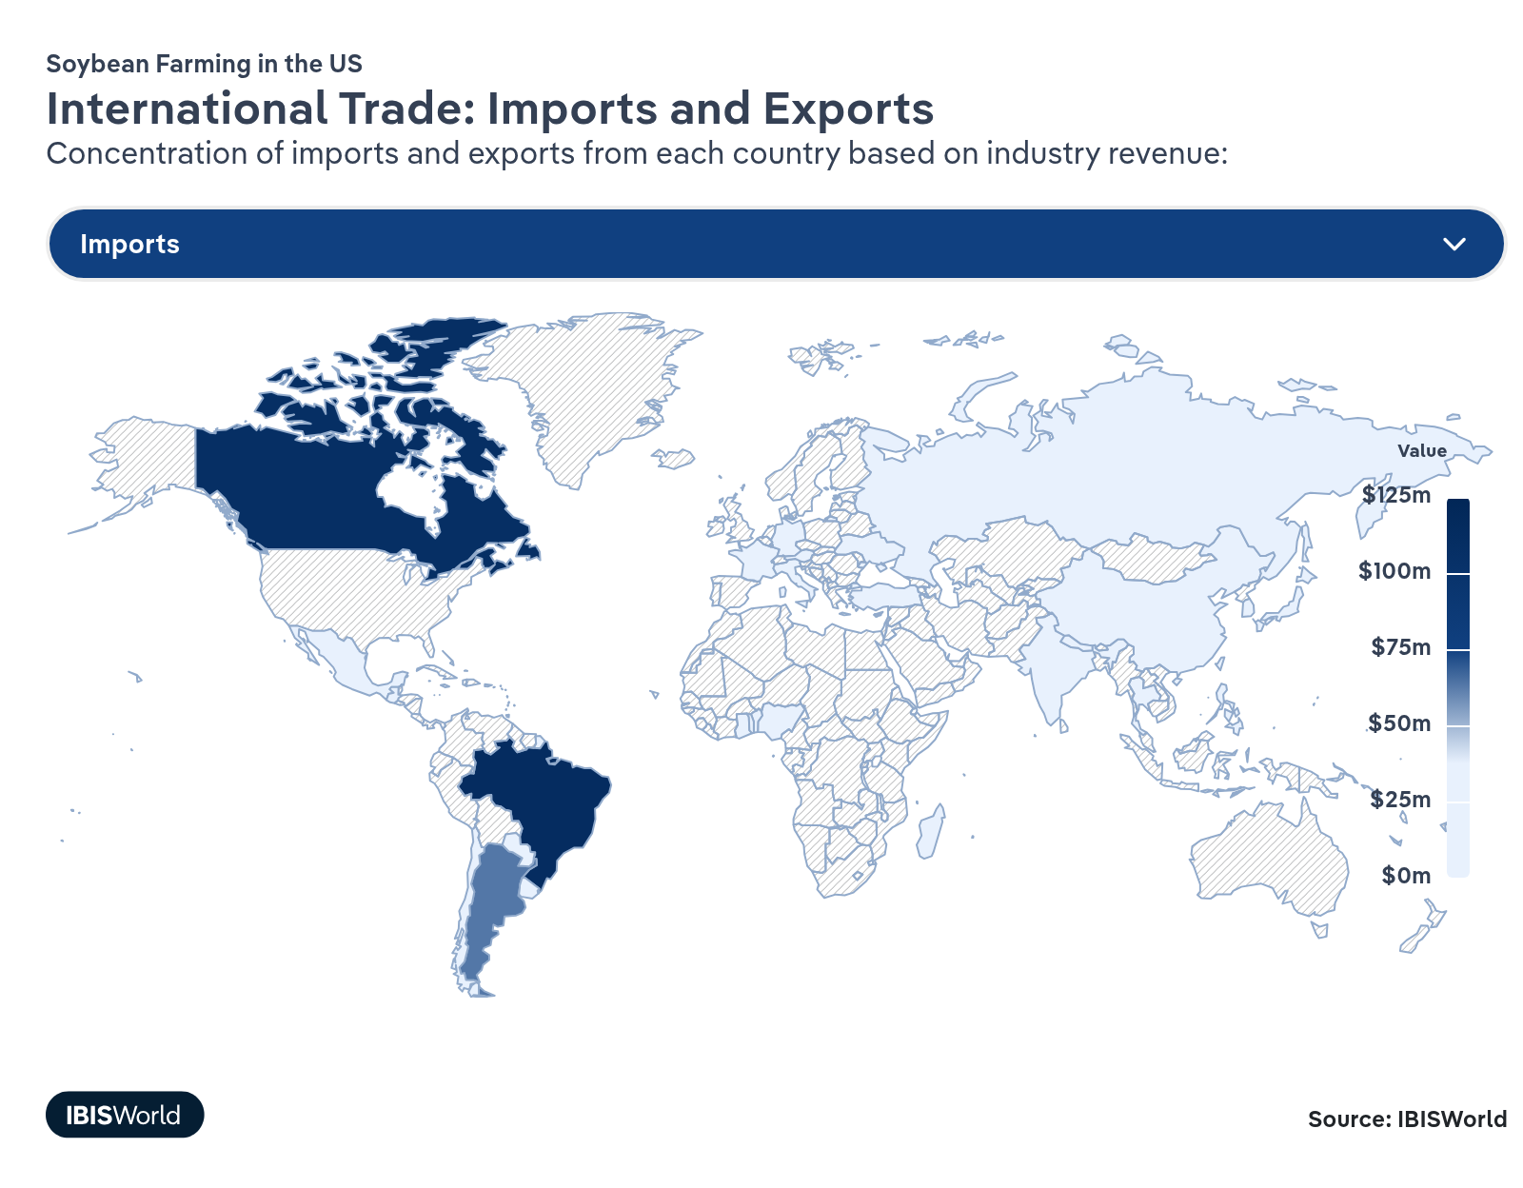
International Trade Exports
International Trade Exports
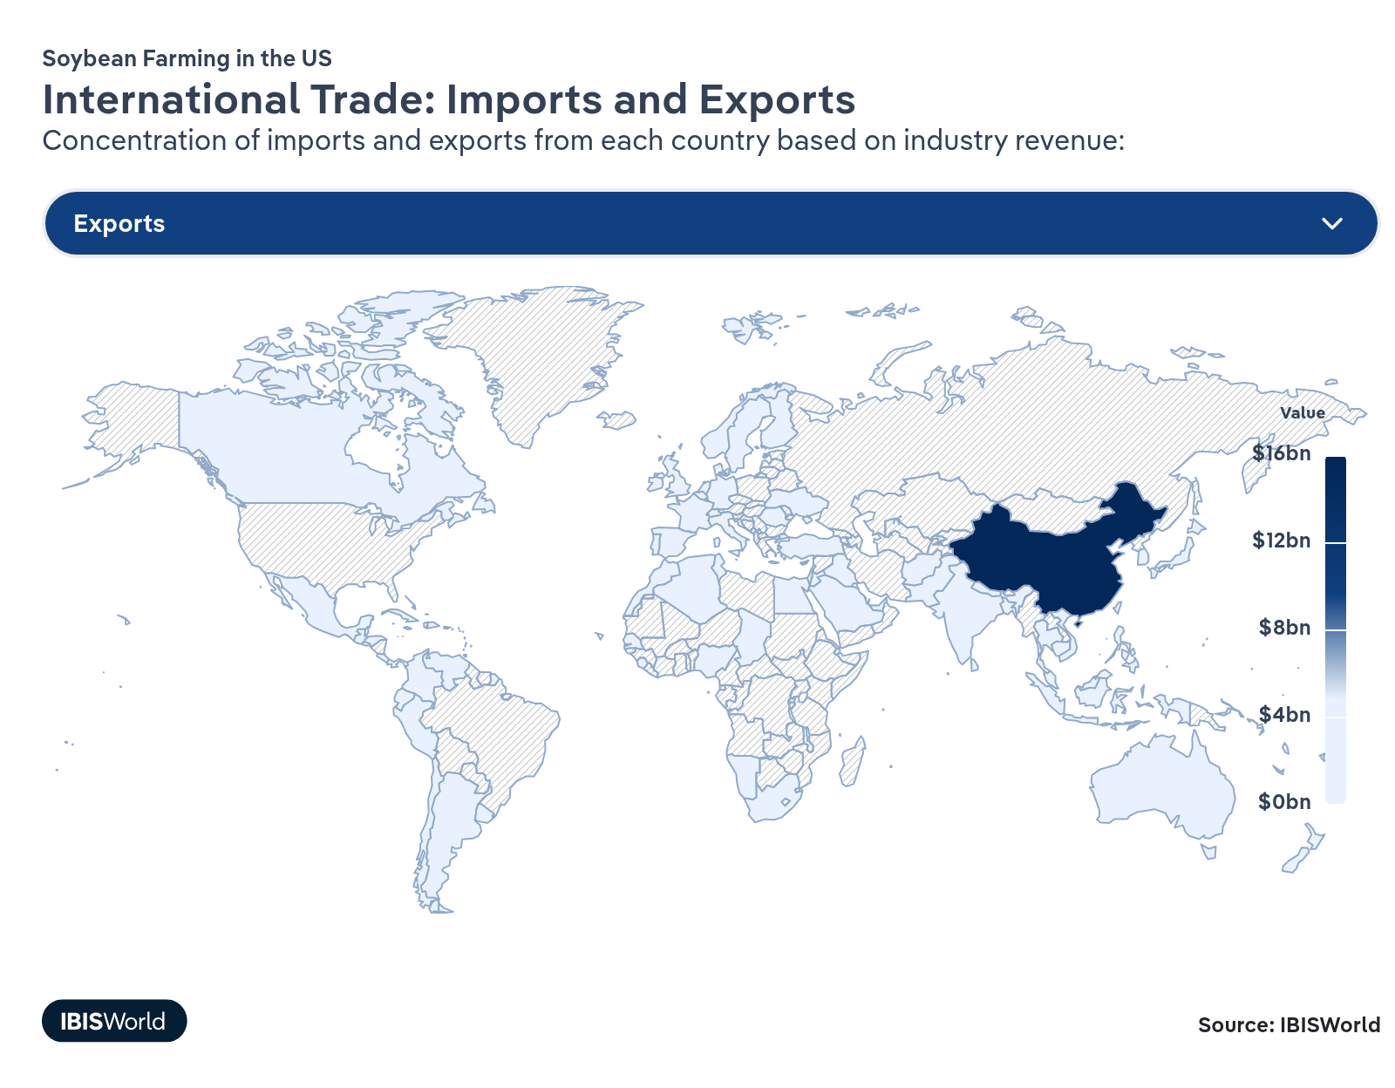

Imports
Low | Decreasing

What are the industry’s import trends?

Canada satisfies US demand for soybean imports, though tariffs threaten this balance
- Despite being a net soybean exporter, the US regularly imports soybeans and soy products from Canada, especially when regional shortfalls or quality needs arise. Under USMCA, soybeans, meal and oil move tariff-free across the border, and Canada has become a consistent source of specific classes of soybeans and meal for US feed and food processors.​
- Tariff tensions between these providers largely left the soybean trade unscathed as USMCA’s protections meant most agricultural products, including soy, remained exempt from duties, and as of January 2026, most retaliatory tariffs on USMCA-covered goods have been removed altogether.
- For US soybean farmers and processors, this relatively insulated North American trade corridor acts as a pressure valve when China or other distant markets wobble, supporting demand for both whole beans and processed products. Canadian soy can backfill US deficits in certain niches or when climate threats challenge domestically-produced supply, adding some competition but also making the regional soy complex more resilient.

Non-GMO and food-grade soy imports fill key US niches
- Although the US is a major exporter of commodity soybeans, domestic buyers of non-GMO and food-grade beans sometimes look abroad – especially to Canada and select origins in South America – for specific varieties and quality traits suited to tofu, natto and other traditional foods. These imported beans tend to be identity-preserved, with tighter specs on protein content, seed size, color and traceability than standard export-grade US soy. As a result, even in years with ample US production, specialty end users may contract overseas to fill narrow but exacting niches.​
- Non-GMO acres remain a small share of US soybean plantings, and competition from higher-yielding GM varieties can constrain the domestic supply of the exact food-grade types certain buyers want. When contract volumes or quality fall short, importers may bring in additional non-GMO beans to maintain a year-round supply or to satisfy private standards in premium markets, such as organic-adjacent retail segments or regional tofu brands. This pattern is particularly visible in some Midwestern and coastal processing hubs with established Asian-food demand.​
- These imports highlight both a threat and an opportunity for domestic producers. Growers who do not participate in identity-preserved contracts see little direct impact, but those willing to manage segregation, testing and documentation compete head-to-head with imported beans for long-term supply relationships. If domestic producers cannot reliably meet specialty specs at competitive prices, processors and food manufacturers may keep a portion of sourcing offshore, limiting the upside for this higher-profit slice of the soybean market.​

Exports
High | Decreasing

What are the industry’s export trends?

China’s slowdown and Brazil’s surge are reshuffling export math
- China is still the anchor of global soybean demand, but its import growth has cooled as hog inventories stabilize and feed rations become more efficient, which flattens incremental demand for US beans. At the same time, Brazil has cemented itself as China’s primary soybean supplier, already covering 70.0% of Chinese imports in recent seasons and expanding ports, rail and river systems tailored to that trade, as reported by the Associated Press in 2025.
- For US farmers, this means China is no longer a default growth outlet; Brazil increasingly sets the marginal price and volume into the world’s biggest buyer. US exporters face tougher head-to-head competition and must lean on freight advantages to non-China destinations, relationships in Mexico and other Americas markets and quality or reliability claims rather than volume alone.​
- In response, soybean producers are diversifying sales into Latin America, the Middle East and Southeast Asia, while farmer groups push for infrastructure, trade deals and specialty soy programs that make US beans harder to replace.​

Tariffs, geopolitics and a strong dollar rattle soybean export momentum
- Trade tensions between the United States and key buyers – especially China – have periodically disrupted soybean flows with tariffs, retaliatory measures and behind-the-border barriers such as quota management and slower customs clearances, creating sharp year-to-year swings in shipments. Episodes of new or threatened tariffs in the current period have repeatedly shifted Chinese purchases away from the leaving US exporters scrambling to redirect cargoes to other destinations when politics flare.​
- At the same time, stretches of US dollar strength against currencies like the Brazilian real have made US soybeans more expensive on a landed basis, tilting price-sensitive buyers toward South American origin when freight and exchange rates align. Even modest currency moves can flip tenders away from the Gulf to Brazilian or Argentine ports, especially for buyers in emerging markets managing acute feed cost pressures.​
- For US farmers and exporters, this mix of geopolitics and exchange rates means export momentum is more fragile and unpredictable than underlying global demand alone.

5. Geographic Breakdown
https://my.ibisworld.com/us/en/industry/11111/geographic-breakdown

Key Takeaways
- Soybean plants need large fields of open space. The Plains region grows nearly half of US soybeans because it has the necessary space.
- The Great Lakes limit drought potential. Consistent supplies of water and irrigation make the surrounding states ideal for stable soybean growing.

Business Locations
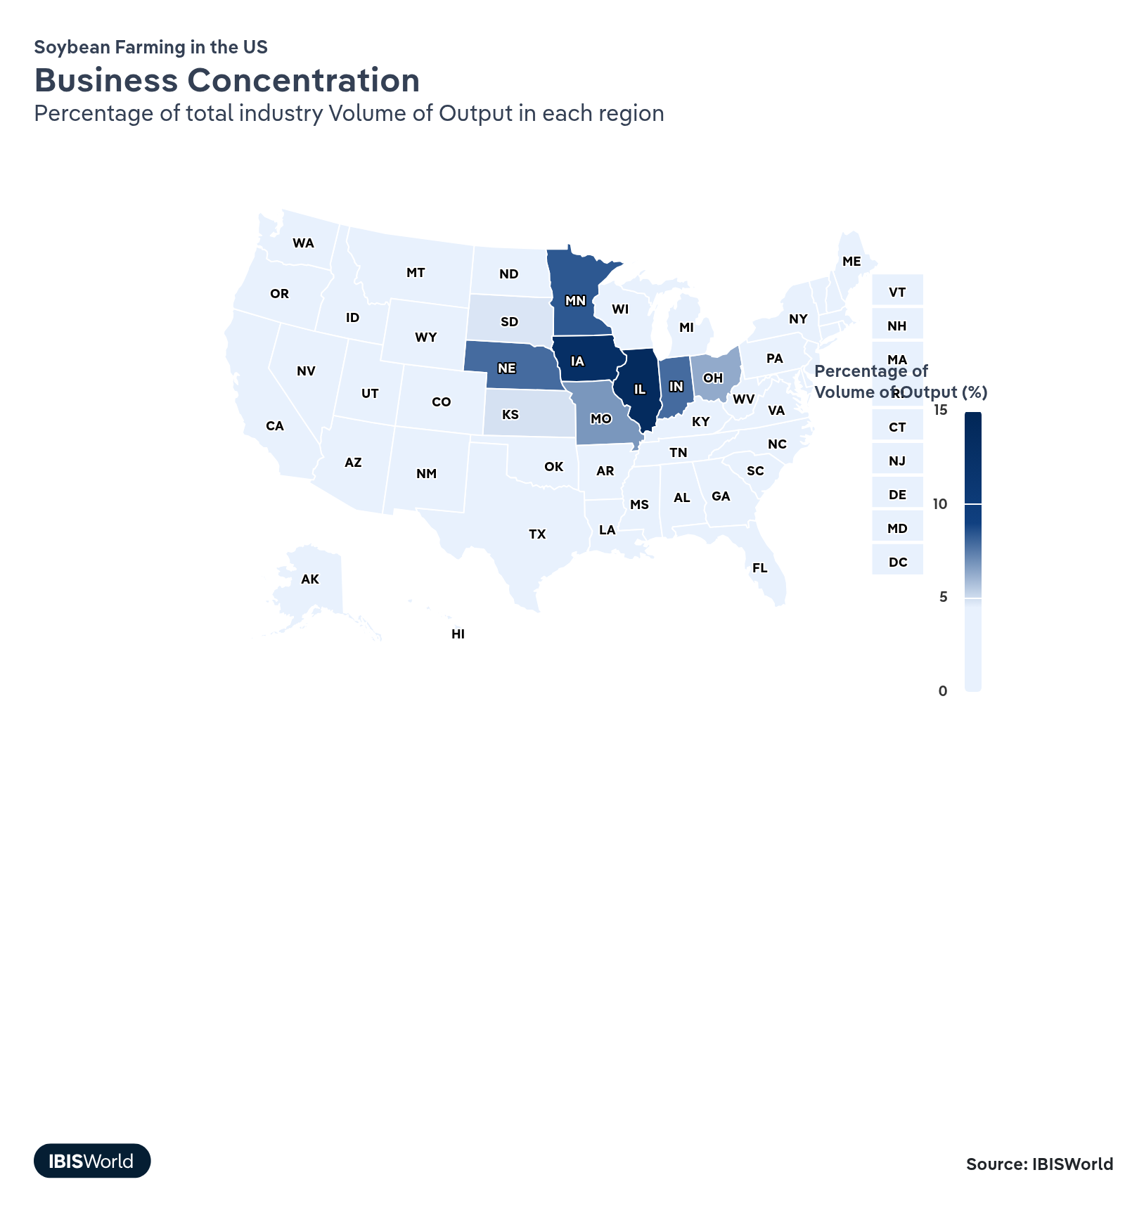
State | Volume of Output  $ million | Population  %
Illinois | 5,771,771 | 3.7
Iowa | 5,351,082 | 0.9
Minnesota | 3,469,731 | 1.7
Indiana | 3,279,996 | 2.0
Nebraska | 3,282,043 | 0.6
Missouri | 2,827,082 | 1.8
Ohio | 2,623,602 | 3.5
Kansas | 2,049,453 | 0.9
South Dakota | 2,005,131 | 0.3
North Dakota | 1,883,766 | 0.2
Arkansas | 1,565,140 | 0.9
Mississippi | 1,059,020 | 0.9
Wisconsin | 1,026,755 | 1.7
Michigan | 945,927 | 3.0
Kentucky | 874,786 | 1.3
Tennessee | 799,431 | 2.1
North Carolina | 597,417 | 3.3
Louisiana | 559,480 | 1.3
Pennsylvania | 328,747 | 3.8
Maryland | 242,415 | 1.8
Virginia | 254,604 | 2.6
New York | 153,155 | 5.8
Oklahoma | 157,186 | 1.2
Alabama | 126,118 | 1.5
South Carolina | 115,552 | 1.6
Delaware | 81,382 | 0.3
Georgia | 43,062 | 3.3
New Jersey | 44,513 | 2.8
Texas | 32,259 | 9.4
Alaska | 0 | 0.2
Arizona | 0 | 2.2
California | 0 | 11.5
Colorado | 0 | 1.8
Connecticut | 0 | 1.1
District of Columbia | 0 | 0.2
Florida | 0 | 7.0
Hawaii | 0 | 0.4
Idaho | 0 | 0.6
Maine | 0 | 0.4
Massachusetts | 0 | 2.1
Montana | 0 | 0.3
Nevada | 0 | 1.0
New Hampshire | 0 | 0.4
New Mexico | 0 | 0.6
Oregon | 0 | 1.2
Rhode Island | 0 | 0.3
Utah | 0 | 1.0
Vermont | 0 | 0.2
Washington | 0 | 2.3
West Virginia | 0 | 0.5
Wyoming | 0 | 0.2

Where are industry businesses located?

Plains states dominate US soybean production with vast fertile farmland
- The Plains region, including states like Iowa, Indiana, and Nebraska, is the heart of US soybean production due to its expansive, fertile fields and well-established agricultural infrastructure. These states benefit from deep, rich soils in areas like the Corn Belt that are ideal for soybean cultivation. The relatively flat topography also allows for efficient large-scale farming operations.
- The region's climate, with adequate rainfall during key growing months, supports rain-fed soybean production in many areas. Where needed, developed irrigation systems tap into aquifers to supplement rainfall.
- These states ' long-standing farming traditions and knowledge mean that skilled labor is more common than in other parts of the country. Many farms have been passed down through generations, with farmers often passing down farming expertise and skills to their families at the same time.
- While rising farmland prices pose challenges, the established scale of operations in this region helps maintain cost competitiveness. The concentration of soybean production also supports a robust network of processors, transportation and other industry infrastructure.
- Land-grant universities in the Plains region, such as Iowa State University and the University of Nebraska-Lincoln, provide crucial support to farmers through their Cooperative Extension Services. These institutions offer research-based information, educational programs and on-the-ground assistance to help farmers improve their agricultural practices, adapt to new technologies and address challenges in crop and livestock management.

The Great Lakes and the Mississippi River provide growers with ample water
- Soybeans demand a reliable water supply, and regions adjacent to the Great Lakes and Mississippi River benefit from abundant freshwater resources. Access to these major water bodies provides a reliable and cost-effective irrigation source, helping mitigate risks from periodic droughts or irregular rainfall patterns. This water security supports more consistent soybean yields.
- The Great Lakes region's climate, moderated by the lakes, can extend growing seasons in some areas. The Mississippi River Valley's alluvial soils are also highly fertile and well-suited for soybean production. River systems in these regions, particularly the Mississippi, also offer efficient transportation routes for moving soybeans to processing facilities and export terminals.
- Similar to the Plains, farmers in the Great Lakes region benefit from ready access to extension services provided by universities like Michigan State University and the University of Wisconsin-Madison. These services are often focused on sustainable farming, exemplified by Michigan State University's Center for Regenerative Agriculture. This center conducts research and outreach to help farmers improve their operations while implementing sustainable practices, including increasing soil carbon sequestration.

Climate, soil and land use limit soybean cultivation in other US regions
- Soybean farms are less common in other US regions because of soil composition, climate and land availability constraints. Arid climates in much of the Southwest often lack sufficient rainfall or affordable irrigation to support large-scale soybean cultivation, making other crops or rangeland more practical.
- Mountainous areas such as the Appalachians have terrain that is poorly suited to mechanized soybean production, with steeper slopes and fragmented, smaller fields limiting equipment efficiency. Coastal and heavily urbanized regions, especially in the Northeast and parts of California, also face high land values and intense competition from residential, commercial and specialty-crop uses, which undermines the economics of large soybean acreages.
- Some areas, like parts of the Southeast, have soil types less ideal for soybeans or face greater pest and disease pressures due to climate conditions. These regions often focus on other agricultural products better suited to local conditions or higher-value crops that can offset land constraints and costs.
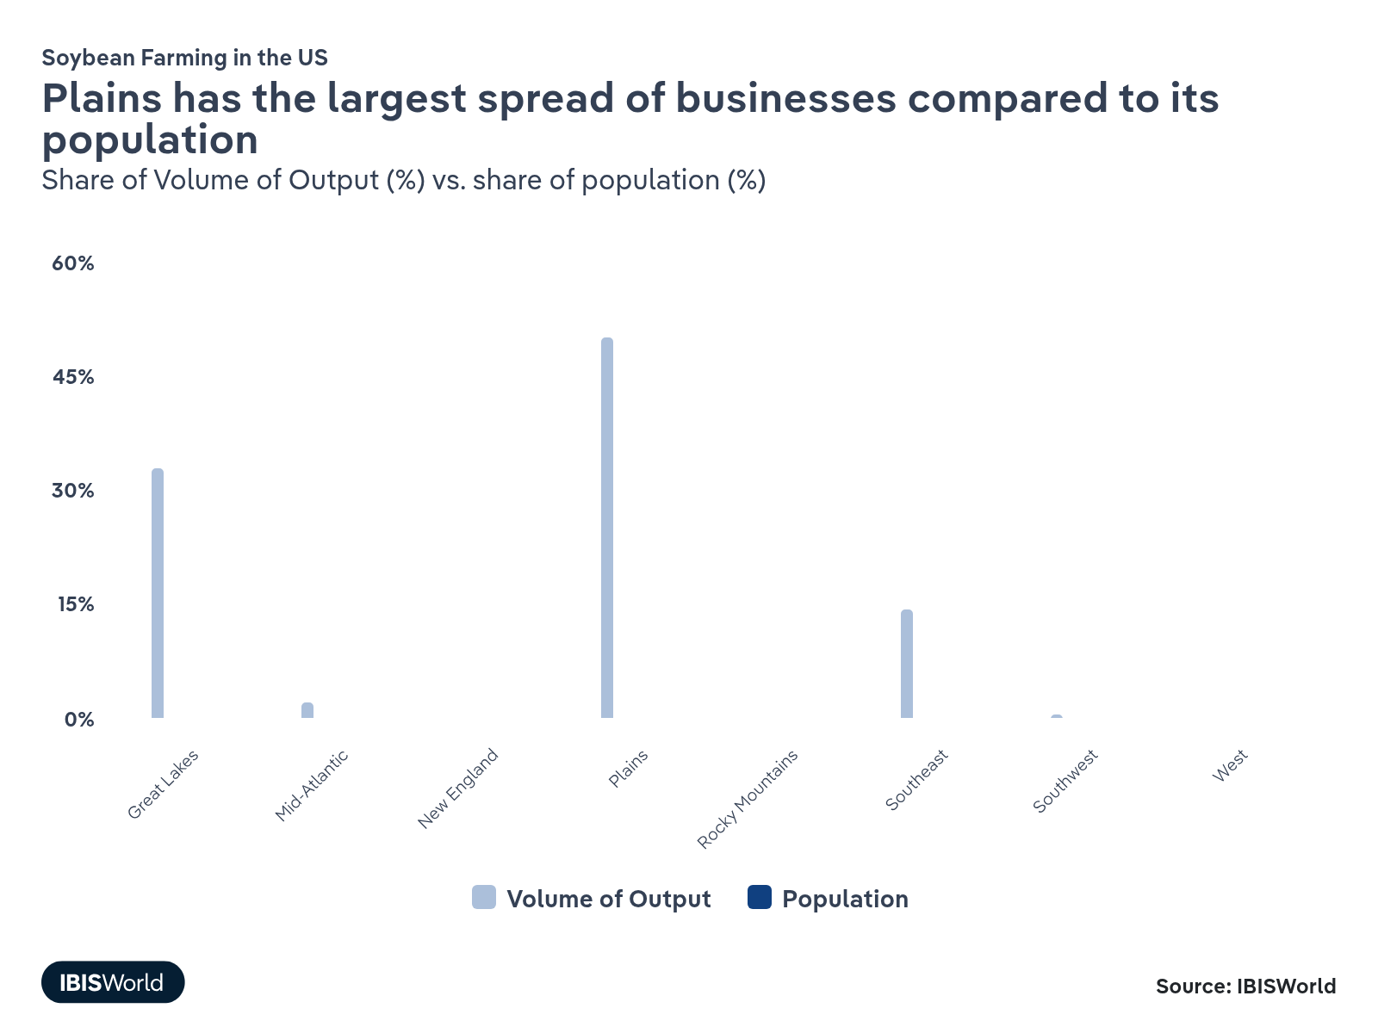
How do businesses use location to their advantage?
Operate in a location with appropriate climatic conditions
New technology has enabled soybeans to be raised in areas that were previously too difficult to cultivate. However, yields may be insufficient to justify planting and harvesting costs. Farmers must carefully choose planting locations and quantities.
Manage seasonal production
Soybean farms can benefit from operating in areas with longer growing seasons or conditions that allow for crop rotation and off-season production.

6. Competitive Forces
https://my.ibisworld.com/us/en/industry/11111/competitive-forces

Key Takeaways
- Soybean farms must reduce costs to better compete with other soybean farms, feed grain producers and oilseed growers. Product innovation and differentiation can help, but price will have the most significant impact on demand.
- Health-focused alternatives have threatened soybeans in both the edible oil and animal feed markets. With health concerns rising around seed oils, many consumers have turned away from soybean oils.

Concentration
Low

What impacts the industry’s market share concentration?

Small soybean farms keep it in the family
- Soybean growing has a long history in the US, so most growers are long-standing family farms. These family-run farms often maintain lower costs by relying on family labor rather than hired workers.
- The limited availability of farmland in the US poses challenges for expanding soybean acreage, but this limitation also serves as a barrier to large-scale investors entering the industry. As a result, small family farms face less pressure from corporate competition, preserving the traditional, small-operation structure of US soybean farming.

GMO seed producers dominate the soybean seed market
- Since the development of GMO soybeans in 1996, genetically modified varieties have become the industry standard. The majority of US soybean acreage now uses GMO seeds, which offer benefits like herbicide resistance and improved yields. While these varieties carry a premium cost, they reduce volatility for growers by providing more consistent harvests and simplified weed management.
- The GMO soybean seed market is highly concentrated, dominated by a small number of large biotechnology companies. Firms like Bayer (which acquired Monsanto), Corteva Agriscience and Syngenta control the majority of GMO soybean seed production and distribution. This concentration gives these companies significant influence over seed prices and availability.
- Recent deal activity reinforces this concentration: for example, a 2023 collaboration between Bunge and Corteva focuses on developing higher-protein, improved-amino-acid soybeans, further integrating trait, seed and downstream processing interests rather than creating new independent competitors. In 2025, plant genetics business GDM also acquired corn and soybean seed supplier AgReliant Genetrics.

Upstream and downstream concentration contrasts with fragmented soybean farm ownership
- In contrast to the fragmented farm base, both upstream input suppliers and downstream grain traders and crushers show high and rising concentration, which shapes effective market power around soybeans. On the downstream side, the completion of Bunge’s merger with Viterra in 2025 has created an even larger global grain and oilseed exporter and processor, strengthening the position of the ABCD trading group in global soybean flows.
- Upstream, seed, crop-protection and machinery markets remain dominated by a handful of firms, while fertilizer, retail agronomy and related input sectors have seen continued consolidation and M&A activity in the current period, leaving farmers with fewer alternatives. Recent examples include Nutrien Ag Solutions’ 2024 acquisition of Suncor’s AgroScience biocontrol assets and ongoing purchases of ag-retail businesses such as Agrosema in Brazil, which expand a single retailer’s footprint and proprietary product offerings.
- In machinery, large manufacturers continue to roll up distribution and precision-agriculture technology, illustrated by AGCO’s acquisition of an 85.0% stake in Trimble’s agricultural technology portfolio in 2023 and John Deere’s 2024 purchase of Hutchinson Farm Supply, both of which concentrate equipment and digital services in a few global platforms.​
How do successful businesses handle concentration?
Have a large supply contract
Soybean farms need a steady supply of seeds, so having a set contract with a seed producer can limit volatility and help keep production volumes stable.
Become a member of an industry organization
Many small family-owned soybean farms have limited resources and can benefit from membership in an industry organization that promotes resource sharing.

Barriers to Entry
High | Steady

What challenges do potential industry entrants face?

Legal
- Legal challenges for new entrants into US soybean farming include navigating an extensive regulatory environment. Farmers must comply with federal and state regulations regarding environmental protection, such as the Clean Water Act and the Resource Conservation and Recovery Act. Additionally, genetically modified organisms (GMOs) regulations require careful adherence to biotechnology and labeling standards. This complex legal landscape can be daunting for newcomers, necessitating legal expertise and often significant investment in ensuring compliance to avoid penalties.

Start-Up Costs
- The start-up costs for soybean farming in the US are substantial, creating a significant barrier for new entrants. Potential farmers must invest in purchasing or leasing land, high-quality seeds and necessary machinery such as tractors, planters and harvesters. Costs for infrastructure, fertility management and potential irrigation systems add to the expense. Access to capital and favorable credit terms are crucial, as the initial financial outlay can be prohibitive without adequate funding.

Differentiation
- Differentiating soybean products in a competitive market poses a distinct challenge for new industry entrants. Newcomers must find ways to distinguish their products, focusing on niche markets such as organic or non-GMO soybeans. Establishing a brand identity and building relationships with buyers can offer differentiation among crops that are otherwise similar.

Capital Expenses
- Capital expenses are a major challenge for new soybean farmers. The initial investment in equipment and technology for soy farming operations is high. This includes purchasing machinery like combines, sprayers and grain storage facilities, which are essential for efficient production and post-harvest handling. The continuous need for technological upgrades to increase yield and stay competitive can strain financial resources, necessitating a robust business plan and secure financial backing to manage these capital-intensive requirements.
How can potential entrants overcome barriers to entry?
Secure economies of scale
Achieving economies of scale allows US soybean farmers to lower production costs by maximizing output. This cost efficiency provides a competitive edge, enabling them to navigate market volatility and enhance profitability, which is crucial for overcoming barriers to entry.
Establish supply contracts for key inputs
Securing supply contracts provides a stable and reliable source of essential farming inputs. This stability helps mitigate risks associated with fluctuating input prices, enabling new entrants to maintain consistent production and better manage cash flow.

Substitutes
Moderate | Increasing

What are substitutes for industry services?

Corn farming
- Corn remains the dominant source of animal feed because of its low growing costs. With corn prices rising faster than soybean prices, soy has gained more of an advantage in markets traditionally dominated by corn. Soybeans also offer higher protein content, making them a valuable addition to poultry, pig and cattle feed.
- Soybeans’ higher protein value often justifies their higher cost for livestock farmers, making them indispensable in feed formulations. Additionally, the protein content of soybeans is crucial for soy-based human foods and meat replacements, where corn cannot adequately substitute. This ensures soybeans maintain a strong foothold in both animal and plant-based food markets.

In-house
- An increasing number of beef cattle producers are shifting from traditional soybean-based feed to grass feeding. This trend is driven by the rising popularity of grass-fed beef, which is perceived to be healthier for cattle and results in higher-quality meat.
- Despite the draws of its benefits, grass-fed beef is costly, serving only a niche, luxury meat market. Grass-feeding is also more susceptible to extreme weather events and droughts that can wipe out grass fields as compared to having stores of prepared cattle feed.

Other edible oils
- A broad set of other vegetable and specialty oils competes directly with soybean oil in the US, including canola, sunflower, peanut, olive and avocado oils. These substitutes are used in many of the same frying, baking and processed food applications as soybean oil, so buyers can often switch with limited equipment changes.​
- Several of these oils, especially avocado and olive, are marketed around their fatty acid profile and are frequently perceived as healthier alternatives. High-oleic versions of sunflower, canola and other oils have gained share in foodservice and packaged foods because of their frying life and oxidative stability.
How do successful businesses compete with substitutes?
Produce a differentiated product
Producing a differentiated product allows US soy farmers to offer unique attributes such as non-GMO or organic soy, appealing to niche markets and consumer preferences. This differentiation reduces the threat from substitute crops and enhances market competitiveness.
Develop strong technical product knowledge
Gaining in-depth technical knowledge about soy cultivation enables farmers to optimize crop yields and adapt to environmental changes. This expertise helps maintain high-quality standards, ensuring soy's competitiveness and reducing the appeal of alternative crops in the market.

Buyer & Supplier Power
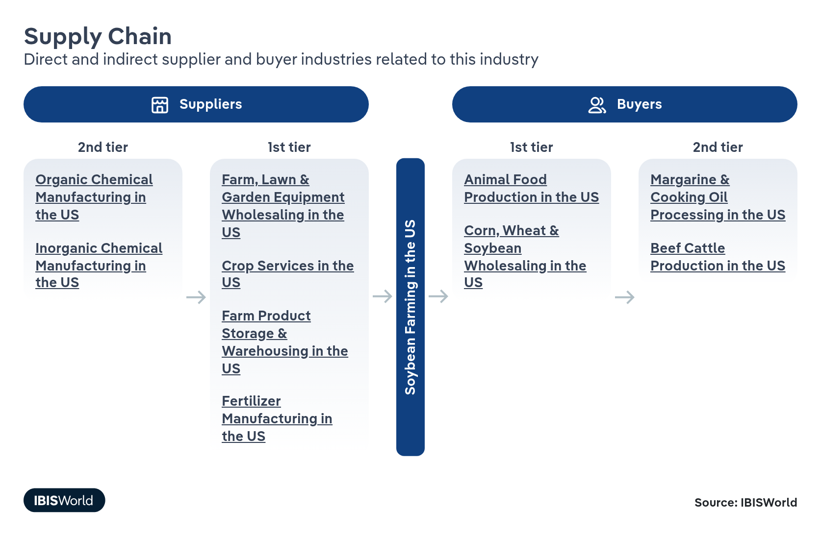

What power do buyers and suppliers have over the industry?

Buyers: Price competition
High | Steady
- A relatively small group of multinational grain traders and crushers – ADM, Bunge, Cargill, Louis Dreyfus – controls a large share of global soybean trade and crushing capacity, giving major buyers significant leverage over price and basis levels offered to farmers. These companies can shift origin between countries or substitute with other oilseeds, which limits individual farmers’ ability to negotiate premiums, especially in regions with only one or two local elevators or crush plants.
- Large domestic crushers and livestock feed manufacturers also wield bargaining power because they buy in high volume and can blend supplies from multiple states and origins. Expanded US crush capacity for biofuel demand increases local competition in some areas, but buyers still typically set contract terms and quality discounts, leaving most individual soybean growers price-takers.​

Suppliers: Limited suppliers for farmers to choose between
Moderate | Increasing
- The soybean farming industry faces significant supplier power due to the limited number of providers for essential inputs like seeds, fertilizers and specialized machinery. This concentration allows suppliers to exert considerable influence over prices and terms of purchase.
- With fewer alternatives available, farmers experience reduced bargaining power, forcing them to comply with supplier conditions. The specialized nature of machinery and patented seeds further intensifies dependence.
- Farmers are subject to strong fluctuations in the cost of fertilizer and machinery, which directly impact production costs and affect their overall profitability and competitiveness. Forming cooperatives can empower farmers to negotiate better terms and prices collectively. Diversifying supply sources by incorporating smaller or local suppliers can decrease dependence on major suppliers.
How do successful businesses manage buyer & supplier power?
Secure export markets
Accessing international buyers diversifies revenue streams and reduces dependence on domestic markets, helping soybean farmers dilute individual buyer influence and manage concentrated buyer power more effectively.​
Offer a competitively priced product
Competitive pricing attracts more buyers and strengthens farmers’ market position, improving their ability to negotiate contracts, manage basis risk and partially offset concentrated buyer power.​

7. Companies
https://my.ibisworld.com/us/en/industry/11111/companies

No single company accounts for more than 5% of total industry market share.

8. External Environment
https://my.ibisworld.com/us/en/industry/11111/external-environment

Key Takeaways
- Subsidies help protect soybean farmers when soybean prices decline. Subsidies also reduce volatility brought on by harsh growing conditions and adverse weather.
- A depreciating US dollar will support a recovering export market. Exports already account for more than half of soybean sales. As the dollar depreciates, exports will grow further.

External Drivers

What demographic and macroeconomic factors impact the industry?
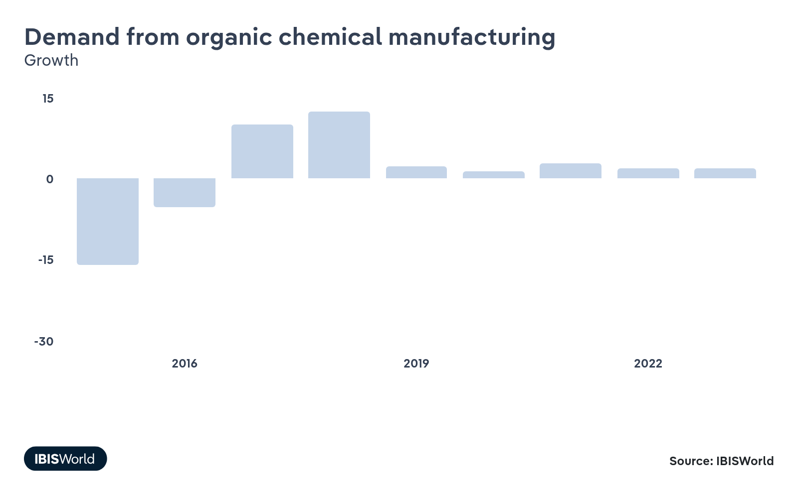
The demand from organic chemical manufacturing boosts the soybean industry as soybeans serve as a raw material for biodegradable plastics, lubricants and other plant-based products. This sector diversifies market opportunities for soybeans beyond traditional food and feed uses. As industries and consumers increasingly prioritize sustainable products, soybean derivatives see rising demand, providing farmers with additional revenue streams and encouraging investment in soybean production.
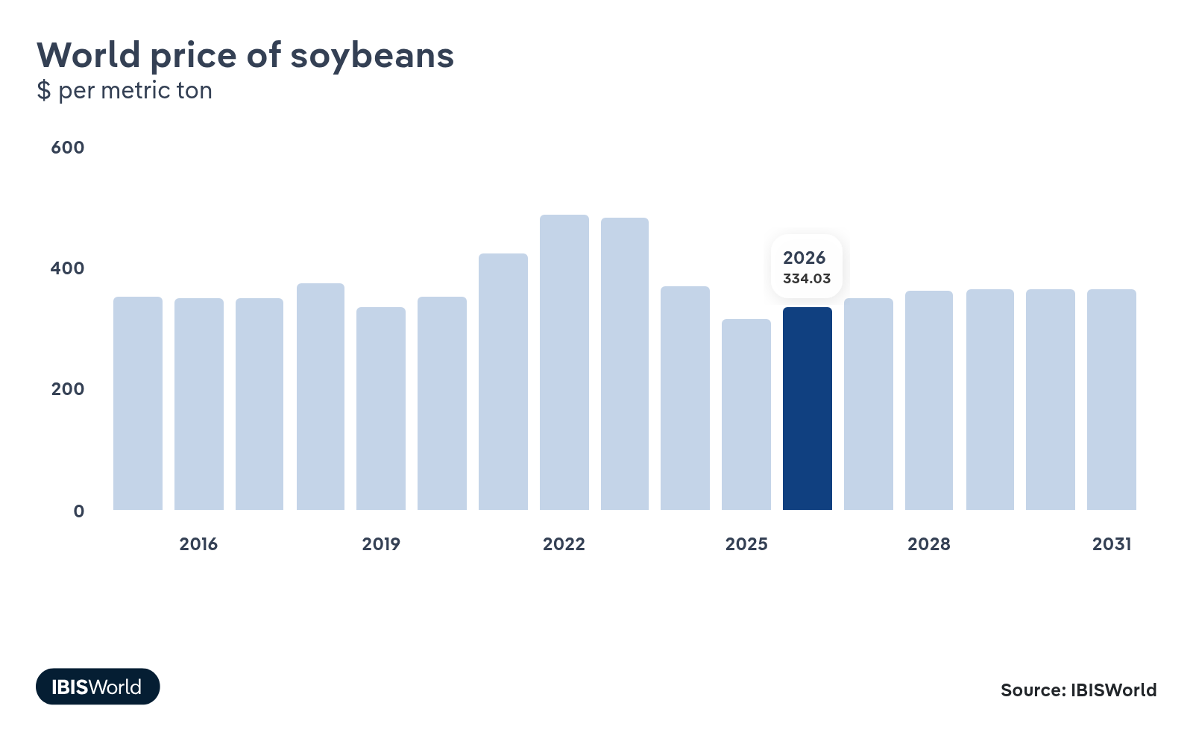
The world price of soybeans directly affects farmers’ profitability and planting decisions. High global prices incentivize increased production, boosting income and allowing investment in advanced farming technologies. Conversely, low prices can strain revenues, impacting farm operations and reducing innovation. Price fluctuations can also influence export competitiveness as US soybeans are held up against competitors in the global market. A drop in soybean prices poses a big threat to the industry.
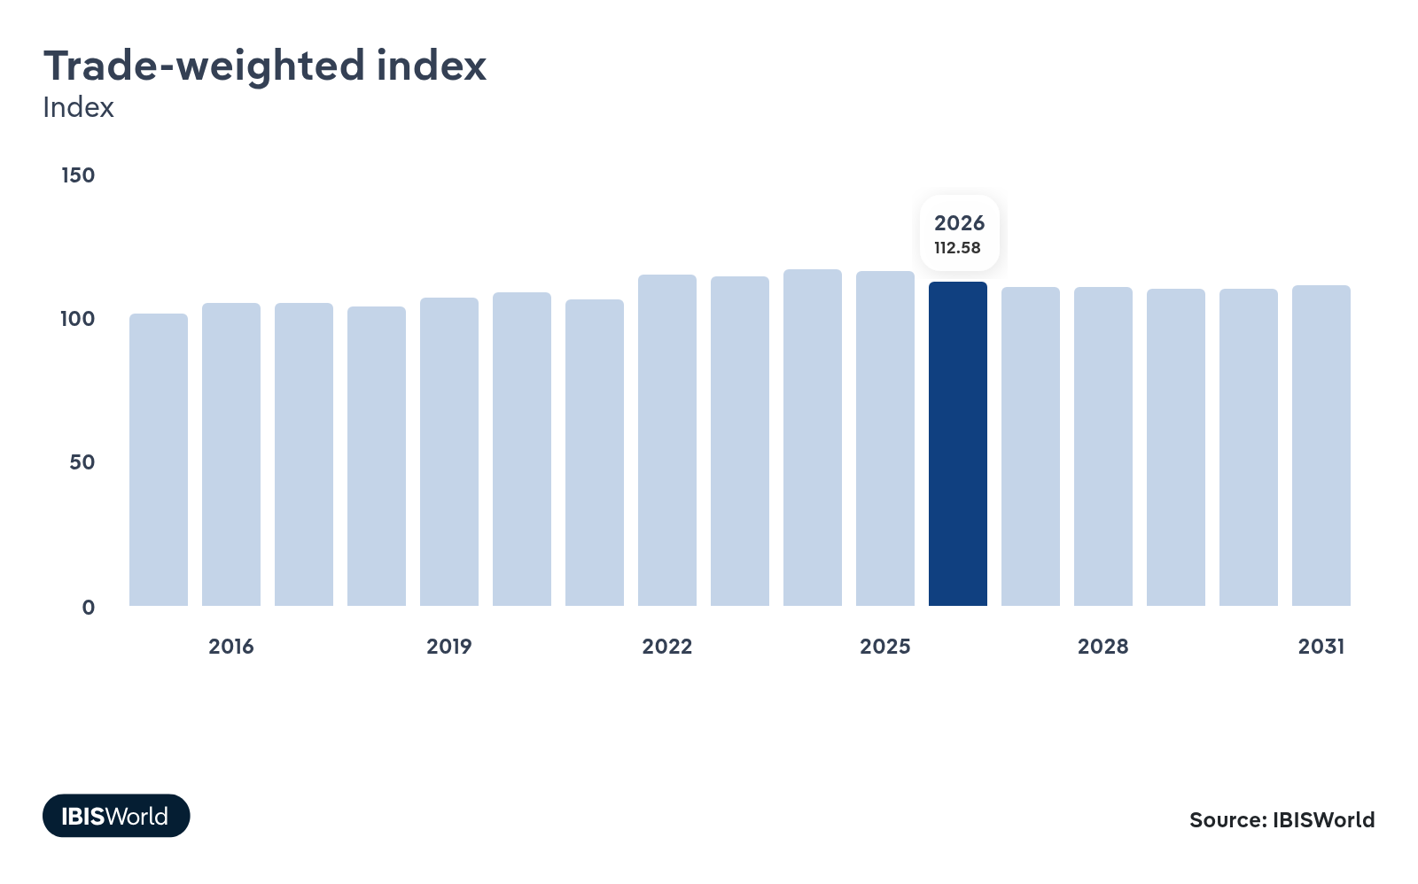
The trade-weighted index, reflecting the value of the US dollar against other currencies, substantially impacts soybean exports. A strong dollar makes US soybeans more expensive abroad, reducing demand and export revenue. Conversely, a weaker dollar enhances competitiveness, boosting exports as soybeans become cheaper for international buyers. This economic measure guides strategic export decisions, affecting international market share and industry growth. The depreciation of the US dollar presents and opportunity for US soybean farmers.
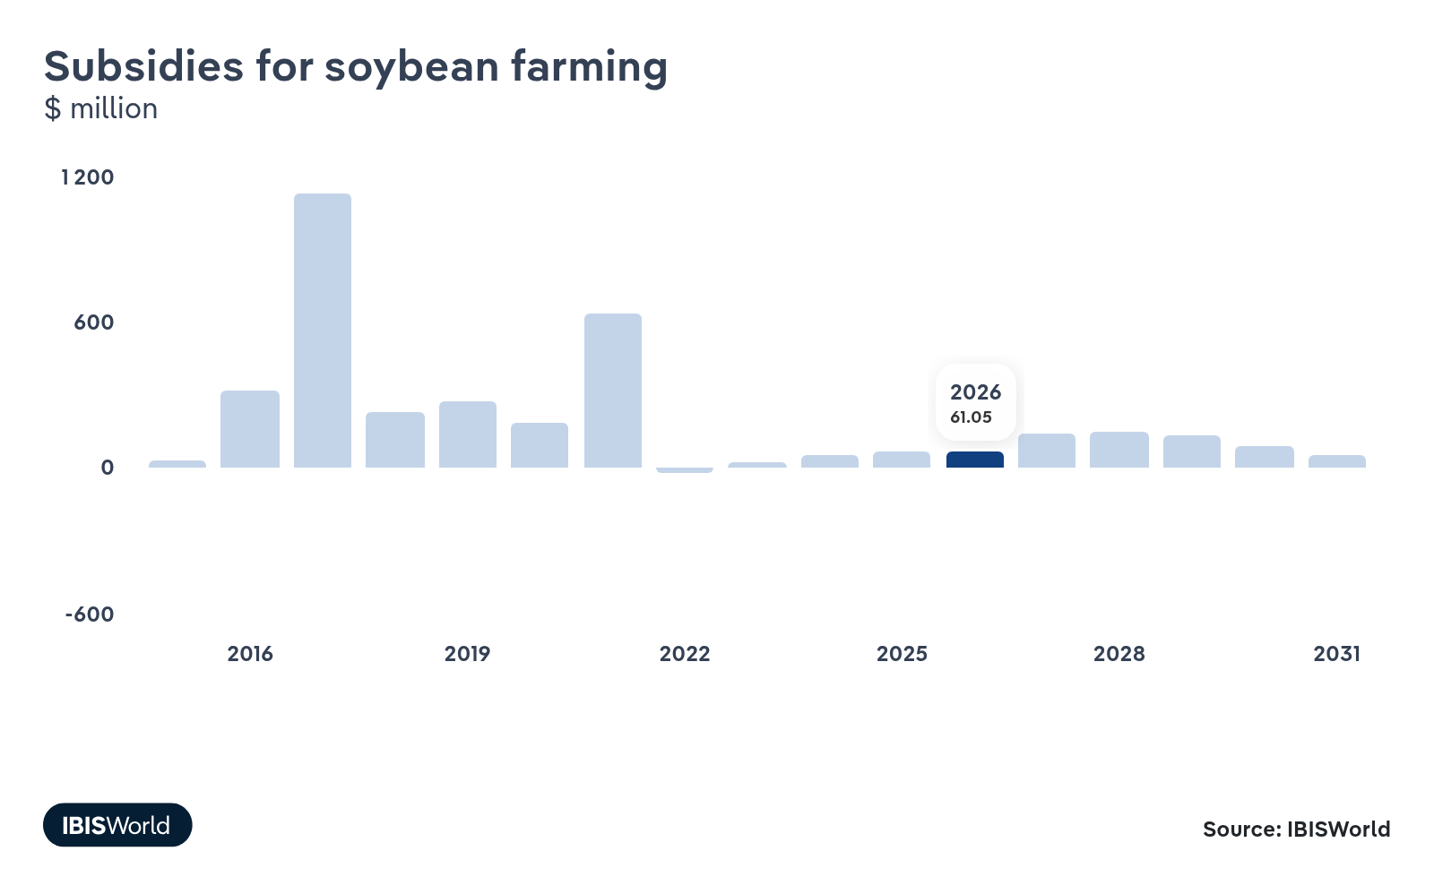
Subsidies provide financial stability for soybean farmers by buffering against market volatility and adverse weather, which can otherwise threaten farm income and credit access. These supports help producers maintain operations, invest in productivity-enhancing technologies and adopt sustainable practices that improve long-term soil and resource management. By reducing financial risk, subsidies stabilize soybean supply chains and support consistent national production levels, strengthening overall sector resilience.​

Regulation & Policy
Moderate | Steady

What regulations impact the industry?

Clean Water Act (CWA)
The Clean Water Act regulates pollutants discharged into US waters and affects soybean farming by setting limits on runoff from agricultural operations. Farmers must manage the use of fertilizers and pesticides to prevent water contamination. The CWA exempts agricultural stormwater runoff from federal permitting requirements as long as it is caused by precipitation. However, farmers must still implement best management practices to minimize pollution. For example, they may need to create buffer zones near water bodies, use cover crops to reduce erosion and carefully time fertilizer applications.

Federal Insecticide, Fungicide, and Rodenticide Act (FIFRA)
FIFRA governs the registration, distribution, and use of pesticides in the United States. Pesticides used on soybeans and other crops must be thoroughly tested and approved by the EPA before they can be sold or used. Soybean farmers must follow strict guidelines for applying approved pesticides to control pests and diseases while minimizing environmental impact. This includes adhering to application rates, timing, and methods specified on pesticide labels. FIFRA also mandates proper pesticide storage, disposal and record-keeping practices.

Federal Seed Act
The Federal Seed Act requires that soybean seeds, including genetically modified varieties, be labeled with accurate information about their contents and production history. This law ensures that farmers can access reliable seed quality information when making purchasing decisions. Labels must include details such as seed purity percentage, germination rate, presence of noxious weed seeds and any chemical treatments applied to the seeds.

Renewable Fuel Standard (RFS)
The RFS mandates the blending of renewable fuels, such as biodiesel from soybeans, into the national fuel supply. This regulation influences demand for soybeans, as they are a key feedstock for biodiesel production. Producers benefit from this demand while contributing to national renewable energy goals. The RFS has led to a dramatic shift in corn and soybean markets. By 2023, almost 50.0% of US soybean oil was used for industrial biofuel production, with the remainder mainly used for food, according to a 2024 Federal Reserve analysis.

Conservation compliance
Conservation compliance provisions under the Food Security Act link eligibility for federal farm program benefits and crop insurance premium subsidies to soil and wetland protection practices on cropland. Soybean farmers who drain wetlands, convert new land from native sod or farm highly erodible land without an approved conservation plan risk losing access to commodity, conservation and disaster payments, as well as certain FSA loans. In practice, this pushes soybean producers to maintain conservation plans, avoid new wetland conversions and adopt erosion-control measures like contour farming, grassed waterways and residue management if they want to retain federal support.​

Agricultural Worker Protection Standard (WPS)
The EPA’s Agricultural Worker Protection Standard is a federal regulation designed to reduce the risks of pesticide exposure for workers and handlers on farms, including soybean operations. Soybean farmers who employ workers to mix, load or apply pesticides – or to enter treated fields – must provide safety training, access to decontamination supplies, posting of treated-area warnings and observe restricted-entry intervals listed on pesticide labels. The WPS also requires recordkeeping and emergency-response information so that employees can obtain medical care promptly if exposure occurs, which affects how soybean farms schedule spraying and organize labor during the growing season.​

Assistance
Moderate | Steady

What assistance is available to this industry?

Agricultural support programs (FSA and NRCS)
FSA and NRCS provide financial assistance, technical support and conservation planning that directly affect soybean producers’ cost structure and risk profile. FSA administers commodity, disaster and loan programs, while NRCS helps soybean farmers design and implement conservation practices such as nutrient management, cover crops and erosion control on working cropland. For example, soy producers commonly work with a local NRCS office to develop a conservation plan and then use FSA to establish a farm number and access payment and loan programs tied to that plan. This coordinated framework supports both farm income stability and compliance with conservation and eligibility requirements specific to field-crop operations like soybeans.​

Federal Crop Insurance Program
The Federal Crop Insurance Program (FCIP), run by the USDA’s Risk Management Agency, offers subsidized yield and revenue insurance that covers most planted soybean acres in the US. Soybean farmers can choose products such as Yield Protection or Revenue Protection, with the federal government subsidizing a substantial share of the premium and sharing underwriting risk with private insurers. In practice, this means a producer can insure against losses from drought, excess moisture, disease and price declines, helping them secure operating credit and withstand bad crop years.

Environmental Quality Incentives Program (EQIP)
The Environmental Quality Incentives Program (EQIP), administered by NRCS, provides cost-share and technical assistance for conservation practices on working lands, which includes soybean fields. Soybean growers can receive multi-year contracts to help pay for practices such as cover crops, reduced tillage, nutrient management and on-farm drainage or water-quality improvements, with NRCS typically sharing a significant portion of installation costs. In recent years, EQIP has supported expanded cover-crop adoption in row-crop systems. For soybean producers, this assistance can reduce erosion, improve soil structure and meet sustainability expectations from downstream buyers while offsetting up-front practice costs.​

Export credit guarantees
Programs such as GSM-102 provide credit guarantees to encourage financing of commercial exports of US agricultural products, including soybeans. By reducing financial risk to lenders, credit guarantees encourage exports to buyers in countries — mainly developing countries — that have sufficient financial strength to have foreign exchange available for scheduled payments. For 2025, the USDA has announced the availability of credit guarantees for sales of US agricultural commodities under the Commodity Credit Corporation's (CCC) Export Credit Guarantee Program (GSM-102) on October 7, 2024.

American Soybean Association (ASA)
The ASA helps soybean farmers by advocating for favorable policies, securing research funding and promoting sustainable farming practices. By representing farmers’ interests in legislative discussions, the ASA helps shape trade policies that enhance market access and competitiveness. It also provides farmers with essential resources, educational programs and support networks to navigate market challenges and adopt innovative practices. The ASA ensures that soybean farmers have the tools and support needed to thrive in a dynamic agricultural landscape through these efforts.

Farmer cooperatives
Cooperatives play a vital role in supporting soybean farmers by providing essential resources and strategies. By pooling their resources, farmers can reduce costs, increase profitability and gain better access to markets. This collective approach allows them to purchase inputs at lower prices and sell their products in larger markets for better rates. Cooperatives also offer additional benefits like legal support and improved product quality, contributing to rural development. For instance, they often provide shared facilities like storage and processing plants, helping smaller farmers access economies of scale.

9. Financial Benchmarks
https://my.ibisworld.com/us/en/industry/11111/financial-benchmarks
Profit Margin  16.7 %  ↑ Higher than sector | Average Wage  $9,306  ↓ Lower than sector | Largest Cost  Purchases  44.8% of Revenue

Key Takeaways
- Input costs have grown for soybean farms. Fertilizer prices, in particular, have increased in the current period, though they have cooled from 2021 and 2022 extremes.
- Profit has risen and fallen for soybean farmers alongside soybean prices. The strong volatility of these price changes has made it difficult for farmers to quickly balance their costs with falling prices.

Cost Structure
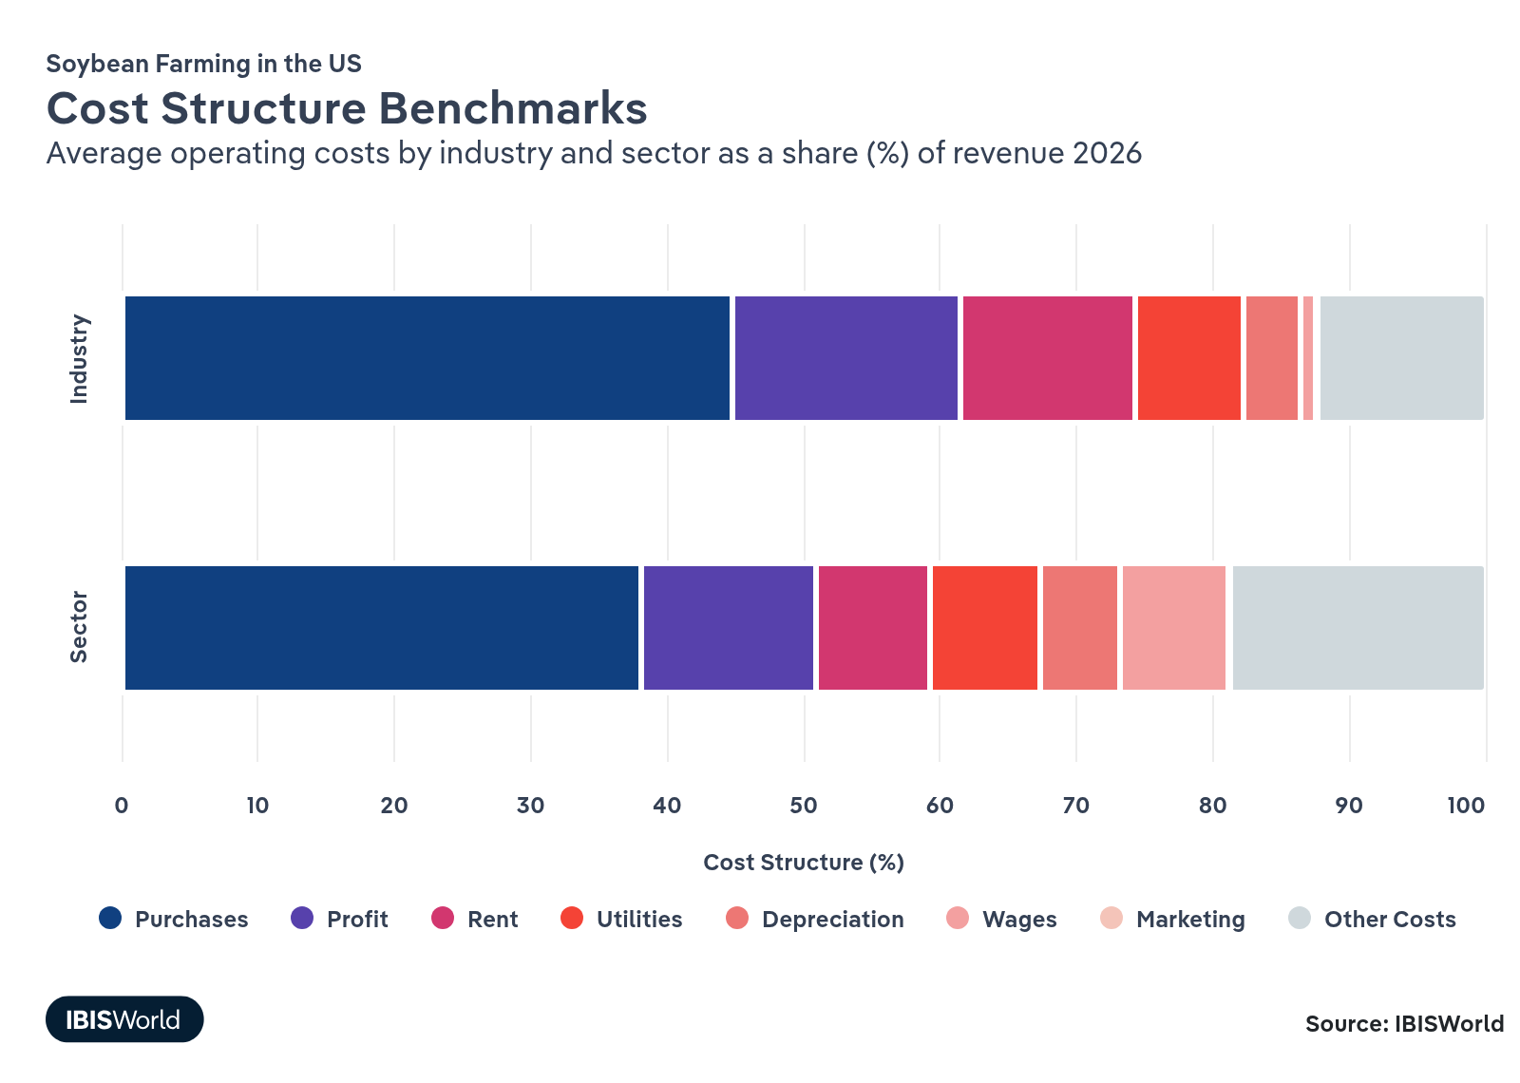
Chart displays current year only in the PDF version of this report. You can view and download chart for all other years associated with this industry on my.ibisworld.com.

What trends impact industry costs?

Declining soybean prices challenge average industry profit
- In recent years, soybean prices have been on a rollercoaster. After rising sharply due to increased global demand and supply chain disruptions, prices have been declining since 2023 as supply balances out and biofuel demand stalls. This volatility makes soybean farmers price-takers in a commoditized market, amplifying their financial challenges.
- Key costs impacting soybean farmers include seeds, fertilizers and machinery, all of which have seen price increases in the current period. These costs are substantial, affecting overall profitability and forcing farmers to focus on cost management strategies. Recent years' input price drops have helped to relieve some of these pressures. Still, soy prices have fallen faster and pushed profit down since 2022.
- To adapt, farmers are focusing on practical cost-saving measures. Embracing precision agriculture can help manage resources better and cut costs. By aligning with consumer trends toward organic and sustainable practices, farmers can also explore niche, high-profit markets to boost revenue.

Easing oil and fertilizer prices offer relief to farm input costs
- After a period of rising prices, crude oil and fertilizer costs began decreasing in 2023 and 2024. Though fertilizer prices are forecast to increase through the end of 2025 as major producers such as the US, Canada, Russia and Belarus provide ample supply, they are set to remain stable in 2026. Overall, US soybean input expenses have leveled off from inflated peaks in 2021 and 2022.
- Soybean farming is machinery-intensive, requiring substantial fuel for tractors, harvesters and other equipment to plant, maintain and harvest crops. When crude oil prices soared due to geopolitical tensions, the cost of operating this machinery significantly increased.
- Fertilizer costs also spiked alongside oil prices because energy is a key part of their production. Fertilizers depend heavily on natural gas and oil derivatives, impacting the cost and availability of essential chemicals, such as herbicides and pesticides.
- To tackle high input costs, farmers can strategically reduce their reliance on fertilizers and pesticides without compromising yield. According to 2024 research from Michigan State University, moving to no-till practices can save $15 to $25 per acre, as tillage has little impact on soybean yield. Additionally, reducing planting rates can maintain productivity while cutting seed costs, offering potential savings without significant yield loss.

Softer land costs follow crop income downturns
- After peaking with the 2021–2022 income boom, effective land costs for soybeans have eased, with recent crop budgets showing lower budgeted rent per acre even as published cash rent surveys remain near record highs. Some landlords have become more flexible on terms and renewals as falling commodity prices and several years of negative projected returns weaken tenants’ ability to pay top-of-market rents.​
- This moderation in rent costs has helped cushion the blow from strong inputs and deflated soybean prices, slowing the erosion of farm balance sheets. Compared with more location-constrained specialty crops, soybean producers benefit from broader land options and can more readily shift acres or renegotiate, which slightly improves resilience during this profitability down-cycle.​

Farmers have maintained stable utilities costs despite water stress
- Utilities and energy costs for soybean farms have stayed relatively stable as a share of revenue from 2021 through 2026, even through periods of drought and high irrigation demand. Several factors have contributed to this: soybeans remain concentrated in rain-fed Midwest regions less exposed to extreme irrigation costs, and efficiency gains in pumping, grain handling and on-farm storage have helped offset higher power prices.​
- This stability contrasts with more water-intensive Western crops, where utilities have become a major volatility driver. For soybean producers, having utilities behave more like a predictable fixed cost simplifies budgeting and keeps the main profit struggles centered around wages, agrochemical inputs and machinery rather than on unpredictable energy or water bills.​

Slowly rising machinery costs are pushing up depreciation
- Depreciation costs in soybean farming have inched up since 2021 as machinery prices and investments have climbed. Larger farms have increased machinery investment per acre, spreading fixed costs, while many mid-sized operations stretch the life of existing equipment to avoid high new-machine prices and interest rates.​
- This gentle but persistent rise in depreciation keeps a floor under fixed costs and limits how far total costs can fall, even as some variable inputs ease. Compared with more capital-light specialty crops, soybean operations carry higher long-run equipment burdens, which can constrain profitability in years of weak prices and discourage rapid acreage expansion.​

Farm labor wages continue to rise due to tightening labor supplies
- Wages for soybean farms have been pushed up over the current period. The USDA notes that a shrinking supply of US workers, high minimum wages in agricultural states like Washington and California and special regulations governing H-2A workers and migrant and seasonal farmworkers have all raised the proportion of wage costs to revenue.
- According to the 2024 USDA Farm Labor Survey, farm operators paid hired workers an average gross wage of $18.95 per hour during the July 2024 reference week, up 2.0% from July 2023. Average gross wages have since risen further, sitting at $19.52 as of the latest May 2025 edition of the survey.

Marketing costs remain low due to B2B sales strategies
- Marketing costs for soybeans have remained low, which is typical of the B2B, large contract agriculture sector. Soybean farmers usually rely on regional connections and established relationships with food processors for the bulk of their sales, making marketing campaigns largely unnecessary. Cooperatives also help to provide connections between farmers and soybean buyers, further reducing marketing costs.
- Bulk sales to processors like ADM and Cargill also help maintain these low costs. Overdependence on large customers can add risk, however, as losing major deals with them can decimate farms' revenue streams
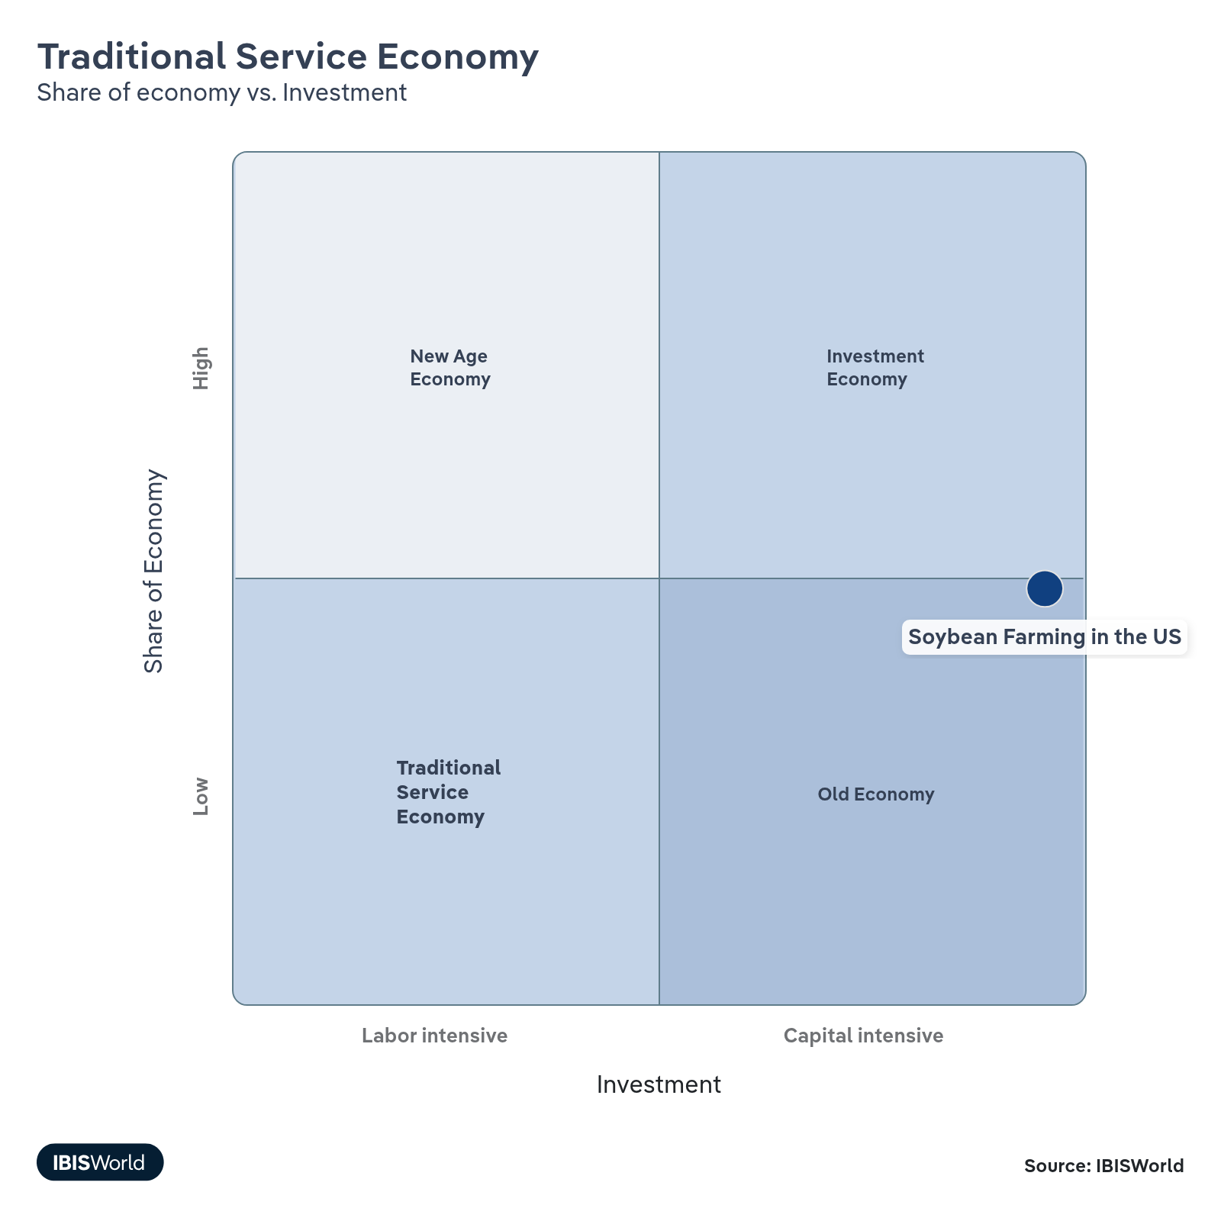

Financial Ratios

Earnings Ratios
Ratio | 2019 | 2020 | 2021 | 2022 | 2023 | 3-Year | 5-Year | 10-Year
EBIT/Revenue | 22.6 | 22.9 | 22.1 | 18.0 | 18.8 | 18.4 | 20.5 | 20.9
EBITDA/Revenue | 25.7 | 25.6 | 24.5 | 22.5 | 24.6 | 23.5 | 24.3 | 24.5
Leverage Ratio | 3.7 | 3.9 | 4.1 | 4.4 | 4.1 | 4.3 | 4.1 | 4.0

Industry Tax Structure
Ratio | 2019 | 2020 | 2021 | 2022 | 2023 | 3-Year | 5-Year | 10-Year
Taxes Paid/Revenue | 3.4 | 3.0 | 2.6 | 2.6 | 2.1 | 2.4 | 2.6 | 3.0

Income Statement
Ratio | 2019 | 2020 | 2021 | 2022 | 2023 | 3-Year | 5-Year | 10-Year
Total Revenue | 100.0 | 100.0 | 100.0 | 100.0 | 100.0 | 100.0 | 100.0 | 100.0
Business receipts | 87.1 | 87.1 | 87.1 | 87.1 | 87.1 | 87.1 | 87.1 | 87.1
Cost of goods | 42.8 | 34.9 | 33.1 | 44.8 | 34.9 | 39.8 | 36.9 | 39.6
Gross Profit | 57.2 | 65.1 | 66.9 | 55.2 | 65.1 | 60.2 | 63.1 | 60.4
Expenses
Salaries and wages | 1.8 | 1.5 | 9.9 | 3.3 | 2.8 | 3.0 | 4.4 | 3.2
Advertising | 1.5 | 1.4 | 1.1 | 1.2 | 1.0 | 1.1 | 1.2 | 1.4
Depreciation | 2.9 | 2.3 | 2.3 | 2.7 | 2.1 | 2.4 | 2.4 | 2.7
Depletion | 0.1 | 0.0 | 0.2 | 0.0 | 0.6 | 0.3 | 0.2 | 0.1
Amortization | 0.1 | 0.3 | 0.0 | 1.7 | 3.1 | 2.4 | 1.3 | 0.7
Rent paid | 0.7 | 2.2 | 3.8 | 0.3 | 1.0 | 0.6 | 1.8 | 1.5
Repairs | 0.3 | 0.3 | 0.3 | 0.2 | 0.1 | 0.2 | 0.2 | 0.2
Bad debts | 0.4 | 0.3 | 0.2 | 0.1 | 0.0 | 0.0 | 0.1 | 0.4
Employee benefit programs | 0.9 | 0.8 | 0.7 | 0.6 | 2.0 | 1.3 | 1.0 | 1.0
Compensation of officers | 0.5 | 6.5 | 1.2 | 0.9 | 5.5 | 3.2 | 3.5 | 2.3
Taxes paid | 3.4 | 3.0 | 2.6 | 2.6 | 2.1 | 2.4 | 2.6 | 3.0
Interest Income | 1.6 | 1.7 | 1.4 | 1.9 | 1.2 | 1.6 | 1.6 | 1.8
Other Income
Royalties | 1.8 | 2.1 | 1.7 | 1.4 | 0.9 | 1.2 | 1.5 | 1.7
Rent Income | 0.0 | 0.1 | 0.1 | 0.9 | 0.6 | 0.7 | 0.4 | 0.2
Net Income | 15.6 | 16.9 | 16.7 | 12.9 | 13.1 | 13.0 | 14.9 | 14.6
Charitable contributions | 0.0 | 0.0 | 0.0 | 0.2 | 0.1 | 0.1 | 0.1 | 0.0
Dividends | 0.0 | 0.0 | 0.0 | 0.0 | 1.2 | 0.6 | 0.3 | 0.1
Interest paid | 3.6 | 3.0 | 2.8 | 2.5 | 3.6 | 3.1 | 3.0 | 3.3
Net gain, noncapital assets | 0.6 | 0.5 | 0.6 | 0.2 | 0.2 | 0.2 | 0.4 | 0.6
Net long-term capital gain less net short-term loss | 1.5 | 1.4 | 1.7 | 1.4 | 0.9 | 1.1 | 1.4 | 1.4
Net loss, noncapital assets | 0.0 | 0.0 | 0.1 | 0.2 | 0.1 | 0.2 | 0.1 | 0.1
Net short-term capital gain less net long-term loss | 0.0 | 0.0 | 0.0 | 1.2 | 0.7 | 1.0 | 0.5 | 0.2
Other deductions | 23.7 | 25.0 | 23.9 | 25.0 | 23.6 | 24.3 | 24.4 | 24.1
Other receipts | 7.3 | 7.1 | 7.4 | 5.9 | 7.3 | 6.6 | 6.9 | 6.9
Pension, profit-sharing, etc., plans | 1.2 | 0.9 | 0.9 | 0.7 | 2.2 | 1.4 | 1.2 | 1.3

Balance Sheet
Ratio | 2019 | 2020 | 2021 | 2022 | 2023 | 3-Year | 5-Year | 10-Year
Assets
Cash and Equivalents | 6.3 | 4.8 | 5.9 | 5.8 | 5.4 | 5.6 | 5.5 | 6.0
Notes and accounts receivable | 15.5 | 16.8 | 13.8 | 11.6 | 13.8 | 12.7 | 14.0 | 15.2
Allowance for bad debts | 0.1 | 0.1 | 0.0 | 0.9 | 0.9 | 0.9 | 0.5 | 0.2
Inventories | 8.0 | 5.5 | 6.3 | 9.3 | 15.0 | 12.1 | 9.0 | 8.6
Other current assets | 4.2 | 2.7 | 2.9 | 2.6 | 2.4 | 2.5 | 2.6 | 3.4
Other investments | 13.5 | 17.7 | 25.4 | 34.0 | 27.7 | 30.8 | 26.2 | 18.4
Property, Plant and Equipment | 62.3 | 46.0 | 46.8 | 40.9 | 48.8 | 44.9 | 45.6 | 57.5
Accumulated depreciation | 45.2 | 32.8 | 33.0 | 27.5 | 33.4 | 30.5 | 31.7 | 40.1
Intangible assets (Amortizable) | 1.8 | 6.5 | 6.7 | 2.0 | -0.3 | 0.8 | 3.7 | 2.6
Accumulated amortization | 0.5 | 1.7 | 1.6 | 1.6 | 0.0 | 0.8 | 1.2 | 0.8
Other assets | 3.4 | 2.3 | 2.3 | 5.4 | 4.8 | 5.1 | 3.7 | 3.4
Total assets | 100.0 | 100.0 | 100.0 | 100.0 | 100.0 | 100.0 | 100.0 | 100.0
Accounts payable | 12.0 | 12.3 | 11.2 | 9.4 | 12.5 | 10.9 | 11.3 | 12.2
Liabilities and Net Worth
Mort, notes, and bonds under 1 yr | 9.9 | 7.7 | 5.8 | 7.9 | 10.4 | 9.2 | 8.0 | 9.1
Other current liabilities | 6.0 | 3.4 | 3.0 | 5.5 | 3.6 | 4.5 | 3.9 | 4.3
Loans from shareholders | 9.0 | 7.0 | 5.8 | 9.2 | 10.1 | 9.6 | 8.0 | 8.9
Mort, notes, bonds, 1 yr or more | 24.4 | 15.9 | 29.2 | 18.8 | 20.8 | 19.8 | 21.2 | 22.6
Other liabilities | 5.6 | 5.5 | 3.6 | 4.2 | 4.3 | 4.2 | 4.4 | 4.5
Total liabilities | 100.0 | 100.0 | 100.0 | 100.0 | 100.0 | 100.0 | 100.0 | 100.0
Capital stock | -6.7 | 0.7 | -6.8 | 9.6 | 5.2 | 7.4 | 2.2 | -2.5
Additional paid-in capital | 67.9 | 54.3 | 65.6 | 47.1 | 34.6 | 40.9 | 50.4 | 60.3
Retained earnings, appropriated | -12.3 | -2.7 | -9.7 | -7.7 | -5.4 | -6.5 | -6.4 | -9.5
Retained earnings-unappropriated | -12.7 | -2.6 | -6.4 | -2.3 | 4.1 | 0.9 | -1.8 | -7.7
Cost of treasury stock | 3.1 | 1.6 | 1.3 | 1.6 | 0.2 | 0.9 | 1.2 | 2.1
Net worth | 33.1 | 48.1 | 41.4 | 45.1 | 38.3 | 41.7 | 43.2 | 38.4
Accumulated depletion | 9.5 | 3.7 | 3.3 | 1.7 | 1.3 | 1.5 | 2.5 | 5.9
Depletable assets | 24.6 | 21.9 | 14.3 | 5.1 | 4.2 | 4.7 | 11.4 | 16.5
Government Obligations | 0.0 | 0.0 | 0.0 | 1.7 | 1.3 | 1.5 | 0.7 | 0.4
Land | 12.7 | 9.9 | 10.1 | 8.3 | 8.0 | 8.2 | 9.1 | 11.4
Loans to shareholders | 2.1 | 2.4 | 1.3 | 2.1 | 2.3 | 2.2 | 2.0 | 2.3
Mortgage and real estate loans | 0.3 | 0.1 | 0.1 | 0.6 | 0.2 | 0.4 | 0.3 | 0.3
Tax Exempt Securities | 0.6 | 1.7 | 2.1 | 2.2 | 2.1 | 2.2 | 2.0 | 1.3

Liquidity Ratios
Ratio | 2019 | 2020 | 2021 | 2022 | 2023 | 3-Year | 5-Year | 10-Year
Current Ratio | 1.2 | 1.3 | 1.6 | 1.5 | 1.5 | 1.5 | 1.5 | 1.4
Quick Ratio | 1.0 | 1.1 | 1.2 | 1.1 | 1.0 | 1.0 | 1.1 | 1.0
Sales/Receivables | 6.8 | 6.0 | 7.3 | 8.6 | 7.2 | 7.9 | 7.3 | 6.9
Days' Receivables | 53.5 | 61.3 | 50.2 | 42.5 | 50.4 | 46.4 | 51.1 | 53.6
Days' Inventory | 64.3 | 57.1 | 69.1 | 75.5 | 156.6 | 116.0 | 89.6 | 78.4
Inventory Turnover | 5.7 | 6.4 | 5.3 | 4.8 | 2.3 | 3.6 | 4.7 | 5.1
Payables Turnover | 3.8 | 2.8 | 3.0 | 4.8 | 2.8 | 3.8 | 3.3 | 3.4
Days' Payables | 96.8 | 128.4 | 123.6 | 76.4 | 130.5 | 103.4 | 114.7 | 110.0
Sales/Working Capital | 13.6 | 10.9 | 7.9 | 7.7 | 6.0 | 6.9 | 8.1 | 10.1

Coverage Ratios
Ratio | 2019 | 2020 | 2021 | 2022 | 2023 | 3-Year | 5-Year | 10-Year
Interest Coverage | 6.3 | 7.7 | 8.0 | 7.1 | 5.2 | 6.2 | 7.0 | 6.4
Debt Service Coverage Ratio | 2.8 | 3.3 | 4.2 | 2.8 | 2.4 | 2.6 | 3.2 | 2.9

Leverage Ratios
Ratio | 2019 | 2020 | 2021 | 2022 | 2023 | 3-Year | 5-Year | 10-Year
Fixed Assets/Net Worth | 4.7 | 2.5 | 2.8 | 1.9 | 2.5 | 2.2 | 2.4 | 3.6
Debt/Net Worth | 3.0 | 2.1 | 2.4 | 2.2 | 2.6 | 2.4 | 2.3 | 2.6
Tangible Net Worth | 33.1 | 48.1 | 41.4 | 45.1 | 38.3 | 41.7 | 43.2 | 38.4

Operating Ratios
Ratio | 2019 | 2020 | 2021 | 2022 | 2023 | 3-Year | 5-Year | 10-Year
Return on Net Worth, % | 72.0 | 47.6 | 53.4 | 40.0 | 49.1 | 44.6 | 47.5 | 57.4
Return on Assets, % | 23.8 | 22.9 | 22.1 | 18.0 | 18.8 | 18.4 | 20.5 | 21.6
Sales/Total Assets | 1.1 | 1.0 | 1.0 | 1.0 | 1.0 | 1.0 | 1.0 | 1.0
EBITDA/Revenue | 25.7 | 25.6 | 24.5 | 22.5 | 24.6 | 23.5 | 24.3 | 24.5
EBIT/Revenue | 22.6 | 22.9 | 22.1 | 18.0 | 18.8 | 18.4 | 20.5 | 20.9

Cash Flow & Debt Service Ratios (% of sales)
Ratio | 2019 | 2020 | 2021 | 2022 | 2023 | 3-Year | 5-Year | 10-Year
Cash from Trading | 56.6 | 69.4 | 64.1 | 51.9 | 58.6 | 55.2 | 61.0 | 59.6
Cash after Operations | 52.5 | 56.1 | 47.0 | 48.9 | 46.5 | 47.7 | 49.6 | 51.1
Net Cash after Operations | 50.0 | 58.0 | 46.3 | 44.3 | 48.7 | 46.5 | 49.3 | 49.7
Debt Service P&I Coverage | 3.7 | 4.5 | 3.7 | 4.1 | 3.2 | 3.7 | 3.9 | 3.7
Interest Coverage (Operating Cash) | 14.0 | 19.4 | 16.6 | 17.4 | 13.5 | 15.5 | 16.7 | 15.2

Valuation Multiples

Valuation Multiples
Ratio | 2019 | 2020 | 2021 | 2022 | 2023 | 3-Year | 5-Year | 10-Year
EV/Revenue | 0.7 | 0.7 | 0.8 | 0.8 | 0.7 | 0.8 | 0.7 | 0.7
EV/EBITDA | 2.7 | 2.9 | 3.1 | 3.3 | 3.0 | 3.2 | 3.0 | 3.0
EV/EBIT | 3.1 | 3.2 | 3.5 | 4.2 | 4.0 | 3.9 | 3.6 | 3.5

Key Ratios
Year | Revenue per Employee  ($) | Revenue per Enterprise  ($ Million) | Employees per Estab.  (Units) | Employees per Enterprise  (Units) | Average Wage  ($) | Wages/ Revenue  (%) | Estab. per Enterprise  (Units) | IVA/ Revenue  (%) | Imports/ Demand  (%) | Exports/ Revenue  (%)
2006 | 276,715 | 0.3 | 1.0 | 1.0 | 4,396 | 1.6 | 1.0 | 33.9 | 0.5 | 39.1
2007 | 538,697 | 0.6 | 1.0 | 1.0 | 6,649 | 1.2 | 1.0 | 37.1 | 0.7 | 42.7
2008 | 437,788 | 0.4 | 1.0 | 1.0 | 4,134 | 0.9 | 1.0 | 35.8 | 1.6 | 58.7
2009 | 491,232 | 0.5 | 1.0 | 1.0 | 7,842 | 1.6 | 1.0 | 26.9 | 1.2 | 47.8
2010 | 439,283 | 0.4 | 1.0 | 1.0 | 7,671 | 1.7 | 1.0 | 35.0 | 1.3 | 53.2
2011 | 586,850 | 0.6 | 1.0 | 1.0 | 6,062 | 1.0 | 1.0 | 33.3 | 1.4 | 52.8
2012 | 662,704 | 0.7 | 1.0 | 1.0 | 10,600 | 1.6 | 1.0 | 33.9 | 1.7 | 55.8
2013 | 586,113 | 0.6 | 1.0 | 1.0 | 6,581 | 1.1 | 1.0 | 33.5 | 3.2 | 48.2
2014 | 462,796 | 0.5 | 1.0 | 1.0 | 8,579 | 1.9 | 1.0 | 33.2 | 6.3 | 58.6
2015 | 457,842 | 0.5 | 1.0 | 1.0 | 6,771 | 1.5 | 1.0 | 26.7 | 3.3 | 57.1
2016 | 515,438 | 0.5 | 1.0 | 1.0 | 8,324 | 1.6 | 1.0 | 28.6 | 1.9 | 54.6
2017 | 457,917 | 0.5 | 1.0 | 1.0 | 8,615 | 1.9 | 1.0 | 33.0 | 2.3 | 55.9
2018 | 474,974 | 0.5 | 1.0 | 1.0 | 7,506 | 1.6 | 1.0 | 33.7 | 1.6 | 46.3
2019 | 479,681 | 0.5 | 1.0 | 1.0 | 5,095 | 1.1 | 1.0 | 30.7 | 1.7 | 55.1
2020 | 462,452 | 0.5 | 1.0 | 1.0 | 7,016 | 1.5 | 1.0 | 33.7 | 1.6 | 61.7
2021 | 527,608 | 0.5 | 1.0 | 1.0 | 5,805 | 1.1 | 1.0 | 18.4 | 1.9 | 56.0
2022 | 756,421 | 0.8 | 1.0 | 1.0 | 8,202 | 1.1 | 1.0 | 23.6 | 1.8 | 56.1
2023 | 779,841 | 0.8 | 1.1 | 1.1 | 8,098 | 1.0 | 1.0 | 23.3 | 1.7 | 49.5
2024 | 737,463 | 0.7 | 1.0 | 1.0 | 9,272 | 1.3 | 1.0 | 22.8 | 1.7 | 52.4
2025 | 729,906 | 0.7 | 1.0 | 1.0 | 9,253 | 1.3 | 1.0 | 21.7 | 2.4 | 63.5
2026 | 750,555 | 0.8 | 1.0 | 1.0 | 9,306 | 1.2 | 1.0 | 22.1 | 2.3 | 64.1
2027 | 769,183 | 0.8 | 1.0 | 1.0 | 9,352 | 1.2 | 1.0 | 22.4 | 2.3 | 64.4
2028 | 794,426 | 0.9 | 1.1 | 1.1 | 9,412 | 1.2 | 1.0 | 22.6 | 2.3 | 64.5
2029 | 816,900 | 0.9 | 1.1 | 1.1 | 9,466 | 1.2 | 1.0 | 22.7 | 2.3 | 64.5
2030 | 832,406 | 1.0 | 1.1 | 1.1 | 9,501 | 1.1 | 1.0 | 22.7 | 2.3 | 64.6
2031 | 842,280 | 1.0 | 1.1 | 1.2 | 9,525 | 1.1 | 1.0 | 31.5 | 2.3 | 64.3
2032 | 849,031 | 1.0 | 1.2 | 1.2 | 9,540 | 1.1 | 1.0 | 31.6 | 2.3 | 64.3
*Figures are inflation adjusted to 2026
*Figures are inflation adjusted to 2026

10. Key Statistics
https://my.ibisworld.com/us/en/industry/11111/key-statistics

Industry Data

Values
Year | Revenue  ($ Million) | IVA  ($ Million) | Estab.  (Units) | Enterprises  (Units) | Employment  (Units) | Exports  ($ Million) | Imports  ($ Million) | Wages  ($ Million)
2006 | 27,067.1 | 9,187.7 | 96,032 | 96,029 | 97,816 | 10,583.6 | 87.3 | 430.0
2007 | 34,969.5 | 12,963.0 | 62,923 | 62,919 | 64,915 | 14,933.3 | 146.1 | 431.6
2008 | 38,990.7 | 13,952.3 | 87,037 | 87,034 | 89,063 | 22,870.2 | 269.9 | 368.2
2009 | 50,252.5 | 13,529.5 | 99,847 | 99,843 | 102,299 | 24,007.2 | 309.6 | 802.2
2010 | 50,399.4 | 17,630.3 | 112,012 | 112,008 | 114,731 | 26,796.6 | 319.6 | 880.1
2011 | 47,179.8 | 15,717.0 | 77,519 | 77,512 | 80,395 | 24,909.7 | 312.4 | 487.3
2012 | 61,677.9 | 20,903.6 | 89,947 | 89,940 | 93,070 | 34,437.6 | 458.3 | 986.6
2013 | 61,154.4 | 20,475.7 | 100,930 | 100,923 | 104,339 | 29,472.6 | 1,052.5 | 686.6
2014 | 55,194.5 | 18,311.4 | 115,632 | 115,624 | 119,263 | 32,325.2 | 1,543.2 | 1,023.1
2015 | 44,352.1 | 11,862.1 | 93,251 | 93,241 | 96,872 | 25,323.3 | 657.4 | 656.0
2016 | 55,603.3 | 15,898.2 | 104,025 | 104,015 | 107,876 | 30,356.6 | 494.7 | 898.0
2017 | 50,205.1 | 16,554.3 | 105,833 | 105,822 | 109,638 | 28,050.0 | 529.6 | 944.5
2018 | 47,186.8 | 15,885.7 | 95,556 | 95,543 | 99,346 | 21,858.2 | 405.1 | 745.7
2019 | 42,697.8 | 13,095.9 | 85,129 | 85,113 | 89,013 | 23,508.8 | 332.1 | 453.6
2020 | 51,303.5 | 17,266.4 | 107,077 | 107,064 | 110,938 | 31,639.6 | 326.7 | 778.4
2021 | 58,060.1 | 10,662.6 | 106,244 | 106,229 | 110,044 | 32,530.0 | 488.6 | 638.8
2022 | 67,739.7 | 16,019.2 | 85,688 | 85,667 | 89,553 | 38,035.6 | 535.7 | 734.5
2023 | 59,791.2 | 13,945.8 | 72,632 | 72,604 | 76,671 | 29,601.6 | 533.8 | 620.9
2024 | 48,676.2 | 11,085.5 | 65,459 | 65,433 | 66,005 | 25,495.0 | 394.2 | 612.0
2025 | 44,332.3 | 9,610.8 | 60,873 | 60,849 | 60,737 | 28,151.5 | 390.0 | 562.0
2026 | 45,738.8 | 10,111.5 | 59,696 | 59,466 | 60,940 | 29,335.3 | 391.3 | 567.1
2027 | 47,374.0 | 10,617.7 | 59,097 | 58,684 | 61,590 | 30,529.8 | 399.9 | 576.0
2028 | 48,489.4 | 10,964.0 | 56,859 | 56,215 | 61,037 | 31,268.1 | 408.6 | 574.5
2029 | 48,820.4 | 11,098.0 | 54,178 | 53,354 | 59,763 | 31,501.2 | 410.6 | 565.7
2030 | 48,877.2 | 11,101.5 | 52,180 | 51,240 | 58,718 | 31,557.6 | 410.4 | 557.9
2031 | 48,724.2 | 15,326.4 | 50,683 | 49,671 | 57,848 | 31,345.3 | 413.3 | 551.0
2032 | 48,724.2 | 15,400.3 | 49,597 | 48,522 | 57,388 | 31,320.7 | 414.2 | 547.5

*Figures are inflation adjusted to 2026

Annual Change
Year | Revenue  % | IVA  % | Estab.  % | Enterprises  % | Employment  % | Exports  % | Imports  % | Wages  %
2006 | N/A | N/A | N/A | N/A | N/A | N/A | N/A | N/A
2007 | 29.2 | 41.1 | -34.5 | -34.5 | -33.6 | 41.1 | 67.4 | 0.4
2008 | 11.5 | 7.6 | 38.3 | 38.3 | 37.2 | 53.1 | 84.8 | -14.7
2009 | 28.9 | -3.0 | 14.7 | 14.7 | 14.9 | 5.0 | 14.7 | 117.9
2010 | 0.3 | 30.3 | 12.2 | 12.2 | 12.2 | 11.6 | 3.2 | 9.7
2011 | -6.4 | -10.9 | -30.8 | -30.8 | -29.9 | -7.0 | -2.2 | -44.6
2012 | 30.7 | 33.0 | 16.0 | 16.0 | 15.8 | 38.2 | 46.7 | 102.4
2013 | -0.8 | -2.0 | 12.2 | 12.2 | 12.1 | -14.4 | 129.6 | -30.4
2014 | -9.7 | -10.6 | 14.6 | 14.6 | 14.3 | 9.7 | 46.6 | 49.0
2015 | -19.6 | -35.2 | -19.4 | -19.4 | -18.8 | -21.7 | -57.4 | -35.9
2016 | 25.4 | 34.0 | 11.6 | 11.6 | 11.4 | 19.9 | -24.8 | 36.9
2017 | -9.7 | 4.1 | 1.7 | 1.7 | 1.6 | -7.6 | 7.1 | 5.2
2018 | -6.0 | -4.0 | -9.7 | -9.7 | -9.4 | -22.1 | -23.5 | -21.0
2019 | -9.5 | -17.6 | -10.9 | -10.9 | -10.4 | 7.6 | -18.0 | -39.2
2020 | 20.2 | 31.8 | 25.8 | 25.8 | 24.6 | 34.6 | -1.6 | 71.6
2021 | 13.2 | -38.2 | -0.8 | -0.8 | -0.8 | 2.8 | 49.6 | -17.9
2022 | 16.7 | 50.2 | -19.3 | -19.4 | -18.6 | 16.9 | 9.6 | 15.0
2023 | -11.7 | -12.9 | -15.2 | -15.2 | -14.4 | -22.2 | -0.3 | -15.5
2024 | -18.6 | -20.5 | -9.9 | -9.9 | -13.9 | -13.9 | -26.1 | -1.4
2025 | -8.9 | -13.3 | -7.0 | -7.0 | -8.0 | 10.4 | -1.1 | -8.2
2026 | 3.2 | 5.2 | -1.9 | -2.3 | 0.3 | 4.2 | 0.3 | 0.9
2027 | 3.6 | 5.0 | -1.0 | -1.3 | 1.1 | 4.1 | 2.2 | 1.6
2028 | 2.4 | 3.3 | -3.8 | -4.2 | -0.9 | 2.4 | 2.2 | -0.3
2029 | 0.7 | 1.2 | -4.7 | -5.1 | -2.1 | 0.7 | 0.5 | -1.5
2030 | 0.1 | 0.0 | -3.7 | -4.0 | -1.7 | 0.2 | 0.0 | -1.4
2031 | -0.3 | 38.1 | -2.9 | -3.1 | -1.5 | -0.7 | 0.7 | -1.2
2032 | 0.0 | 0.5 | -2.1 | -2.3 | -0.8 | -0.1 | 0.2 | -0.6

*Figures are inflation adjusted to 2026

DISCLAIMER
This product has been supplied by IBISWorld Inc. (‘IBISWorld’) solely for use by its authorized licenses strictly in accordance with their license agreements with IBISWorld. IBISWorld makes no representation to any other person with regard to the completeness or accuracy of the data or information contained herein, and it accepts no responsibility and disclaims all liability (save for liability which cannot be lawfully disclaimed) for loss or damage whatsoever suffered or incurred by any other person resulting from the use of, or reliance upon, the data or information contained herein. Copyright in this publication is owned by IBISWorld Inc. The publication is sold on the basis that the purchaser agrees not to copy the material contained within it for other than the purchasers own purposes. In the event that the purchaser uses or quotes from the material in this publication – in papers, reports, or opinions prepared for any other person – it is agreed that it will be sourced to: IBISWorld Inc.

