
INDUSTRY REPORT
Beer Manufacturing in Australia
Dec 2025

About

IBISWorld
IBISWorld specializes in industry research with coverage on thousands of global industries. Our comprehensive data and in-depth analysis help businesses of all types gain quick and actionable insights on industries around the world. Busy professionals can spend less time researching and preparing for meetings, and more time focused on making strategic business decisions.

Table Of Contents | Standard

1. About 4
Codes 4
Definition 4
Related Terms 4
What's Included 4
Companies 4
Related Industries 5
Additional Resources 5
2. At a Glance 6
Key Takeaways 6
Products and Services 8
Major Players 9
Key External Drivers 10
Industry Structure 10
SWOT 11
Executive Summary 11
3. Performance 12
Highlights 12
Key Takeaways 12
Performance Snapshot 13
Outlook 22
Life Cycle 25
4. Products and Markets 26
Key Takeaways 26
Products and Services 27
Major Markets 32
International Trade 34
Imports 37
Exports 38
5. Geographic Breakdown 39
Key Takeaways 39
Business Locations 40
6. Competitive Forces 44
Key Takeaways 44
Concentration 44
Barriers to Entry 46
Substitutes 47
Buyer & Supplier Power 49
7. Companies 51
Key Takeaways 51
Market Share 52
Companies 53
8. External Environment 68
Key Takeaways 68
External Drivers 68
Regulation & Policy 71
Assistance 73
9. Financial Benchmarks 75
Key Takeaways 75
Cost Structure 75
Financial Ratios 79
Valuation Multiples 82
Key Ratios 83
10. Key Statistics 84
Industry Data 84

1. About
https://my.ibisworld.com/au/en/industry/C1212/about

Codes
ANZSIC 2006 | 1212

Definition
Industry operators manufacture beer, ale, stout or porter. Operators generally package beer in kegs, bottles or cans, and sell it to bars, wholesalers and retailers. The industry does not include production of non-alcoholic beer.

Related Terms

ALCOHOL BY VOLUME (ABV)
A standard measure of how much alcohol is contained in a given volume of an alcoholic beverage.

HOPS
A plant extract from the flower of the hop vine and used to impart flavour and bitterness to beer. It’s also a natural preservative.

KEG
A container commonly used to store, transport and serve beer. Keg sizes vary, so can’t be used as a standard unit of measurement.

What's Included
- Full-strength traditional beer
- Mid-strength beer
- Light beer
- Premium beer
- Low-carbohydrate beer
- Craft beer

Companies
- Asahi Holdings
- Lion
- Coopers Brewery
- Good Drinks Australia
- Coca-Cola Europacific Partners Holdings (Australia)

Related Industries

Industries in the Same Sector
- Competitors:
  - Wine Production in Australia
  - Spirit Manufacturing in Australia
  - Soft Drink Manufacturing in Australia
  - Fruit Juice Drink Manufacturing in Australia
- Complementors:
  - No data available

International Industries
- Global Beer Manufacturing
- Breweries in the US
- Craft Beer Production in the US
- Breweries in Canada
- Beer Manufacturing in New Zealand
- Beer Production in the UK
- Beer Production in Ireland
- Beer Production in China

Additional Resources
- Independent Brewers Association
- Australian Brews News
- Brewers Association of Australia

2. At a Glance
https://my.ibisworld.com/au/en/industry/C1212/at-a-glance
Revenue  $9.8bn  ’21-’26 ↑ 5.1 %  ’26-’31 ↑ 1.3 % | Employees  14,059  ’21-’26 ↑ 9.6 %  ’26-’31 ↑ 3.3 % | Businesses  887  ’21-’26 ↑ 5.8 %  ’26-’31 ↑ 2.5 %
Profit  $324.8m  ’21-’26 ↓ 16.9 % | Profit Margin  3.3%  ’21-’26 ↓ 7.4 pp | Wages  $991.0m  ’21-’26 ↑ 4.3 %  ’26-’31 ↑ 0.3 %

Key Takeaways

Performance
- Consumers' growing preference for higher-priced beers has boosted industry revenue despite demand falling. While overall beer consumption has fallen, higher priced beers have increased revenue as consumers spend more per beer for perceived quality and unique experiences.
- Rising costs have slashed profit margins for beer manufacturers. Climbing excise taxes, increased costs for key inputs like coarse grains and rising competition due to increased industry participation have led to expenses outpacing selling prices, squeezing profit margins.
- Asahi and Lion's market dominance through acquisitions makes it challenging for smaller breweries to compete. Controlling around half of the market, their scale and resources overshadow small independent brewers struggling with rising costs and limited market reach.
- Declining per capita beer consumption is threatening manufacturers' performance. Health consciousness and rising beer prices are causing Australians to drink less beer, forcing breweries to innovate and adapt to maintain revenue and attract customers.

Products and Markets
- The new 10% U.S. tariff on Australian beer will raise exporters' costs and likely reduce their competitiveness in the US market. Brewers may seek alternative markets as a result. However, the US is not a significant export market for the industry.
- Craft beer sales are outpacing other segments. Consumers are increasingly favouring craft beers for their perceived quality and trendiness, boosting craft beer's revenue share over the past five years.
- Mid-strength beer is gaining popularity as people drink less alcohol. With declining per capita alcohol consumption, consumers are shifting from full-strength to mid-strength beers, doubling this segment's share of total beer sold since 2000.
- Light beer's appeal is declining as consumers opt for non-alcoholic options. Light beers' revenue share has nearly halved over the past five years as consumers favour zero-alcohol beers, which are not part of the industry, over light beers.
- Liquor retailers are increasingly bypassing wholesalers to purchase directly from manufacturers. Major retailers like Coles and Woolworths are also developing private-label beer brands, reducing reliance on wholesalers and challenging their market position.

Products and Services
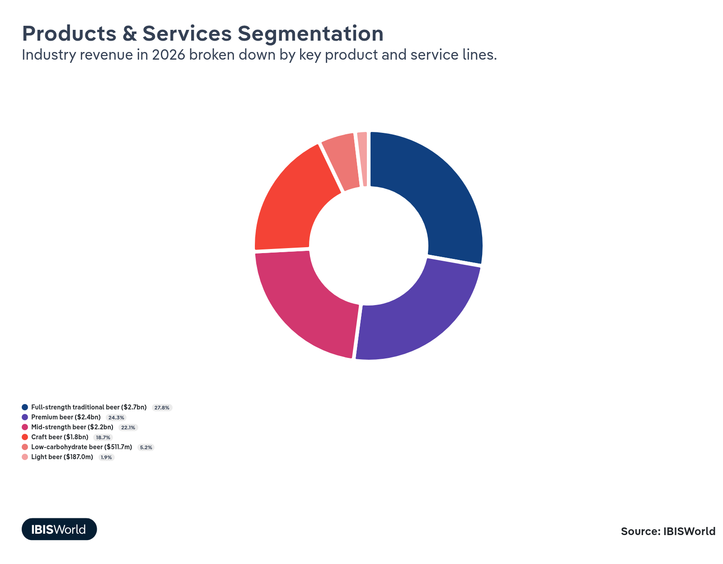

Major Players
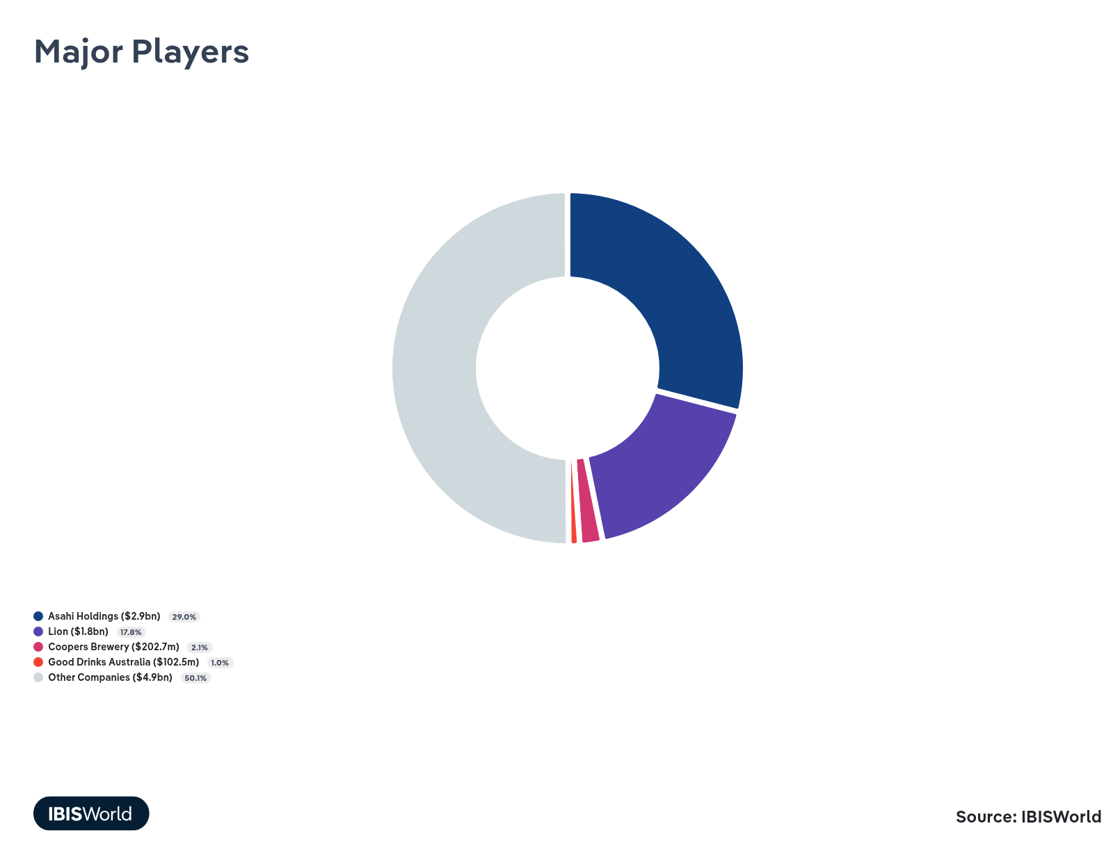

Key External Drivers
Key External Drivers | Impact
Demand from liquor retailing | Positive
Demand from pubs, bars and nightclubs | Positive
Per capita alcohol consumption | Positive
Real household discretionary income | Positive
Domestic price of coarse grains | Negative

Industry Structure
Characteristic | Level | Trend
Concentration | Moderate
Barriers To Entry | High | Decreasing
Regulation and Policy | High | Increasing
Life Cycle | Decline
Revenue Volatility | Moderate
Assistance | Low | Increasing
Competition | High | Increasing
Innovation | Low

SWOT
Strengths  High & Decreasing Barriers to Entry  Low & Increasing Level of Assistance  Low Imports  Low Product/Service Concentration  High Revenue per Employee | Weaknesses  High Competition  Decline Life Cycle Stage  Low Profit vs. Sector Average  High Customer Class Concentration  High Capital Requirements | Opportunities  High Revenue Growth (2021-2026)  High Revenue Growth (2026-2031)  Demand from liquor retailing | Threats  Low Performance Drivers  Domestic price of coarse grains

Executive Summary

Raising the bar: Continued falls in beer consumption are challenging revenue as the major brewers rely on acquisitions to stay in control
Despite declining per capita beer consumption, the Beer Manufacturing industry's revenue has grown over the past five years, thanks to rises in selling prices and consumers' growing preference for higher-priced craft and premium beers. Drinkers are shifting away from traditional full-strength beers, opting instead for craft beers offering perceived quality and unique drinking experiences. This has increased demand for the products of smaller, independent breweries, pushing down market share concentration. Major brewers Asahi and Lion have responded to this trend by expanding their craft beer portfolios through acquisitions and significant marketing investments, as seen in Lion's 2021 acquisition of Fermentum Pty Ltd. Lion has cited increased sales of the Stone & Wood brand, priced at 1.5x that of standard brands, as the reason for revenue growth during 2024-25.
Increased competition due to rising industry participation and declining demand has slashed profit margins, as manufacturers, especially small and independent breweries lacking economies of scale, have struggled to pass on rising production costs. These financial pressures have led to closures and restructuring among smaller brewers. Asahi and Lion control around half of industrywide revenue, making it challenging for smaller breweries to compete, as they struggle with distribution agreements and limited market reach. The overall decline in beer consumption, which in 2023-24 hit its lowest point since 1970-71, poses a significant threat to the industry. It has compelled manufacturers to diversify their product offerings and introduce mid-strength and low-carbohydrate beers. Overall, revenue has grown at an annualised 5.1% over the past five years, reaching an expected total of $9.8 billion in 2025-26, when revenue will rise by an estimated 1.0%.
Over the coming years, the Beer Manufacturing industry will face challenges. Declining per capita beer consumption will continue to threaten the industry's future, forcing manufacturers to balance price increases with the risk of weakening demand. However, improved economic conditions may encourage consumers to spend more on premium or craft beers, helping to partially offset declining volumes and leading to price-driven revenue growth. Revenue is estimated to grow at an average of 1.3% over the five years through to 2030-31, reaching $10.5 billion.

3. Performance
https://my.ibisworld.com/au/en/industry/C1212/performance

Highlights
Revenue  $9.8bn  2021-26 CAGR ↑ 5.1 %  2026-31 CAGR ↑ 1.3 % | Employees  14,059  2021-26 CAGR ↑ 9.6 %  2026-31 CAGR ↑ 3.3 % | Businesses  887  2021-26 CAGR ↑ 5.8 %  2026-31 CAGR ↑ 2.5 %
Profit  $324.8m  2021-26 CAGR ↓ 16.9 % | Profit Margin  3.3%  2021-26 CAGR ↓ 7.4 pp

Key Takeaways
- Consumers' growing preference for higher-priced beers has boosted industry revenue despite demand falling. While overall beer consumption has fallen, higher priced beers have increased revenue as consumers spend more per beer for perceived quality and unique experiences.
- Rising costs have slashed profit margins for beer manufacturers. Climbing excise taxes, increased costs for key inputs like coarse grains and rising competition due to increased industry participation have led to expenses outpacing selling prices, squeezing profit margins.
- Asahi and Lion's market dominance through acquisitions makes it challenging for smaller breweries to compete. Controlling around half of the market, their scale and resources overshadow small independent brewers struggling with rising costs and limited market reach.
- Declining per capita beer consumption is threatening manufacturers' performance. Health consciousness and rising beer prices are causing Australians to drink less beer, forcing breweries to innovate and adapt to maintain revenue and attract customers.

Performance Snapshot
Revenue: | ↑ 2021-26 Revenue CAGR +5.1%
Revenue  $9.8bn  ’21-’26 ↑ 5.1 %  ’26-’31 ↑ 1.3 % | 2026 Revenue Growth  ↑ 1.0 % | Revenue Volatility  Moderate
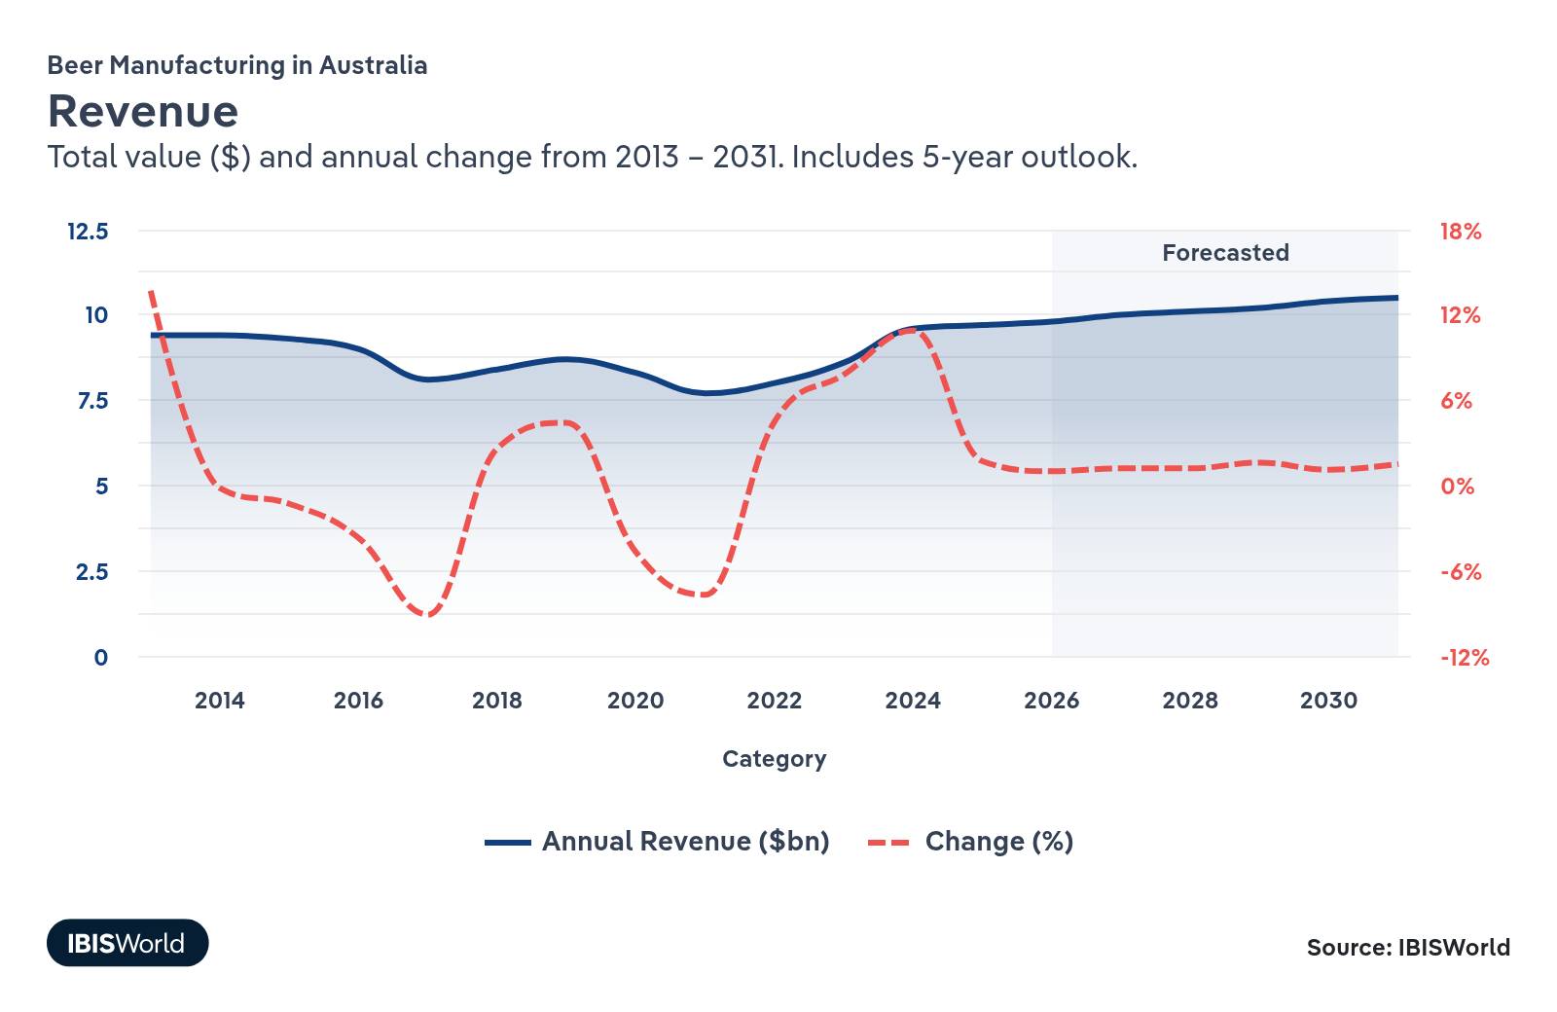
Employees: | ↑ 2021-26 Employees CAGR +9.6%
Employees  14,059  ’21-’26 ↑ 9.6 %  ’26-’31 ↑ 3.3 % | Employees per Business  16  ’21-’26 ↑ 3.5 %  ’26-’31 ↑ 0.8 % | Revenue per Employee  $700k  ’21-’26 ↓ 4.1 %  ’26-’31 ↓ 1.9 %
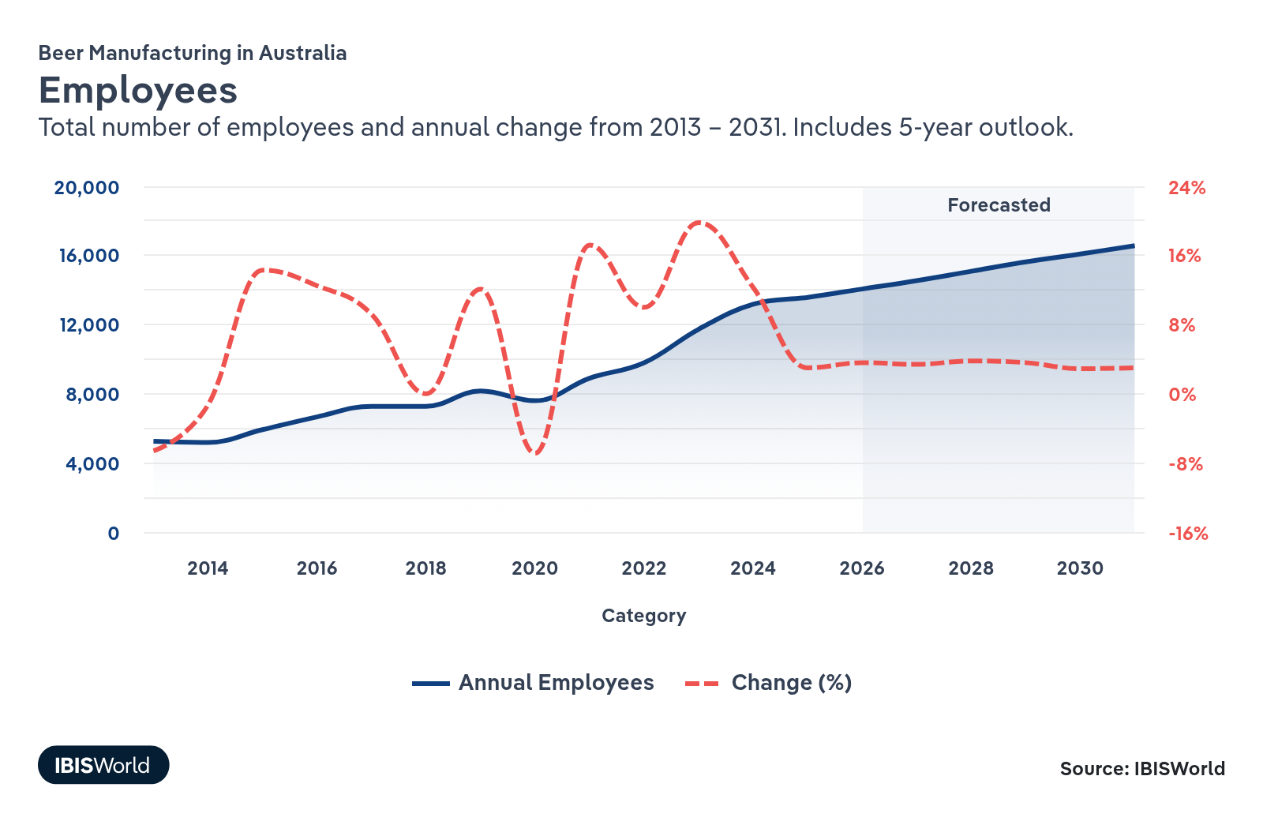
Businesses: | ↑ 2021-26 Business CAGR +5.8%
Businesses  887  ’21-’26 ↑ 5.8 %  ’26-’31 ↑ 2.5 % | Employees per Business  16  ’21-’26 ↑ 3.5 %  ’26-’31 ↑ 0.8 % | Revenue per Business  $11.1m  ’21-’26 ↓ 0.7 %  ’26-’31 ↓ 1.1 %
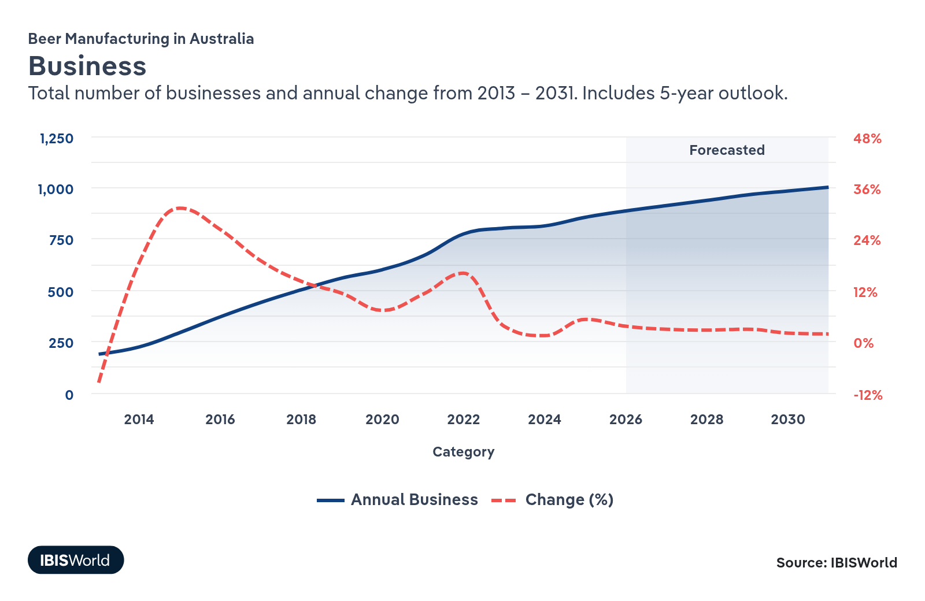
Profit: | ↓ 2021-26 Profit CAGR -16.9%
Total Profit  $324.8m  ’21-’26 ↓ 16.9 % | Profit Margin  3.3%  ’21-’26 ↓ 7.4 pp | Profit per Business  $366.1k
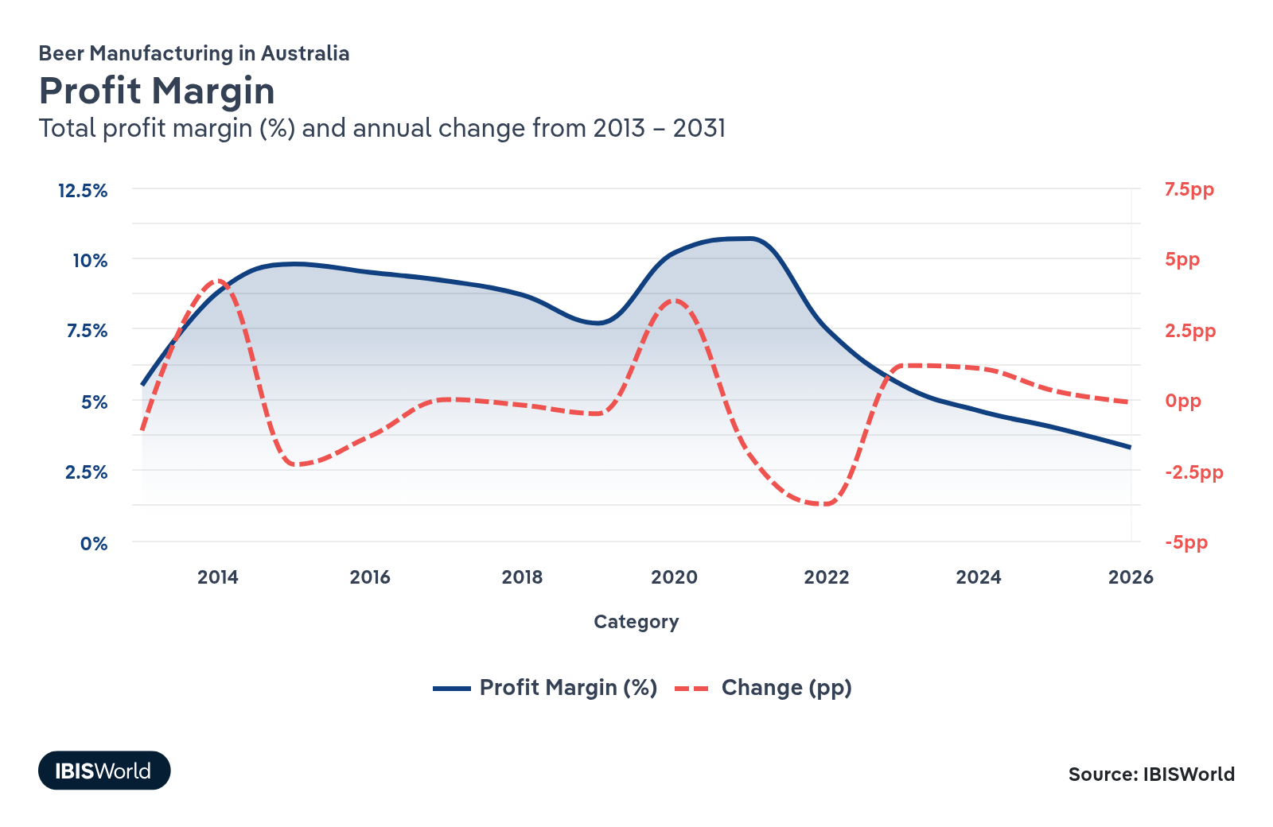
Current Performance
Current Performance

What's driving current industry performance?

Consumers’ growing preference for higher-priced beers has boosted industry revenue despite declining consumption
- Consumers are shifting away from traditional full-strength beers like Victoria Bitter and XXXX Gold and towards higher priced craft beers, elevating selling prices and increasing revenue. As per capita beer consumption falls to historic lows, drinkers are spending more per beer, favouring premium-priced craft beers for their perceived quality.
- Growth in the craft beer segment’s share of industry revenue is helping to offset declines in sales volumes, supporting revenue growth for producers.
- Major brewers Asahi and Lion are capitalising on craft beer’s popularity, both explicitly stating their intentions to expand their market share in the craft beer segment. Recognising craft beers' better margins, these companies have expanded their market presence through acquisitions and marketing investments. In 2024-25, Lion explicitly credited higher sales of its craft brand Stone & Wood, which is priced at 1.5 times that of standard brands, for growth in beer revenue in Australia.
- Lion's 2021 acquisition of Fermentum Pty Ltd, the parent company of popular craft beer Stone & Wood, helped it tap into demand for craft beer. It has since unveiled designs for $30.0 million in upgrades to its Stone & Wood brewery and taproom in Murwillumbah, NSW, boosting its visibility in the craft beer market. Asahi, which owns craft brands like 4 Pines and Balter Brewing, has stated that one of its key strategies is to invest in its craft beer portfolio’s depth and scale to drive up average selling prices.
- Craft beers’ popularity bolsters small brewers' viability, increasing enterprise numbers and employment as new brewers have filled niches in the market. This trend has increased fragmentation and reduced market share concentration since the craft brewery sector is more fragmented, with consumers eager to support independently owned breweries. This has contributed to the two largest brewers’ revenue share falling in the past five years.

Falling per capita beer consumption is threatening manufacturers' performance
- With rising health consciousness and climbs in the price of beer due to inflation and continual increases in excise tax, Australians are turning away from beer. According to the ABS, per capita beer consumption fell by 10.0% from 2019-20 to 2023-24. In contrast, per capita RTD consumption rose by 26.7% over the same period. The total volume of beer available for consumption in 2023-24 was the lowest since 1970-71.
- The slump in per capita beer consumption is forcing manufacturers to market beers at higher pricepoints to offset falling sales volumes. This has helped counterbalance the decline in traditional beer sales and led to revenue growing at an average of 5.1% from 2020-21 to 2025-26 despite demand dipping at an estimated average of 1.3%.
- The shrinking beer market limits potential revenue growth and seriously threatens the Beer Manufacturing industry if brewers can’t innovate and adapt. Breweries are diversifying their product offerings, exploring alternative beverage segments like low-alcohol drinks, or enhancing marketing strategies to retain and attract customers. Embracing these trends is crucial for maintaining revenue in a declining consumption environment.

The cost to produce a beer has risen, slashing profit margins and leading to closures
- Beer manufacturers’ costs have increased significantly in recent years. The prices of key inputs like hops, malt and aluminium have surged and other operational expenses like utilities and aluminium costs have also escalated. While the selling price of beer has increased over the same period, providing revenue growth, manufacturers have struggled to fully pass on these rising costs to consumers, due to falling demand and rising competition. The number of industry enterprises has climbed at an average of 4.8% from 2020-21 to 2025-26, while demand has fallen at an estimated 1.3% over the same period, forcing competitors into intense price competition. This has led to a decline in industrywide profit margins from 10.7% in 2020-21 to 3.4% in 2025-26.
- Financial pressures affect small and independent breweries in particular as they lack the economies of scale to absorb rising costs.
- Consecutive years of rising costs have come to a head in more recent times, with a spate of breweries restructuring or ceasing operations altogether. During 2025, Sydney Beer Co. entered voluntary administration, and Newstead Brewing Co. permanently ceased operations. At least 47 breweries closed or entered administration between January 2023 and February 2025, underscoring the pressures on industry profitability.

Asahi and Lion continue to lead the industry
- Asahi and Lion control around half of Beer Manufacturing industry revenue through strategic acquisitions. In June 2020, Asahi acquired Carlton United Breweries (CUB) for $16.0 billion, expanding its market share from 5.3% in 2018-19 to 36.3% in 2020-21. Similarly, in 2021, Lion purchased Fermentum Group, owner of popular brands Stone & Wood and Two Birds Brewing, for $500.0 million.
- Recent acquisitions have raised concerns about reduced competition and limited consumer choice, but the Australian Competition and Consumer Commission (ACCC) approved them after addressing potential market impacts. The ACCC required Asahi to divest some beer brands for its acquisition to be approved. Following Lion's acquisition of Fermentum, the ACCC determined that enough independent breweries remained to maintain market competitiveness despite it acquiring one of Australia's largest independent brewers.
- Asahi and Lion’s control over the industry makes it challenging for smaller breweries to compete. Despite representing the majority of enterprises and employment, independent breweries contribute far smaller proportions of industry revenue. Small, independent breweries struggle with distribution agreements and prime retail placements in hospitality venues, limiting their ability to expand.
- Smaller breweries are leveraging growing consumer interest in craft beers by creating niche products and operating their own brewpubs and taprooms. They can differentiate themselves from larger competitors by focusing on unique flavours, local ingredients and personalised customer experiences. Direct-to-consumer sales through brewpubs allow them to build brand loyalty and community engagement, helping to expand their market presence despite limitations in distribution.
- In the face of declining beer consumption, Asahi has turned more of its focus to expanding its ready-to-drink (RTD) portfolio, pushing down it's beer-specific market share. The company launched the market leader, Hard Rated, in 2023. Asahi’s Australian RTD sales have grown at around 7% year over the past five years as of March 2025.

Consumer preferences have shifted to mid-strength and low-carb options
- The popularity of mid-strength and non-alcoholic beers has grown, driven by consumers seeking lower alcohol options. Mid-strength beer's market share has increased from 18.7% in 2020-21 to 22.1% in 2025-26, as many consumers prefer to slightly reduce their alcohol intake rather than switch to low-alcohol options.
- To capitalise on the growing preference for mid-strength beer, industry leader Asahi introduced Carlton Dry 3.5% in 2024 and has heavily promoted it since. The product was Australia's highest-selling new beer in 2024. Similarly, Asahi also introduced VB Low Carb in 2024 to cater to health-conscious drinkers seeking traditional beer tastes with fewer carbohydrates.
- The rising popularity of non-alcoholic beer is leading consumers away from light beer, as its appeal has diminished, and consumers are now choosing non-alcoholic options instead. Light beer's share of beer produced has slumped from 3.2% in 2020-21 to an estimated 1.9% in 2025-26.

What influences industry volatility?

Demand fluctuations have heightened volatility
- The Beer Manufacturing industry has exhibited a moderate level of revenue volatility over the five years through to 2025-26, partly because of swings in demand.
- Variations in household discretionary income and consumer sentiment directly influence beer demand, as beer is often considered a luxury item. Economic uncertainties, including interest rate changes aimed at controlling heightened inflation, have impacted consumers' willingness to spend on non-essential products like beer, leading to irregular demand patterns.
- During periods of rising discretionary income, consumers tend to increase spending on beer or opt for higher margin beers, boosting revenue. Conversely, when consumer confidence wanes, spending on beer decreases, contributing to revenue volatility.
- Compared to other beverage production industries, beer is more susceptible to economic swings because of its dependence on discretionary spending.

Rising input costs and selling prices contribute to volatility
- Shifts in beer’s selling price have contributed to revenue volatility for the Beer Manufacturing industry in the past five years.
- Global events, like the Russia-Ukraine conflict, have disrupted supply chains, causing sharp increases in prices for hops, malt, utilities and storage. These rising input costs have been partly passed on to consumers, elevating volatility.
- Intense competition from substitutes like wine and cider and growing demand for higher value premium and craft beers have led to variability in selling prices. Brewers have to adjust prices to remain competitive, which impacts revenue consistency.
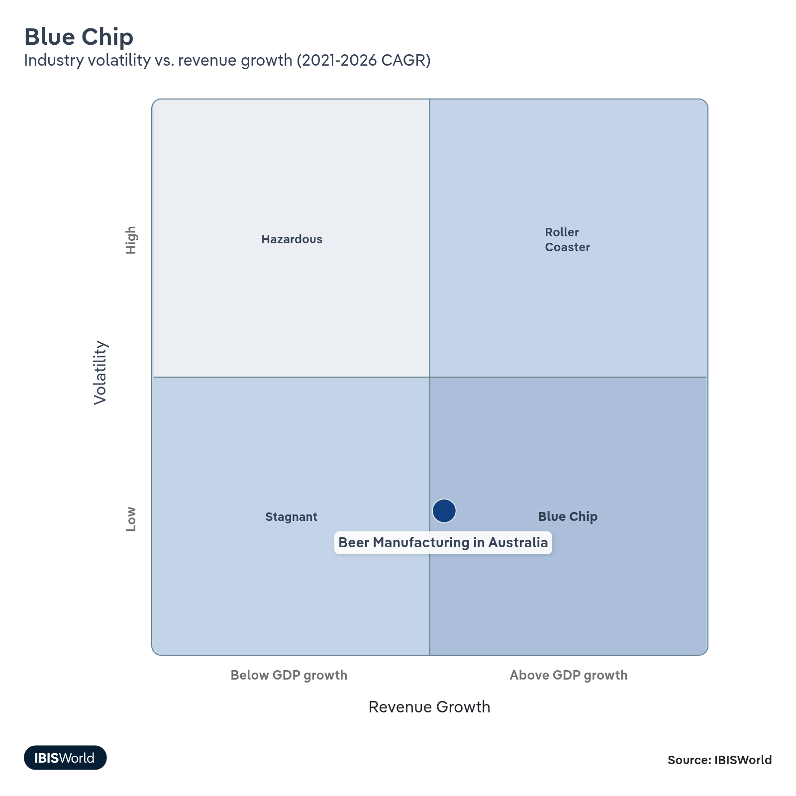

How do successful businesses overcome volatility?
Secure economies of scale
Manufacturers can work on securing economies of scale to reduce per-unit costs, making them less sensitive to tax hikes and increases in input prices.
Pass on cost increases
Manufacturers can help stabilise their revenue by passing on increased production costs to their consumers. They can do this by marketing their beers as craft or premium, as consumers are willing to pay more for these products.
Outlook | ↑ 2026-31 Revenue CAGR +1.3%

What's driving the industry outlook?

Consumers will continue drifting away from beer, threatening manufacturers' viability
- Per capita beer consumption is expected to continue its long-term decline over the next five years, seriously threatening the Beer Manufacturing industry’s operations. This decline aligns with a broader reduction in overall alcohol consumption as health consciousness rises.
- Breweries must increase selling prices to maintain steady revenue amid falling sales volumes. However, significant price hikes risk weakening demand if consumers perceive them as too expensive. Balancing price adjustments without deterring price-sensitive customers will be crucial for manufacturers seeking to offset volume declines.
- Improved economic conditions, with real household discretionary income and consumer sentiment poised to grow over the next five years because of normalising inflation and reduced interest rates, present opportunities for breweries. Consumers with higher disposable income may be more willing to spend on premium or craft beers for their perceived quality and taste, helping to offset declining volumes through higher priced offerings. The revenue growth forecast over the coming years will be driven by price-growth, since demand is expected to continue its long-term decline.

Excise taxes will challenge brewers' profit margins, despite the 2-year freeze
- The Independent Brewers Association has reported that Australia has the third-highest tax on beer globally, behind only Norway and Finland. Such high taxation levels significantly impact breweries’ cost structures.
- After the excise tax on beer rose 16% from 2021 to 2024, from August 2025 to August 2027, Australia's biannual excise tax increases on draught beer at hospitality venues will freeze for two years, providing some relief to profit margins. This will predominantly benefit Asahi and Lion, who control taps at many hospitality venues, and brewers who operate their own hospitality venues.
- The ongoing escalation following August 2027 will place additional financial pressure on beer manufacturers, tightening profit margins. Since beer prices have already been rising quickly, it’s challenging for brewers to fully pass these tax increases on to consumers without risking reduced sales. This means that climbing taxes are forecast to force some smaller brewers to close or consolidate in an effort to remain viable.
- Effective from July 2026, the excise remission cap will increase from $350,000 to $400,000. This development will provide additional relief for eligible brewers under the cap.
- To mitigate continued profitability pressures, breweries may need to explore cost-saving measures or advocate for regulatory reforms to alleviate the tax burden. This could involve investing in new brewing systems to enhance efficiency and reduce energy consumption or improving supply chain management by negotiating better deals with suppliers or sourcing local ingredients to reduce purchase expenses.

Smaller beer manufacturers will focus on brewpubs to distinguish themselves
- As major breweries like Asahi and Lion continue to pivot into the craft beer sector, smaller brewers will differentiate themselves by opening brewpubs. These venues offer customers the unique experience of drinking beer in the same place it's brewed, providing an authentic atmosphere that mass producers struggle to replicate. By creating engaging spaces, smaller brewers can build strong local followings and foster brand loyalty, which are essential for competing against large-scale major players with substantial marketing budgets.
- Long Point Brewing Co. received approval for a planned $13.0 million, two-story brewpub in Port Kennedy, Perth in 2024. Opening is expected in early 2026. Similarly, Capital Brewing Co in Canberra is planning to open a Lager House in February 2026 and Bass Point Brewing opened a new taphouse in Barrack Heights in late 2024. These developments show how smaller brewers are leveraging brewpubs to offer unique, onsite experiences where customers can enjoy beer crafted on the premises.
- This strategic focus will increase the number of establishments, enterprises and employees at a faster rate than revenue over the next five years. Revenue per establishment is projected to fall, as overall revenue will be spread across a greater number of venues. As more brewers invest in brewpubs, the operational costs associated with running these establishments will increase and profitability will falter as these additional costs become necessary for differentiation in a competitive market. Small brewers must carefully manage expenses while enhancing customer experiences to maintain viability.
- Establishing a brewpub requires significant capital investment for brewing equipment, venue acquisition or leasing, licensing and renovations to create an inviting atmosphere for patrons. Operating a brewpub also incurs substantial ongoing costs, particularly in staffing.

Mid-strength beers’ growing popularity will shape future market trends
- Mid-strength beers will continue gaining popularity over the next five years, capturing a larger share of the Beer Manufacturing industry. As consumers become more health conscious and avoid excessive alcohol consumption, they're increasingly switching from full-strength to mid-strength beers to make more responsible drinking choices.
- There’s growing social acceptance of mid-strength beers, with less stigma around reducing alcohol intake. In 2024, Asahi's newly released Carlton Dry 3.5% was named the highest selling new beer by market research firm Circana, highlighting rising demand for mid-strength options. Campaigns like Asahi's "Embrace the Mid" underscore this movement by promoting beer enjoyment without the effects of higher alcohol content.
- While mid-strength beers appeal to health-conscious consumers, they're often sold at lower prices than full-strength beers. This pricing may hinder revenue growth for manufacturers despite increased sales volumes. However, popularity will continue driving overall market expansion as more consumers choose these products over not purchasing beer at all.
- Releasing mid-strength beers will help beer manufacturers appeal to a wider variety of consumers and stay competitive in the evolving market. By expanding their product portfolios to include mid-strength options, breweries can tap into this growing segment, meet changing consumer preferences and potentially offset revenue challenges associated with lower per-unit prices. This strategic move could help manufacturers maintain or increase their market share in a landscape where traditional full-strength beer consumption is declining.

Growing environmental consciousness will continue to alter production processes
- Consumers' increasing environmental consciousness will prompt beer manufacturers to adopt more sustainable production processes over the next five years. By focusing on sustainability, breweries can enhance their reputation and appeal to eco-conscious consumers, gaining a competitive edge in the market.
- Major brewer Asahi aims to make all its packaging recyclable, compostable, or reusable by 2030. In February 2025, Asahi entered into an eight-year power purchase agreement with Flow Power to source additional energy from a Queensland solar farm. It has also installed Australia's largest solar project at its Yatala, QLD, brewery and begun delivering beer in solar-powered trucks. While these initiatives involve initial costs, they're forecast to improve efficiency and reduce expenses over time.
- Lion is working towards eliminating plastic shrink wrap from its bottles by the end of 2025, which it is on track for, and plastic labels by 2030 to improve its environmental credentials. These efforts align with growing regulatory pressures and consumer expectations for sustainable practices.
- Smaller breweries are embracing sustainability to differentiate themselves in a competitive market. For example, Bodriggy declared itself carbon neutral in April 2024, becoming the first Victorian independent brewery accredited by the Federal Government's Climate Active program. Brick Lane Brewing is working toward removing carbon emissions entirely from its beer production by 2025, installing a solar project in 2023 to cut emissions. Such commitments attract environmentally conscious consumers.
- In the coming years, sustainability will become a key differentiator in the beer market. Breweries investing in eco-friendly practices are set to gain market share as consumers increasingly prioritise environmental responsibility in their purchasing decisions. By implementing sustainability measures, breweries can enhance efficiency, reduce long-term costs despite high initial capital outlays and strengthen their market position.
Life Cycle | Decline

Why is the industry declining?

Contribution to GDP
Though the wider economy has expanded, the Beer Manufacturing industry’s contribution to GDP has fallen because of rising production costs, excise taxes and falling per capita beer consumption. As beer sales weaken, manufacturers generate less profit, exerting downwards pressure on the industry’s contribution to GDP.

Market Saturation
Declining per capita alcohol consumption signals a saturated market for standard beers. While craft brews provide a niche growth area, the broader industry faces limited opportunities to win new consumers. Competing brands increasingly vie for the same customer base, reflecting an industry struggling to generate new demand.

Innovation
Manufacturers have launched products like low-carb and flavoured beers to attract health-conscious and adventurous consumers. These efforts temporarily boost sales and differentiate offerings in an otherwise saturated market. However, technical breakthroughs are incremental rather than transformative, aligning with an industry that relies on product tweaks instead of radical innovation.

Consolidation
Asahi and Lion dominate the market through mergers and acquisitions, consolidating established brands under fewer corporate umbrellas. Despite consolidation at the top, craft beer’s popularity has encouraged the emergence of independent breweries that aim to capture niche consumer segments. These trends underscore an industry shaped by both concentration and fragmentation.

Technology & Systems
Automation and enhanced brewing processes have improved efficiency for large-scale producers, mitigating rising costs and realizing marginal gains in output. Smaller operators often lack the capital to adopt expensive equipment, amplifying large brewers’ competitive advantages. The focus on cost reduction rather than expansive product evolution underscores the industry’s inability to rejuvenate demand.

4. Products and Markets
https://my.ibisworld.com/au/en/industry/C1212/products-and-markets
Largest Market  $2.7bn  Full-strength traditional beer | Product Innovation  Low

Key Takeaways
- The new 10% U.S. tariff on Australian beer will raise exporters' costs and likely reduce their competitiveness in the US market. Brewers may seek alternative markets as a result. However, the US is not a significant export market for the industry.
- Craft beer sales are outpacing other segments. Consumers are increasingly favouring craft beers for their perceived quality and trendiness, boosting craft beer's revenue share over the past five years.
- Mid-strength beer is gaining popularity as people drink less alcohol. With declining per capita alcohol consumption, consumers are shifting from full-strength to mid-strength beers, doubling this segment's share of total beer sold since 2000.
- Light beer's appeal is declining as consumers opt for non-alcoholic options. Light beers' revenue share has nearly halved over the past five years as consumers favour zero-alcohol beers, which are not part of the industry, over light beers.
- Liquor retailers are increasingly bypassing wholesalers to purchase directly from manufacturers. Major retailers like Coles and Woolworths are also developing private-label beer brands, reducing reliance on wholesalers and challenging their market position.

Products and Services
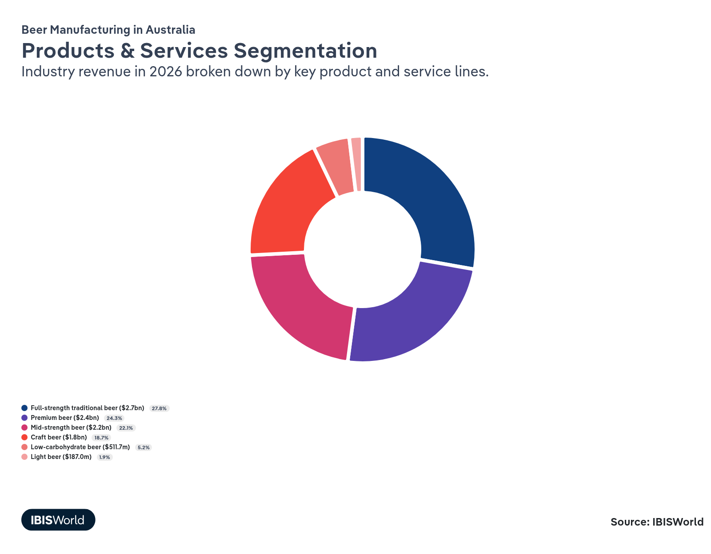

How are the industry’s products and services performing?

Classic full-strength beer lives on as the highest sales segment despite drops in recent years
- Classic full-strength beers are non-craft, non-international beers with an alcohol by volume (ABV) of 3.5% or greater. Examples are popular brands like Victoria Bitter and Carlton Draught.
- Despite being the largest revenue contributor, classic full-strength beers' market share is declining, falling from 32.1% of industry revenue in 2020-21 to 27.8% in 2025-26. The decline has stemmed from consumers increasingly preferring craft beers, mid-strength beers and low-carb options, influenced by growing health consciousness and decreasing per capita alcohol consumption.
- As demand for classic full-strength beers wanes, beer manufacturers have been forced to diversify their product portfolios by introducing low-carb and flavoured beers to align with changing market trends.

Premium beer sales have begun to decline amid economic strain
- Premium beers are made with high-quality ingredients and meticulous brewing processes and are sold at higher prices than standard beers. This segment includes domestic brands like James Boag’s and Crown Lagers and international beers like Peroni, Corona and Carlsberg.
- Rising inflation and the cost-of-living crisis have reduced consumers' discretionary income, leading them to curb spending on premium beers. This has caused this segment’s popularity to fall as people opt for more affordable options.
- Consumers are increasingly preferring craft beers, like Stone & Wood, over premium beers when deciding to splurge because of their trendiness. This shift directs spending away from premium international and domestic brands towards the growing craft segment.
- The premium beer segment has experienced a revenue slump over the past five years, impacted by economic pressures and shifting consumer preferences favouring value or distinctive craft options over traditional premium beers.

Mid-strength beer is growing in popularity as people drink less
- Mid-strength beers have an ABV content between 3.0% and 3.5%, offering a middle ground between full-strength and light beers. Notable brands in this segment include XXXX Gold and Great Northern Super Crisp.
- As Australia's per capita alcohol consumption declines, many consumers are shifting from full-strength to mid-strength beers. This segment's share of total beer sold has doubled since 2000, reflecting a significant change in drinking habits towards lower-alcohol options.
- Mid-strength beers’ growing popularity has outpaced the overall industry. This has pushed most popular beer brands to offer mid-strength variants, expanding consumer choice. In 2024, Asahi introduced Carlton Dry 3.5% to capitalise on these shifting consumer preferences.
- Australia's tiered alcohol taxation system, which imposes higher taxes on beverages with greater alcohol content, means mid-strength beers are more profitable for producers. This financial incentive encourages breweries to promote and expand their mid-strength offerings.

Consumer preferences are shifting towards premium craft beers
- Craft beer is produced by a craft brewery. Although it isn’t widely accepted precisely what makes a beer a craft beer, the term commonly refers to a beer produced by a small-scale, independent brewery.
- Craft beers' share of overall beer market revenue has grown over the past five years. Australians are consuming less beer overall, so they’re willing to spend more on premium-priced craft beers for their perceived quality and unique drinking experiences. Lion has seen notable revenue growth driven by growing sales of its higher-priced Stone & Wood brand.
- Large breweries like Asahi and Lion are strategically entering the craft beer market through acquisitions and significant marketing investments. An example is Lion’s 2021 purchase of Fermentum Group, creators of the popular craft beer Stone & Wood. By leveraging their substantial resources and scale, these companies promote their craft beer brands, bolstering sales and contributing to the segment's revenue growth.

Australians' laser focus on health has been a catalyst for low-carb beer sales
- Low-carb beers are brewed to reduce carbohydrate content, offering consumers a beer option with fewer carbs than traditional brews. They don’t have a specific ABV and this can vary across different brands and styles.
- Increased health consciousness among Australians has boosted low-carb beers’ popularity. As consumers become more mindful of their dietary intake, they're opting for beverages perceived as healthier alternatives without sacrificing alcohol content.
- Many beer brands, like Better Beer and Hahn, are actively promoting their low-carb beers as healthy choices, attracting health-focused consumers. Most major brands now offer low-carb versions of their beers, leading to a surge of new low-carb options in recent years.
- Growing demand for low-carb beers has led to this segment's robust growth and outperformance of traditional beer categories.

Light beer’s appeal is slowly falling away
- Light beers have an ABV under 3.0%, offering a lower alcohol choice for consumers seeking moderation without eliminating alcohol entirely. The light beer segment's revenue share has nearly halved from 4.4% in 2019-20 to 2.7% in 2024-25, reflecting a significant decline as consumers shift their preferences.
- Despite deteriorating per capita alcohol consumption, consumers are increasingly bypassing light beers in favour of non-alcoholic beers, which are not included in the Beer Manufacturing industry. Many of those looking to cut back on alcohol intake are opting to cut alcohol entirely and drink zero-alcohol options rather than light beers.
- Non-alcoholic beers’ popularity diverts sales away from the light beer segment, challenging producers within the industry. Brands may need to adapt by innovating or expanding into the non-alcoholic market to recapture alcohol-abstaining consumers.

What are innovations in industry products and services?

Health-focused beers and new flavours are meeting changing consumer preferences
- Rising health consciousness among consumers has spurred beer manufacturers to develop healthier options, like low-carb beers. In 2024, Victoria Bitter introduced VB Low Carb, catering to health-conscious drinkers seeking traditional beer tastes with fewer carbohydrates.
- With per capita beer consumption declining, many breweries have launched light and mid-strength beers. These products offer reduced alcohol content, appealing to consumers who wish to moderate their intake without abstaining entirely.
- Brewers are creating beers with unique flavours to retain consumer interest and tap into new markets. Matso's, owned by Good Drinks, specialises in alcoholic ginger beer and also offers mango- and chilli-flavoured beers, while Lion has released new Byron Bay Brewery Fruit Lagers.
- Newly released beers have reflected an emphasis on product differentiation to remain competitive. By expanding product lines to include health-focused beers and flavourful alternatives, breweries aim to meet evolving consumer preferences.

Beer manufacturers are increasingly using automation throughout their processes
- Beer manufacturers are increasingly leveraging technology to assist them and reduce operational expenses.
- In 2021, global tech company Bühler introduced a malting plant solution that enables breweries to produce their own malt in-house, increasing production efficiency and ensuring consistent quality by granting greater control over ingredients. Coopers Brewery has adopted this technology, which has helped maintain high and consistent malt quality while boosting production capabilities.
- Breweries are using innovative technologies like Frigid, which help reduce energy consumption and improve operational efficiency. Frigid's technology optimises essential cooling processes, leading to significant energy savings. Smaller breweries like Nowhereman Brewing Co and Big Shed Brewing have implemented Frigid's solutions to enhance their brewing processes, resulting in lower operational costs and a reduced environmental footprint.
What products or services do successful businesses offer?
Establish brand names
Manufacturers must ensure that their brand names are well-marketed, recognisable and synonymous with quality and taste, especially in the craft beer segment where consumers are willing to pay extra.
Market differentiated products
Manufacturers need to develop a wide range of products in accordance with changing consumer preferences. Offering mid-strength and low-carb beers can stop consumers from turning to competitors or substitutes.

Major Markets
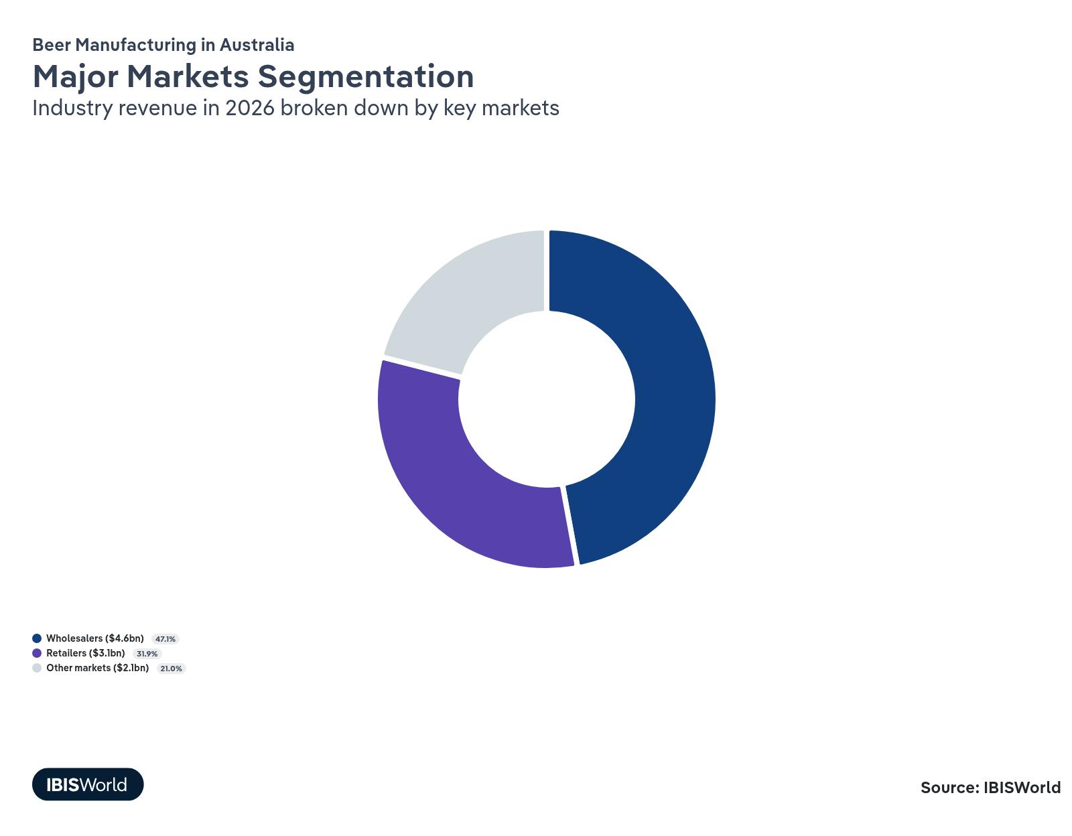

What’s influencing demand from the industry’s markets?

Wholesalers remain the primary beer buyers
- Liquor wholesalers purchase large quantities of beer at low prices from manufacturers and distribute them to liquor retailers and hospitality venues, which then sell to consumers. They remain the primary purchasers in the beer sector, representing the largest market for manufacturers.
- Retailers and hospitality venues are increasingly bypassing wholesalers to buy directly from manufacturers, aiming to reduce costs and increase profit margins. This trend reduces wholesalers' purchasing volumes and challenges their market position, shrinking their market size over the past five years.
- Many small craft breweries rely on wholesalers for distribution because of their limited resources and negotiating power compared to large companies like Asahi. As direct purchasing becomes more prevalent, smaller breweries may face distribution challenges, as they depend on wholesalers to reach broader markets and lack the means to distribute widely on their own.

Liquor retailers are rapidly cutting out the middlemen
- Liquor retailers are businesses that sell alcoholic beverages to consumers for off-premises consumption. This segment includes dedicated liquor stores and supermarket chains with liquor outlets.
- Major retailers like Coles and Endeavour Group are purchasing beer directly from manufacturers rather than through wholesalers. This strategy reduces costs, increases profit margins and streamlines their supply chains. They’re also developing private-label beer brands, diminishing the need for wholesalers. By producing their own brands, supermarkets offer exclusive products at competitive prices, attracting consumers and expanding their market share.
- Large retailers' dominance and direct purchasing practices make it challenging for small beer manufacturers to secure shelf space. Smaller breweries struggle to compete and reach consumers through major retail channels without the negotiating power of larger companies.

Direct relationships with manufacturers and onsite brewing influence the hospitality market’s performance
- Hospitality venues, like pubs and clubs, are included in this market. These establishments purchase beer directly from manufacturers for on-premises consumption.
- Many hospitality venues establish direct relationships with beer manufacturers, bypassing wholesalers. Manufacturers often offer incentives to these venues, like discounts or exclusive products, in exchange for tap real estate and brand promotion within their establishments.
- Some venues, like brewpubs, produce beer onsite and sell it directly to consumers. This vertical integration allows them to control the brewing process and cater to consumer preferences for locally produced, unique beer experiences.
- This market's revenue share has climbed notably since 2020-21, albeit from a low base fuelled by pandemic restrictions. Constrained discretionary incomes have limited this market's growth, as consumers purchase beer from retailers instead to save money.

International Trade
Total Imports  $304.5m  ’21-’26 ↓ 8.2 %  ’26-’31 ↑ 1.2 % | Total Exports  $37.2m  ’21-’26 ↑ 6.7 %  ’26-’31 ↑ 0.4 % | Trade Balance  Net Importer  ↓ Deficit: $-267.3m

International Trade Imports
International Trade Imports
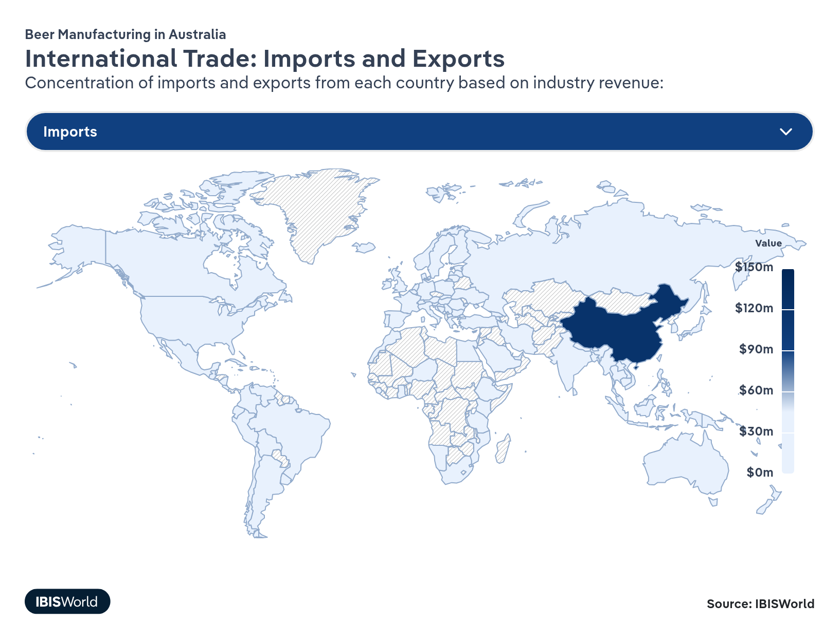
International Trade Exports
International Trade Exports
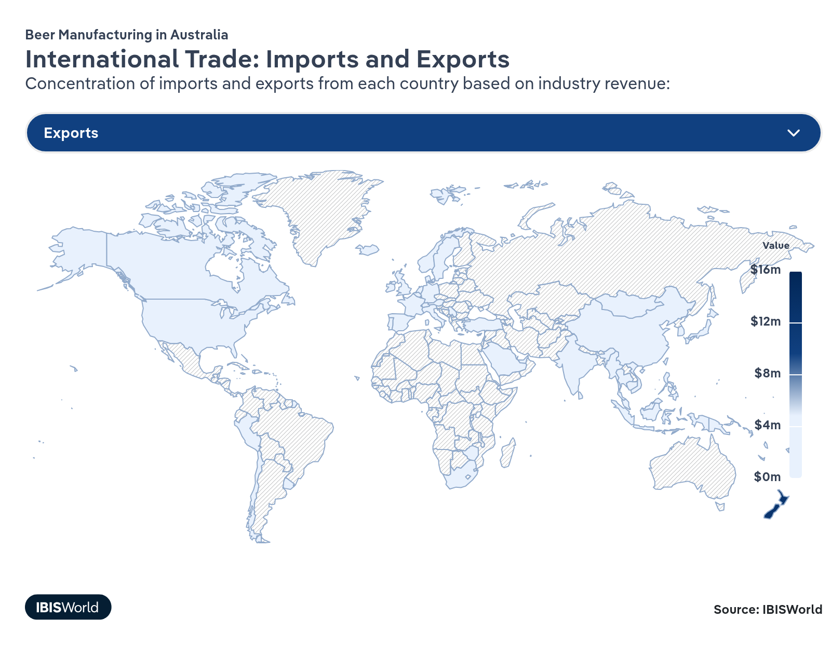

Imports
Low | Decreasing

What are the industry’s import trends?

Imports from China have surged following Corona's move from Mexico and tariff removals
- China's beer imports to Australia spiked from $3.6 million in 2022-23 to $110.9 million in 2023-24 and $97.4 million in 2025-26, marking a substantial shift in trade dynamics and making China the leading source of beer imports for Australia. The import surge results from tariffs on Chinese products lifting in 2023, enhanced trade relations between the two countries and Corona now being brewed in China for the Australasian market.
- China removed its 80.5% tariff on Australian barley in August 2023, which had hindered trade and increased costs for Chinese brewers since May 2020. The removal of the barley tariff reduced production costs for Chinese breweries, enabling them to increase beer exports to Australia and other Oceanian markets.
- Imports from Mexico sunk from $115.0 million in 2022-23 to $21.9 million in 2023-24. This drop is down to Corona, previously brewed exclusively in Mexico, now being brewed in China for the Australasian market. This shift has redirected import origins from Mexico to China, contributing to China’s considerable expansion in the beer production market.

Imports are falling as beer drinkers opt for Australian brews
- Imports of beer to Australia have fallen significantly, with volumes dropping by an annualised 8.2% over the past five years.
- Companies like Asahi and Good Drinks produce popular international beers domestically, reducing the need for imports and contrasting with sectors that rely more heavily on imported products. Imports are expected to make up only 3.0% of domestic demand in 2025-26. These contract brewing arrangements uniquely influence the industry's import patterns compared to the broader beverage sector. While other beverage industries might depend more on imports, the beer market leverages domestic production of international brands like Heineken and Guinness.
- Australian consumers are increasingly favouring locally produced craft beers over premium international brands. Craft beers, primarily made by independent Australian breweries, have gained popularity because of their innovative flavours and local appeal. This shift has redirected spending away from imported premium beers towards domestic products that offer quality and a connection to local communities.
- Imported beers are often marketed as premium products and are typically sold at higher prices than standard beers. Rising inflation and the cost-of-living crisis, which have reduced consumers' discretionary income, have led Australians to curb spending on these premium international beers in favour of more affordable local options. When consumers do choose to splurge, they’re increasingly opting for craft beers in favour of international beers, reducing import demand.

Exports
Low | Increasing

What are the industry’s export trends?

Exports remain slow as Australian beer for international consumption is brewed elsewhere
- Australian beer exports have remained minimal as major brewers produce domestic brands overseas instead of exporting from Australia. In 2025-26, exports are expected to make up less than 0.4% of industry revenue./ Companies like Asahi and Lion, which own popular Australian beer brands, operate multiple production and distribution facilities around the globe, reducing the need to export Australian beer.
- Fosters, owned by Asahi Holdings, is the top-selling Australian beer brand worldwide, but it’s manufactured in countries like the United States and the United Kingdom. By brewing locally in key markets, these companies lower transportation costs, take advantage of lower wage costs in countries outside Australia and cater to local tastes more effectively. This strategy efficiently satisfies consumer demand and bypasses import tariffs and regulations.
- Beer manufacturing export levels are significantly lower compared to the broader beverage sector. While other segments like wine have a strong export presence, with Australian wines being highly sought after globally, the beer market doesn’t share this trend because of the major brewers’ localised production strategies.

Beer exports to Asia have surged amid improved trade relations and rising demand
- Australian beer exports to China have soared from $0.2 million in 2022-23 to $1.5 million in 2024-25 following the removal of barley tariffs. China's decision to lift its 80.5% tariff on Australian barley in August 2023 has reopened the barley trade and strengthened overall trade relations, benefiting Australian beer exporters.
- Improved trade relations with China have had a ripple effect, boosting Australian beer exports to other Asian countries like Indonesia, Japan, South Korea and Singapore.
- New Zealand remains the largest export destination for Australian beer, primarily because of its geographic proximity and similar consumer preferences. The ease of logistics and shared cultural ties make New Zealand a consistent and significant market for Australian breweries.
- Exports to ships and aircraft stores are substantial, accounting for just over 15.0% of overall exports in 2024-25. Supplying beer to international carriers and duty-free outlets allows Australian breweries to reach a global audience and capitalise on international travel routes.

5. Geographic Breakdown
https://my.ibisworld.com/au/en/industry/C1212/geographic-breakdown

Key Takeaways
- Most of Australia’s beer manufacturers are based in New South Wales and Victoria. Unsurprisingly, the two most populous states in the country are home to the most breweries, as businesses try to stay close to their consumer base.
- Government initiatives are spurring brewery growth in Queensland. Queensland's share of industry enterprises has climbed over the past few years as the state's Craft Brewing Strategy and favourable conditions attract new breweries.
- Western Australia, Tasmania and South Australia have a high brewery concentration relative to their populations. Historical roots, access to quality inputs and supportive environments contribute to the over-representation of breweries in these states.

Business Locations
State/Territory | Enterprises (Units)  2026 | Enterprises (%)  2026 | Enterprises (YoY Growth %)  2026 | Population (%)  2026
Victoria | 215 | 24.3 | -0.4 | 25.7
New South Wales | 229 | 25.8 | -0.3 | 31.2
Western Australia | 124 | 14.0 | 0.1 | 10.8
Queensland | 159 | 17.9 | 0.1 | 20.6
Australian Capital Territory | 10 | 1.1 | 5.2 | 1.7
South Australia | 89 | 10.0 | 0.1 | 6.9
Tasmania | 57 | 6.5 | 1.5 | 2.1
Northern Territory | 4 | 0.4 | -5.3 | 0.9

Where are industry businesses located?

New South Wales is home to the most breweries
- New South Wales accounts for 25.7% of Australia's breweries, the highest share among all states. Being the most populous state attracts breweries as they're provided access to a vast consumer base.
- Densely populated cities like Sydney offer both advantages and challenges to breweries. Being close to a large consumer base reduces transport distances, allowing products to reach consumers quickly and reducing distribution expenses. The high population density presents a substantial market for breweries to tap into, boosting sales and brand visibility. However, the cons involve operational challenges like traffic congestion, which can complicate the transportation of goods and make deliveries slower and less predictable.
- Inner-city locations are particularly important for craft breweries operating brewpubs, as being situated in populous areas enhances their visibility and popularity, driving foot traffic and sales.
- Coastal areas in New South Wales, like Byron Bay, attract high levels of tourism activity, prompting breweries to establish operations there. For example, Byron Bay is home to the Stone & Wood Brewery, while Jervis Bay hosts the Jervis Bay Brewing Co.
- New South Wales hosts a diverse range of breweries, from large-scale producers to a growing number of craft breweries. The state's beer market caters to varied consumer preferences, supporting different industry segments.
- New South Wales’s efficient distribution networks and high consumer demand make it an attractive location for breweries. The state's infrastructure and population density continue to support industry growth and expansion.

Victoria's share of the industry is falling
- Victoria is home to 23.7% of enterprises, making it one of the leading states for beer manufacturing. Although its share has declined from 30.9% in 2019, Victoria remains a central hub.
- Melbourne's unique bar and pub scene and sophisticated fine dining environment have bolstered the state’s beer scene. Consumers in Victoria demand higher quality and greater variety in their beer choices, encouraging breweries to establish operations in the state to meet this demand.
- Victoria is Australia's largest hops grower and barley is also cultivated locally. Brewers in the state benefit from lower transport costs and fresher ingredients, which enhance the quality of their beers and allow for innovative brewing practices. This encourages enterprises to locate themselves in the state, which hosts notable breweries like Mountain Goat and Hawkers.
- Victoria's declining industry share is partly because of high operational costs, like rent and labour, in the major city of Melbourne. Congestion poses logistical challenges, resulting in breweries like White Rabbit and Little Creatures relocating to regional areas like Geelong to reduce costs and avoid congestion.
- Victoria faced long and strict lockdowns during the pandemic, severely impacting breweries, leading to closures and prompting breweries to be established in states with fewer restrictions.
- In 2024, Asahi closed the Matilda Bay Brewpub in Healesville, with its beers now brewed in Port Adelaide. This indicates a shift of operations out of Victoria.

Queensland’s government initiatives are seeing new breweries popping up
- Queensland's share of industry enterprises has risen from 15.7% in 2019 to 18.4% in 2024. The state's brewery numbers have more than doubled since 2017, indicating significant industry growth.
- The Queensland Government introduced the Craft Brewing Strategy in November 2018 to support rapid expansion. This strategy aims to enhance the beer manufacturing culture and stimulate demand for locally produced brews.
- Queensland's optimal weather conditions are conducive to beer brewing. The state is home to Australia's largest brewery, Carlton & United Breweries in Yatala and major brands like Lion's XXXX Gold, one of the most popular beers in Australia.
- Despite support, the craft beer industry's development has been constrained by the warm climate and the dominance of non-craft brands like XXXX. Craft brewers have also cited restrictive elements in the licensing regime hindering growth. Notable breweries like Balter Brewing Company and Brisbane Brewing contribute to Queensland's emerging beer scene, while government support and shifting consumer preferences gradually overcome previous constraints.

Western Australia, Tasmania and South Australia are over-represented in terms of establishments to population
- Western Australia is regarded as the home of Australian craft beer. It hosted the nation's first craft brewery, Matilda Bay Brewery, established in the late 1980s. This legacy has fostered a strong brewing culture in the state, with prominent breweries like Little Creatures, Good Drinks and CBCo Brewing also operating in Western Australia. Despite operational challenges because of the state's isolation, the government has supported providing grants since 2018 and introducing the Western Australian Craft Beer Strategy 2024-2034 to expand the market.
- Tasmania boasts the highest number of breweries per head of population in Australia. Ideal growing conditions for hops and barley and access to clean, renowned water sources make it an attractive location for breweries. Tasmania has a deep-rooted beer culture with brewing traditions dating back to the early 1800s. Craft breweries like Moo Brew and Seven Sheds leverage local ingredients to produce high-quality, unique beers.
- South Australia has a higher percentage of Australia's breweries than its population. This reflects a strong local industry presence and commitment to brewing excellence. Many independent breweries in South Australia collaborate to reduce costs through bulk ordering and shared storage and delivery, enhancing their competitiveness. Coopers Brewery is headquartered in South Australia, and the opening of a visitor centre at its Regency Park brewery helped to boost sales during 2024-25.
- The over-representation of breweries in Western Australia, Tasmania and South Australia highlights how historical roots, access to quality inputs and supportive environments contribute to industry concentration.
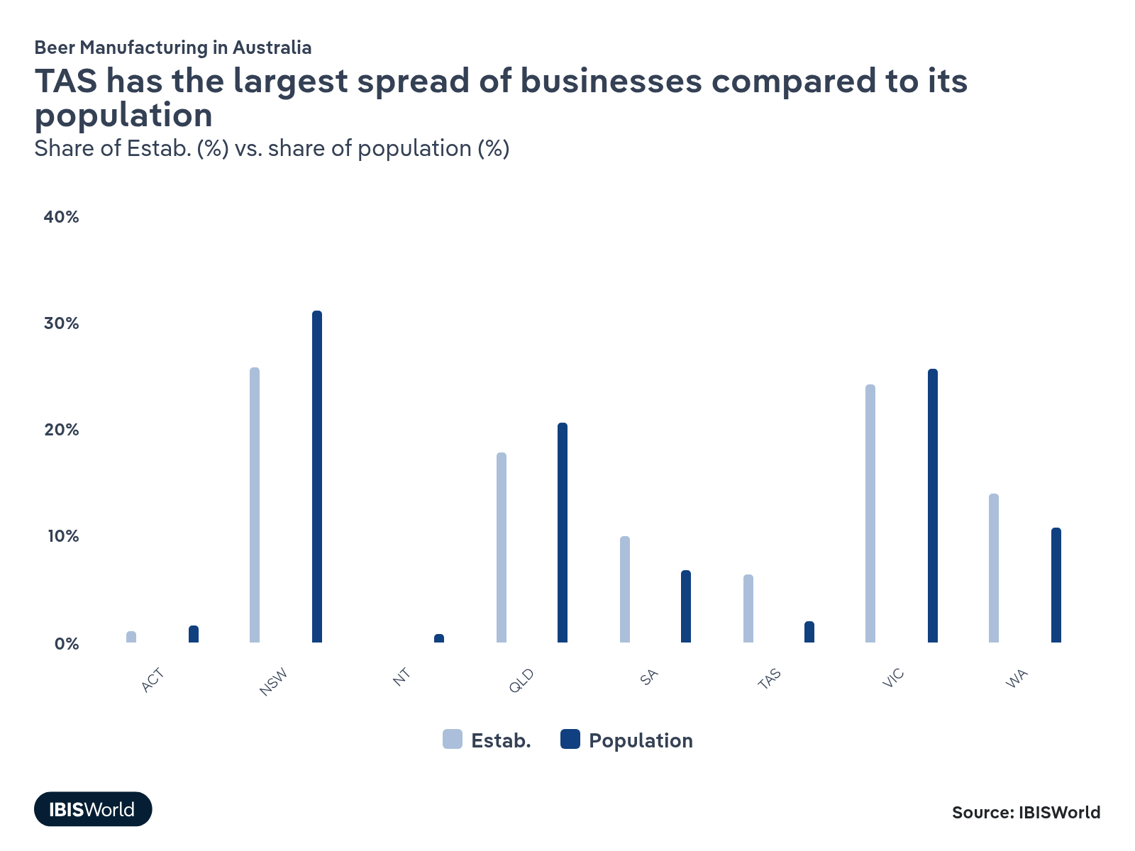
How do businesses use location to their advantage?
Control distribution arrangements
Manufacturers need to be located in regions that allow for easy distribution and help them supply their buyers reliably and efficiently.
Operate in a highly visible location
Breweries that serve beer out of their manufacturing location need to ensure that it’s in a densely populated area with high foot traffic to attract customers.

6. Competitive Forces
https://my.ibisworld.com/au/en/industry/C1212/competitive-forces

Key Takeaways
- New entrants to the Beer Manufacturing industry must obtain land and manufacturing equipment. Businesses must also obtain licenses and compete with major players for shelf and tap space.
- Asahi and Lion dominate the market through economies of scale and acquisitions. Controlling around half the industry’s revenue, these manufacturers’ large production scales, promotional budgets and strategic acquisitions make it challenging for smaller breweries to compete.
- Substitutes like wine, spirits and non-alcoholic beverages intensify competition for beer manufacturers. Rising health consciousness and shifting consumer preferences towards alternatives are diminishing beer demand, forcing brewers to adapt.

Concentration
Moderate
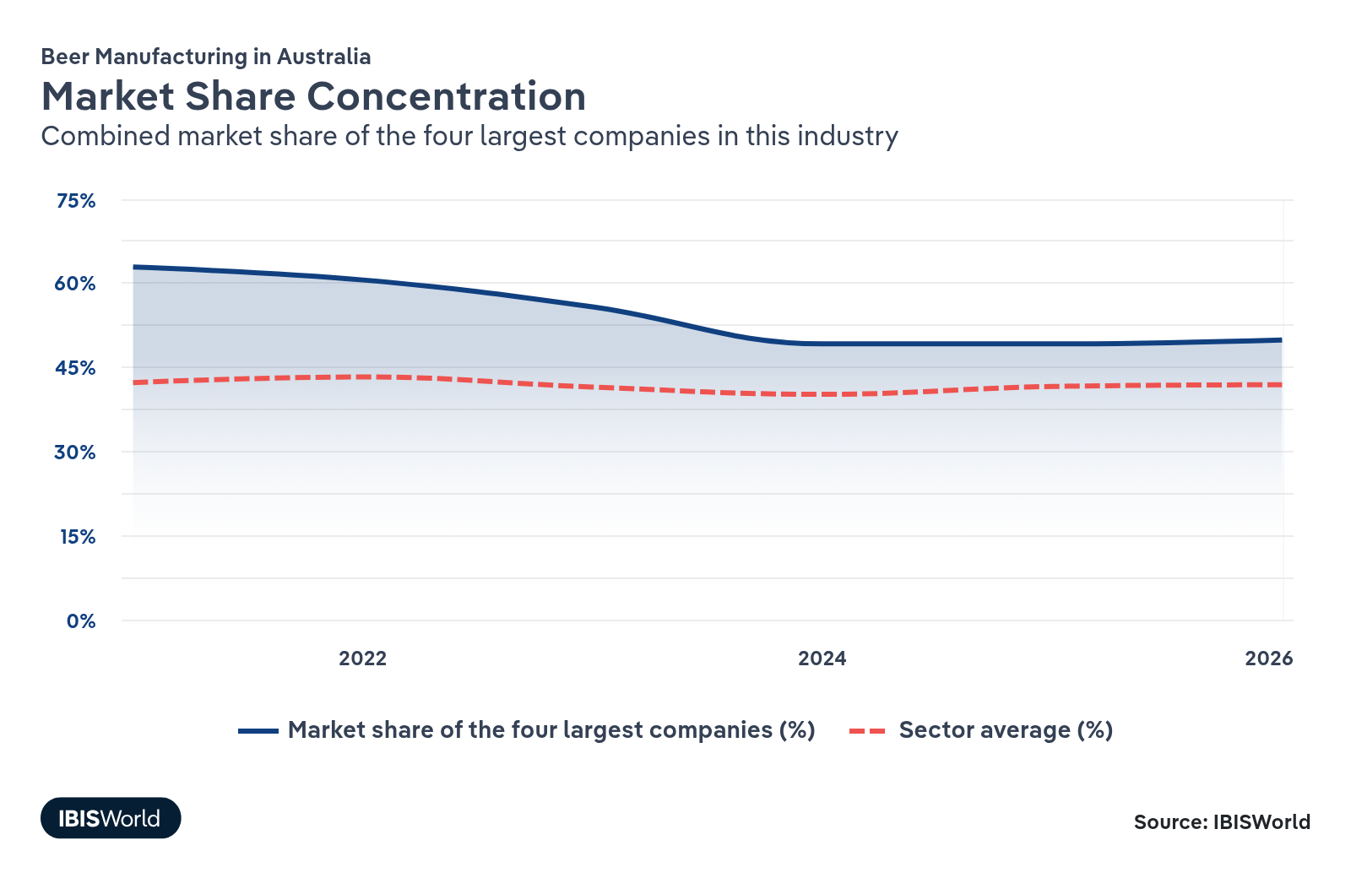

What impacts the industry’s market share concentration?

International brewers continue to dominate the market
- Japanese-owned multinational companies Lion and Asahi control the Australian beer market. In 2025-26, they are expected to account for 48.5% of industry revenue.
- Major acquisitions have fuelled the two major brewers’ market share, as they have the scale and financial power to make substantial acquisitions that significantly shift market dynamics. In 2020, Asahi acquired Carlton & United Breweries for $16.0 billion, bringing popular brands like Victoria Bitter and Carlton Draught into its portfolio. In 2021, Lion acquired Fermentum, the owner of Stone & Wood Brewing Co., for over $500.0 million. This move allowed Lion to add one of Australia's leading independent craft breweries to its portfolio, enhancing its offerings in the growing craft beer segment.
- Smaller breweries are engaging in acquisitions, with Good Drinks acquiring Matso's Brewery in 2018 and attempting to acquire Stomping Ground, although this acquisition was called off in 2023.

The army of craft breweries is fighting back
- A growing consumer preference for craft beers has increased the viability of small independent breweries, leading to a more fragmented industry. Consumers seek unique flavours and locally produced beers, encouraging the establishment and growth of numerous small breweries. This has decreased market share concentration, with the four largest brewers’ revenue share falling over the five years through to 2025-26, reflecting how small breweries are capturing a larger portion of the market.
- Craft beer drinkers tend to favour independently owned breweries. This desire to support local businesses drives consumers away from mass-produced beers offered by large multinational companies. Asahi controls a lower share of the craft beer sector than it does the overall beer market.
- Asahi and Lion have expressed their intentions to grow the popularity of their craft brands in response to shifting consumer preferences.

Large brewers’ economies of scale and distribution deals give them a competitive advantage
- Large breweries Asahi and Lion capitalise on their large production scale and promotional budgets, enabling them to absorb cost increases in utilities, aluminium prices and excise taxes. In contrast, smaller breweries with smaller production volumes struggle with climbing operational expenses, limiting their market reach and at times forcing them to exit the industry.
- Access to prime retail placements and tap space in hospitality venues reinforces large brewers’ dominance, as independent operators lack the resources and scale to secure similar distribution agreements. The necessity of securing such agreements limits small breweries' ability to expand.
- Asahi and Lion leverage their scale to add brands across various product segments to their portfolio, ensuring wide market reach. This bolsters their market share compared to smaller manufacturers focusing on specific niches.
How do successful businesses handle concentration?
Market differentiated products
Beer manufacturers must develop differentiated products that align with consumers' preferences to attract customers away from the two major players, Asahi and Lion.
Secure economies of scale
Beer manufacturers can work on securing economies of scale to reduce their per-unit costs and maintain profitability amid rising operational expenses and excise taxes.

Barriers to Entry
High | Decreasing

What challenges do potential industry entrants face?

Legal
- Australia’s Beer Manufacturing industry is heavily regulated, requiring breweries to hold producer or wholesale licenses, excise tax licenses and adhere to strict labelling laws. Securing these permits demands time and capital, creating a considerable barrier for new entrants. Ensuring compliance with constantly evolving regulations reinforces the importance of legal expertise.

Start-Up Costs
- Entering the Beer Manufacturing industry demands high upfront expenses for equipment, real estate and skilled labour. Developing distribution channels and obtaining necessary packaging materials compound these costs. Prospective brewers may struggle to handle these expenditures without sufficient capital or investor backing, deterring many would-be entrants from launching full-scale brewing operations.

Differentiation
- Established brands dominate retail shelves and tap space through longstanding supplier agreements. To stand out, newcomers must create distinctive flavours, packaging or marketing strategies. However, limited promotional budgets constrain their visibility, increasing the challenge of breaking into the market. Customer loyalty to well-known labels complicates efforts to differentiate new offerings.

Capital Expenses
- Brewing operations require costly infrastructure, including fermentation tanks, cooling systems and related machinery. These capital-intensive investments increase barriers for small entrants that cannot easily scale production. However, small breweries’ costs aren’t as extensive as those of larger, more established competitors because of their smaller production volumes.
How can potential entrants overcome barriers to entry?
Secure economies of scale
Beer manufacturers with larger production facilities can achieve lower per-unit costs, allowing them to reduce pricing and increase marketing expenditure or capital investment.
Attract local support
New entrants can attract support by building relationships with local hospitality venues and liquor retailers to get their products on tap and on shelves.

Substitutes
Moderate | Increasing

What are substitutes for industry services?

Other types of alcohol
- Alcoholic substitutes for beer come in the form of wine, spirits and other ready-to-drink mixed spirit beverages. Wine and spirits consumption has surged over the past decade, while beer intake has notably declined. As tasting tours enrich wine’s appeal and seltzers and mixed spirit drinks gain popularity, these options increasingly divert consumers from traditional beer offerings.
- To capitalise on shifting tastes, Asahi introduced its Hard Rated brand, now Australia's top light RTD spirit, eroding beer’s market share. By diversifying into these alternatives, Asahi has hedged against the country’s declining per capita beer consumption.
- Ready-to-drink spirit beverages often appeal to younger demographics seeking convenient, flavour-focused alcohol choices. Their rise diminishes demand for beer, magnifying the threat these substitutes pose to brewers facing shrinking domestic beer sales.

Non-alcoholic beer
- Non-alcoholic beer is a beverage with little to no alcohol that aims to reproduce the taste of regular beer. Their production falls outside this industry’s scope. As per capita beer consumption falls because of rising health consciousness and wellness trends, non-alcoholic beer has gained popularity.
- Consumers looking to cut back on alcohol are bypassing light beers in favour of zero-alcohol offerings, driving light beer’s revenue share down from 4.4% in 2020 to 2.7% in 2025.
- Major brewers, including Carlton & United Breweries and Coopers, have rapidly expanded their zero-alcohol lines like Carlton Zero, highlighting how non-alcoholic beers are effectively displacing light beer as the go-to low-alcohol alternative.

Do-it-yourself
- Home-brewing involves producing beer at home on a small scale rather than purchasing from retailers or venues.
- Home-brewing enthusiasts benefit from cost savings, custom flavours and hands-on control over the brewing process. However, home brewing demands patience, space and equipment, which can deter casual consumers seeking convenience.
- Coopers has capitalised on rising do-it-yourself trends by offering a home-brewing kit, reflecting how established brewers can accommodate hobbyists. Despite the complexity, this DIY option remains a niche but growing threat, particularly appealing to budget-conscious consumers.
How do successful businesses compete with substitutes?
Conduct market research
Beer manufacturers need to stay up to date with current market trends. For example, they may consider introducing mid-strength or low-carb beers to offer a compromise for people trying to reduce their alcohol consumption or improve their health.
Supply a diverse range of products
Beer manufacturers can capture consumers’ changing tastes and desire for variety by supplying a diverse range of products, which will stop them from turning away to substitutes.

Buyer & Supplier Power
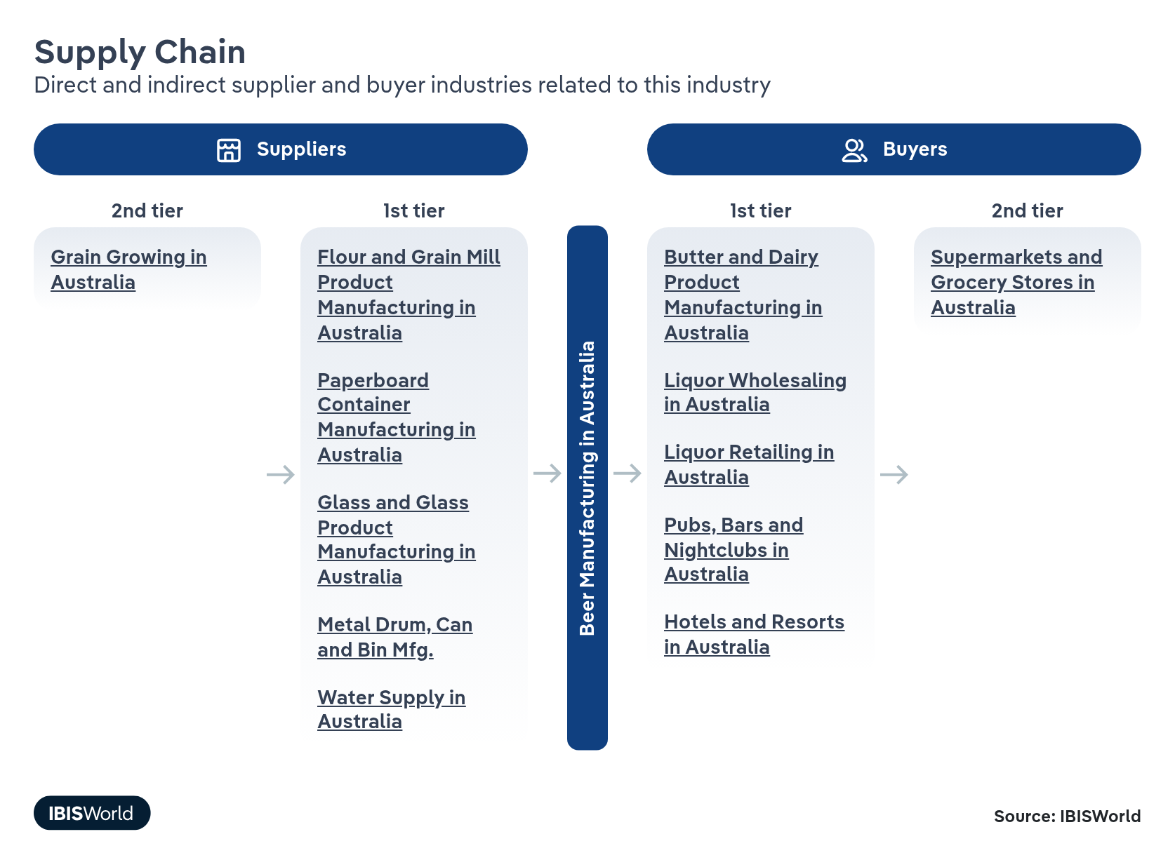

What power do buyers and suppliers have over the industry?

Buyers: An influx of new breweries elevates buyers’ choice
Moderate | Increasing
- Asahi and Lion dominate Australia’s top-selling beers, compelling many hospitality venues to stock these brands to remain competitive. However, larger liquor retailers can use their scale to negotiate favourable terms, offering them more power than smaller hospitality venues.
- Craft beers' surging popularity has led to an influx of new breweries. The number of industry establishments has climbed from 736 in 2020-21 to 970 in 2025-26, which provides retailers and hospitality venues with more options, increasing their leverage when selecting or promoting particular brewers.
- Major supermarkets have amplified their buying power by introducing private-label beers, reducing their dependence on established manufacturers and enabling more aggressive pricing and shelf-placement strategies.

Suppliers: Essential inputs and limited alternatives strengthen supplier power
High | Steady
- Raw materials like malt, hops and sugar are vital for beer production. Farmers set prices according to global commodity markets, leaving brewers with minimal negotiation leeway.
- Switching suppliers is challenging because brewers risk quality inconsistencies and the process is time-consuming. This dependence on specific ingredients boosts suppliers’ leverage.
- Larger brewers can slightly mitigate supplier power with bulk purchasing, whereas smaller, independent producers have less negotiating power.
- Utilities are critical for beer manufacturing. However, as there are few companies to choose from, suppliers' influence on operational costs is amplified.
How do successful businesses manage buyer & supplier power?
Control distribution arrangements
Beer manufacturers can work hard to control distribution arrangements and secure shelf and tap space for their beer in liquor retailing stores and hospitality venues. This will drive attention to their beer.
Establish long-term working relationships with raw material suppliers
Beer manufacturers that develop working relationships with their barley and hops suppliers can ensure that inputs are of high quality and are delivered on time.

7. Companies
https://my.ibisworld.com/au/en/industry/C1212/companies

Key Takeaways
- Lion and Asahi continue to dominate the market. These Japanese companies make up around half of the market, having recently acquired smaller breweries. Their scale and power make it hard for independent breweries to compete.
- Barring the heavyweights, the Beer Manufacturing industry is fragmented. However, craft beer’s increasing popularity has encouraged new players to enter the industry.
- Asahi is focused on premiumisation and its craft brands to offset declining sales volumes with higher margin products. Asahi has begun focusing more on RTDs, introducing Hard Rated in 2023.
- Facing reduced consumption of classic brands like XXXX Gold, Lion acquired Fermentum Pty Ltd in 2021. The firm is the parent company of Stone & Wood, and epitomises Lion’s shift in focus towards capitalising on craft beers’ growing popularity.

Market Share
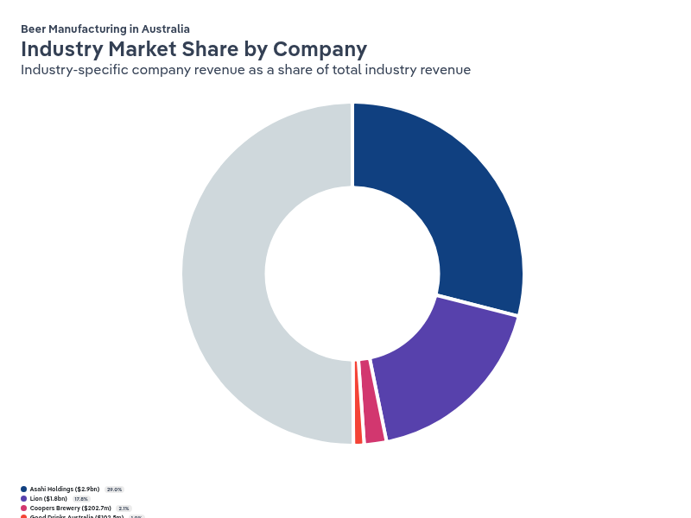
Chart displays current year only in the PDF version of this report. You can view and download chart for all other years associated with this industry on my.ibisworld.com.

Companies
Company | Market Share (%)  2026 | Revenue ($m)  2026
Asahi Holdings | 29.0 | 2,852.3
Lion | 17.8 | 1,752.3
Coopers Brewery | 2.1 | 202.7
Good Drinks Australia | 1.0 | 102.5
Coca-Cola Europacific Partners Holdings (Australia) | 0.5 | 51.4

Asahi Holdings
Asahi Holdings
Company Details
Company Details
Registered Name | Asahi Holdings (Australia) Pty Ltd
Industry Specific Revenue (2026) | $2.9bn
Market Share (2026) | 29.0%

Description
Description
Owned by Japan-based Asahi Group Holdings Limited, Asahi Holdings (Australia) Pty Ltd manufactures and distributes a range of beverages, including soft drinks, bottled waters, fruit juices, cordial and beer. The company employs over 4,500 people and is headquartered in Southbank, Melbourne. Asahi Holdings Australia was formed in April 2009, when Japanese beverage company Asahi purchased Cadbury Schweppes' Australian beverage business for $1.2 billion. The company is licensed to manufacture and distribute PepsiCo products in Australia.

Brands and Trading Names
Brands and Trading Names
- Dirty Granny
- Peroni
- Cricketers Arms
- Asahi Super Dry
- Bulmers
- Carlton and United Breweries
- Schweppes
- Spring Valley
- Wild Moose
- Carlton Drought
- Pepsi
- StrangeLove
- Spring Cider Co.
- Mercury
- Somersby
- Pirate Life
- Solo
- Vodka Mudshake
- Good Tides
- Frantelle
- Woodstock Bourbon
- 4 Pines Brewing Company
- Highland
- Vodka Cruiser
- Green Beacon Brewing Company
- Voss
- Vodka O
- Real Iced Tea Co
- Mountain Goat
- Balter Brewing Company
- Pure Blonde
- Cottee’s
- Mountain Dew
- Victoria Bitter
- Grolsch

- Woodstock Bourbon and Cola
- Sunkist
- Pop Tops
- Charlie's
- Gatorade
- Cool Ridge
- Phoenix Organic
- Crown Lager
- Vibe

Other Industries
Other Industries
- Fruit Juice Drink Manufacturing in Australia
- Bottled Water Manufacturing in Australia
- Craft Beer Production in Australia
- Functional Beverage Production in Australia
- Soft Drink Manufacturing in Australia
- RTD Mixed Spirit Production in Australia
- Spirit Manufacturing in Australia

Company’s Industry Revenue, Market Share, and Profit Margin Over Time
Company’s Industry Revenue, Market Share, and Profit Margin Over Time
Year | Industry Revenue ($ million) | Market Share (%)
2012-13 | 200 | 3.0
2013-14 | 216 | 3.2
2014-15 | 225 | 3.4
2015-16 | 218 | 3.4
2016-17 | 268 | 4.5
2017-18 | 368 | 5.9
2018-19 | 354 | 5.3
2019-20 | 1186 | 18.1
2020-21 | 2259 | 36.3
2021-22 | 2546 | 36.5
2022-23 | 2723 | 34.0
2023-24 | 2735 | 30.0
2024-25 | 2710 | 28.6
2025-26 | 2852 | 29.0

What's impacting Asahi Holdings's performance?

Asahi has considerably expanded by acquiring Carlton United Breweries
- In June 2020, Asahi completed a major horizontal acquisition by purchasing Carlton & United Breweries (CUB), the largest brewer in Australia, for $16.0 billion. This acquisition expanded Asahi's market share from 5.3% in 2018-19 to 36.3% in 2020-21, reshaping the industry's competitive dynamics.
- Through the acquisition, Asahi diversified its offerings across multiple segments. It now owns traditional beers like Carlton Draught and Great Northern, craft beers like Balter Brewing Company and Mountain Goat and premium international beers Peroni and Corona. This broad portfolio allows Asahi to cater to a wide range of consumer preferences, strengthening its market position.
- The ACCC approved the acquisition despite fears of reduced competition limiting consumer choice. Once approved, Asahi was required to divest some of its cider and beer brands, including Stella Artois and Beck's. In 2021, Heineken acquired the remaining divested brands.

Asahi leverages its scale and marketing to outperform smaller independent brewers
- Asahi's significant scale enables it to invest heavily in marketing and brand promotion, achieving widespread brand awareness and market reach. Smaller independent craft brewers lack comparable resources, making competing with Asahi's substantial marketing expenditure challenging. This advantage allows Asahi to dominate shelf space and consumer mindshare.
- The company's large production volumes provide economies of scale, allowing it to better absorb rising operational costs like utilities, aluminium prices and excise taxes. These costs significantly impact the profitability of smaller breweries, but Asahi can mitigate their effects and maintain competitive pricing and healthier profit margins compared to the industry average.
- After acquiring CUB in 2020, Asahi established direct deals with over 100 cereal crop growers across Victoria and New South Wales. This strategic move gives Asahi greater control and transparency over its raw materials, ensuring consistent quality in its beer products.

Asahi’s market share has fallen as it turns its focus to RTDs and non-alcoholic drinks
- In recent years, declining beer consumption has reduced the share of Asahi's Australian revenue that is generated from alcoholic beverages, as well as the proportion of alcohol revenue generated by beer specifically. This has led to a dip in Asahi's market share over the past five years.
- In response to declining beer volumes, Asahi has expanded its ready-to-drink (RTD) portfolio, launching the market leader Hard Rated in 2023. Asahi’s Australian RTD sales have grown at around 7% year over the past five years as of March 2025.
- Asahi has repositioned its core beer portfolio to align with evolving consumer behaviour. As consumers increasingly turn to mid-strength beers, Great Northern has emerged as Australia's largest-selling beer by value. Asahi also launched Carlton Dry 3.5% in 2024 to capture sales in the growing mid-strength segment.

Asahi has focused on premiumisation and craft beer to boost margins amid declining volumes
- Facing sliding beer consumption and sales volumes, Asahi has worked on increasing unit sales prices to drive revenue growth. Between 2023 and 2024, the company achieved a 1.4% increase in unit sales price, reflecting its strategy to offer higher priced products.
- One of Asahi's key initiatives is establishing itself as the market leader in Australia's craft beer market. Recognising consumers are willing to pay more for craft beers, evidenced by a 125% price index compared to its core portfolio, Asahi is investing heavily in this segment to offset declining volumes with higher margin products.
- Asahi has expanded its craft beer portfolio through acquiring popular brands like Mountain Goat, 4 Pines and Balter Brewing Company. To grow brand awareness and establish these brands, the company has used its scale to invest in high-profile marketing initiatives, like partnering with the Australian Open tennis tournament to promote the Balter brand.
Lion
Lion
Company Details
Company Details
Registered Name | Lion Pty Ltd
Industry Specific Revenue (2026) | $1.8bn
Market Share (2026) | 17.8%

Description
Description
Lion Pty Ltd is a wholly owned subsidiary of Japan-based Kirin Holdings Company Limited. Lion operates across Australia and New Zealand, producing and distributing a variety of beverages and food products including beer, wine, spirits, fruit juice, milk, cheese and soy beverages. The company employs approximately 4,700 people and is administered from its head office in Sydney.

Brands and Trading Names
Brands and Trading Names
- Heineken
- West End Draught
- Furphy
- James Squire Orchard Crush
- Little Creatures
- James Boag's
- 5 Seeds
- Iron Jack
- White Rabbit
- James Squire
- Blowflex Mouldings
- Byron Bay Brewery
- Kosciuszko Pale Ale
- XXXX
- Pipsqueak
- Kirin Cider

Other Industries
Other Industries
- Craft Beer Production in Australia
- Cider Production in Australia
- Plastic Bottle Manufacturing in Australia

Company’s Industry Revenue, Market Share, and Profit Margin Over Time
Company’s Industry Revenue, Market Share, and Profit Margin Over Time
Year | Industry Revenue ($ million) | Market Share (%)
2012-13 | 1987 | 29.8
2013-14 | 1899 | 28.1
2014-15 | 1816 | 27.4
2015-16 | 1565 | 24.7
2016-17 | 1548 | 25.9
2017-18 | 1570 | 25.2
2018-19 | 1542 | 22.9
2019-20 | 1465 | 22.4
2020-21 | 1413 | 22.7
2021-22 | 1444 | 20.7
2022-23 | 1485 | 18.6
2023-24 | 1476 | 16.2
2024-25 | 1670 | 17.6
2025-26 | 1752 | 17.8

What's impacting Lion's performance?

Lion has divested from less profitable ventures and is focusing more on craft beer
- Lion has divested non-core assets to concentrate on alcohol production. The company sold its cheese businesses in 2015 and 2019 to Saputo Dairy Australia for $137.0 million and $280.0 million, respectively. In 2020, it also sold its Dairy and Drinks division to Bega Cheese Limited for $560.0 million. These divestments allowed Lion to reallocate resources and capital towards growing its beer portfolio.
- Facing declining consumption of its classic brands, XXXX Gold and Tooheys, Lion is shifting its focus towards the higher margin craft beer segment, where consumers are willing to pay premium prices.

Acquiring Fermentum has fed the company’s presence in craft brewing
- In 2021, Lion reinforced its commitment to craft beer by acquiring Fermentum Pty Ltd, the parent company of Stone & Wood, for $500.0 million. The acquisition has been a key growth driver for Lion in the Australian market, supporting its efforts to capitalise on growing demand for craft beer, enhance profitability and offset declining sales in traditional beer markets.
- The ACCC initially feared that demand for independent breweries would suffer when Stone & Wood became part of Lion. However, the it eventually determined that there were enough independent breweries to fill the void and approved the acquisition.

Lion has closed different breweries across the country
- Lion is closing breweries to improve efficiency and concentrate on its core portfolio. In June 2024, it announced the closure of the Malt Shovel Brewery in Sydney, moving production to larger facilities in northern New South Wales and Geelong, VIC. It also closed the Tiny Mountain taproom in Townsville in 2023 and Adelaide’s West End Brewery in 2021.
- By consolidating production under fewer roofs, Lion aims to reduce overhead costs and enhance economies of scale. This strategy allows the company to reallocate resources towards growing its beer brands, particularly in the craft and premium segments.

Strong performances from Hahn and Stone & Wood have boosted market share
- While demand for beer across Australia continued its long-term decline, Lion's sales volumes grew by 1.3% during the 2024-25 period, outperforming the overall market. Sales prices also grew, driven by sales of health-conscious and premium beers.
- The Hahn and Stone & Wood brands in particular performed strongly, with Stone & Wood revenue climbing by over 10% over the year through to September 2025. Stone & Wood commands prices around 1.5 times more expensive than standard beers, meaning growth in sales disproportionately elevates Lion’s industry-specific revenue. In response, Lion committed $30 million to upgrade the Stone & Wood brewery in Murwillumbah, with a new tasting room set to open before Christmas 2025.
Coopers Brewery
Coopers Brewery
Company Details
Company Details
Registered Name | Coopers Brewery Limited
Industry Specific Revenue (2026) | $202.7m
Market Share (2026) | 2.1%

Description
Description
Coopers Brewery Limited is a locally owned public unlisted company that derives revenue from brewing and distributing beer and cider, selling brewers' products, and manufacturing and selling malt extract. The company employs approximately 140 full-time staff, operates in Australia and the United States, and is administered from its head office in Regency Park, SA.

Company’s Industry Revenue, Market Share, and Profit Margin Over Time
Company’s Industry Revenue, Market Share, and Profit Margin Over Time
Year | Industry Revenue ($ million) | Market Share (%)
2014-15 | 182 | 2.7
2015-16 | 193 | 3.0
2016-17 | 206 | 3.5
2017-18 | 171 | 2.7
2018-19 | 187 | 2.8
2019-20 | 182 | 2.8
2020-21 | 191 | 3.1
2021-22 | 182 | 2.6
2022-23 | 184 | 2.3
2023-24 | 196 | 2.1
2024-25 | 198 | 2.1
2025-26 | 203 | 2.1

What's impacting Coopers Brewery's performance?

Coopers is widening its product range to attract new customers
- Coopers is actively widening its product range by releasing new beers that cater to different consumer preferences, aiming to boost its market share. In 2024, the company launched Coopers Botanic Ale, a juniper-infused beer designed to appeal to both gin and beer enthusiasts, tapping into growing interest in botanical flavours. In 2023, Coopers introduced its Australian Lager, an easy-to-drink beer targeting consumers who prefer lighter, approachable beers.
- The company has expanded its international beer offerings by securing distribution rights for the Japanese beer Sapporo in 2021, adding to its portfolio of imported brands like Carlsberg, Kronenbourg and Mythos. This diversification enhances Coopers' appeal to consumers seeking global beer experiences.
- Coopers maintains a strong position in the home-brewing market, offering home-brewing kits and accessories. This unique selling point distinguishes it from competitors and fosters brand loyalty among DIY brewers.

Coopers is increasing its investment in marketing to boost brand awareness
- Marketing has been a key avenue for Coopers to boost its brand recognition and differentiate itself in a beer market dominated by multinational corporations. In 2022, Coopers rebranded its beer logo and packaging. That same year, it released a short film and augmented reality game as part of its Coopers Roll campaign, which involved $25,000 worth of prizes.
- In 2021, Coopers partnered with advertising agency The Royals to introduce the "Forever Original" tagline, emphasising its long history as Australia's largest family-owned brewery. This strategic marketing approach highlights Coopers' unique selling point, its family-owned nature and independence.
- By investing in creative marketing initiatives and rebranding efforts, Coopers aims to strengthen brand loyalty, focus on brand authenticity and consumer engagement and compete more effectively with larger brewers.

Coopers outperforms competitors with premium offerings and sales volume growth
- In 2023-24, Coopers outpaced the broader beer market, achieving revenue growth through increased selling prices and a 1.5% rise in sales volumes. Similarly, sales volumes grew by 2.3% in 2024-25, which was partly attributed to the opening of a visitor centre at its Regency Park brewery in South Australia. The company upped its selling price through inflation-driven price adjustments and a heightened focus on selling higher priced beers like Stouts and XPAs.
- Both keg and packaged beer sales volumes increased despite consumer cost-of-living pressures. This indicates strong brand loyalty and effective market positioning, which allowed Coopers to maintain and grow its customer base even in a challenging economic environment.
- Coopers' contract brewing arrangement with Molson Coors contributes to revenue diversification and enhancing Coopers' market presence. However, sales volumes of Molson Coors dipped during 2024-25.
Good Drinks Australia
Good Drinks Australia
Company Details
Company Details
Registered Name | Good Drinks Australia Limited
Industry Specific Revenue (2026) | $102.5m
Market Share (2026) | 1.0%

Description
Description
Good Drinks Australia Limited (previously Gage Roads Brewing Co Ltd) is primarily generates revenue through producing beer under its own brands and under contract for a range of customers. The company was founded in 2002 and is based in Perth. The company listed on the ASX in late 2006. The company is a notable craft beer manufacturer but in recent years has also moved into the wholesale liquor space. Good Drinks delisted from the ASX in December 2024.

Brands and Trading Names
Brands and Trading Names
- Alby
- Matso's Broome Brewery
- Gage Roads
- Atomic Beer Project

Other Industries
Other Industries
- Craft Beer Production in Australia

Company’s Industry Revenue, Market Share, and Profit Margin Over Time
Company’s Industry Revenue, Market Share, and Profit Margin Over Time
Year | Industry Revenue ($ million) | Market Share (%)
2014-15 | 25 | 0.4
2015-16 | 26 | 0.4
2016-17 | 28 | 0.5
2017-18 | 34 | 0.5
2018-19 | 41 | 0.6
2019-20 | 38 | 0.6
2020-21 | 52 | 0.8
2021-22 | 59 | 0.8
2022-23 | 78 | 1.0
2023-24 | 83 | 0.9
2024-25 | 90 | 1.0
2025-26 | 102 | 1.0

What's impacting Good Drinks Australia's performance?

Good Drinks is refining its hospitality presence
- In January 2022, Good Drinks expanded its hospitality footprint by opening the 3,000-square metre Gage Roads Fremantle Brewpub, improving consumer engagement and brand visibility.
- In April 2024, Good Drinks announced plans to sell its Atomic Brewpub in Sydney and the Atomic brand itself because it was "not reaching its potential." This decision follows the cancellation of its planned $30.0 million acquisition of Stomping Ground Brewery in Collingwood, Melbourne, in 2023, indicating a strategic shift towards concentrating on more promising ventures.
- Good Drinks opened a second Matso’s Brewery location in Sunshine Coast, QLD, in January 2024. By investing in successful brands like Matso’s, the company aims to strengthen its presence, drive growth and improve overall performance.

Growing demand for contemporary and flavoured beers is boosting Good Drinks’ performance
- Growing consumer demand for contemporary and flavoured beers is boosting Good Drinks' performance. The Matso's brand, acquired in 2018, has experienced significant revenue growth because of strong demand for its ginger beer.
- To capitalise on market trends, Good Drinks has widened its product offering by introducing new beers like the no-carb Rider Beer, appealing to health-conscious consumers, and re-releasing popular Gage Roads Brew Co beers like the Little Dove New World Pale Ale, attracting craft beer enthusiasts.
- The company's flagship brand, Single Fin, has been a key growth driver. Promoted as a lifestyle brand, Single Fin commands premium pricing and achieves wider distribution and higher sales than traditional craft beers, highlighting its market relevance and brand strength.
- Good Drinks has established a national call centre for buyers to expand distribution in regional areas, enhancing its market reach and accessibility across Australia.

Good Drinks has teamed up with sporting organisations and venues
- In September 2017, Good Drinks became the exclusive supplier of beer and cider to the 60,000-seat Perth (Optus) Stadium, with the contract extended until 2028 in 2021.
- Good Drinks entered a partnership with Cricket NSW in 2021 after its 2018 partnership with Cricket Victoria ended. The Cricket NSW sponsorship includes supplying its drinks at stadiums and securing signage space.
- In 2022, Good Drinks partnered with AFL team the Adelaide Crows to become the team’s exclusive supplier of beer, cider and ginger beer. This means its products are available at club functions and premium areas of the club’s stadium. It also extends to signage at the club’s stadium.

Good Drinks delisted from the ASX in December 2024.
- Good Drinks delisted from the ASX on December 29, 2024, after 18 years as a listed company.
- The board decided that being publicly listed was no longer advantageous due to share price undervaluation based on sales volume, revenue and market share. Management believed that strategic flexibility was restricted and that being listed forced excessive disclosure to competitors.
- The share price had performed poorly. Shares were trading at $0.26 in June 2024, down from $0.70 in 2022.
Coca-Cola Europacific Partners Holdings (Australia)
Coca-Cola Europacific Partners Holdings (Australia)
Company Details
Company Details
Registered Name | CCEP Holdings (Australia) Pty Ltd
Industry Specific Revenue (2026) | $51.4m
Market Share (2026) | 0.5%

Description
Description
CCEP Holdings (Australia) Pty Ltd, trading as Coca-Cola Europacific Partners Holdings (Australia), is a foreign-owned proprietary company. The company's head office is in North Sydney. CCEP Holdings (Australia) Pty Ltd's ultimate parent is the UK-based Coca-Cola Europacific Partners plc. The company acquired Coca-Cola Europacific Partners Australia Pty Ltd in 2021 and has assumed its operations.

Brands and Trading Names
Brands and Trading Names
- Powerade
- Fanta
- Kirks
- Fruit Box
- Juice
- Vitaminwater
- Canadian Club
- Coca-Cola
- Australian Bitters Company
- Keri Juice
- Cascade
- Goulburn Valley
- Lift
- Sprite
- Grinders Coffee Roasters
- Mother
- Jim Beam
- Impressed Cold Pressed

Other Industries
Other Industries
- RTD Mixed Spirit Production in Australia
- Spirit Manufacturing in Australia
- Coffee Bean Distributors in Australia
- Fruit Juice Drink Manufacturing in Australia
- Soft Drink Manufacturing in Australia
- Functional Beverage Production in Australia
- Bottled Water Manufacturing in Australia

Company’s Industry Revenue, Market Share, and Profit Margin Over Time
Company’s Industry Revenue, Market Share, and Profit Margin Over Time
Year | Industry Revenue ($ million) | Market Share (%)
2022-23 | 51 | 0.6
2023-24 | 51 | 0.6
2024-25 | 51 | 0.5
2025-26 | 51 | 0.5

What's impacting Coca-Cola Europacific Partners Holdings (Australia)'s performance?

Coca-Cola Europacific Partners has exited the industry
- CCEP has exited the industry by selling Feral Brewing Company to Nail Brewing and Beerfarm in 2024. This comes after selling Australian Beer Co. to Casella in 2022.
- Coca-Cole Amatil sold itself to CCEP in 2020, preceding its exit from the industry.
- The company had decided that reaching scale in the beer market would require significant investment, coming at the expense of its core of spirits, ready-to-drink and non-alcoholic beverages.

You can view and download company details on my.ibisworld.com.

8. External Environment
https://my.ibisworld.com/au/en/industry/C1212/external-environment

Key Takeaways
- Per capita alcohol consumption has declined in recent years, primarily because of a rapid decrease in per capita beer consumption driven by health-conscious consumers. This decline threatens demand and adversely affects beer manufacturers' performance.
- Rising costs increased production costs for beer manufacturers, leading to higher beer prices and price-driven revenue growth. However, manufacturers have partially absorbed these costs, pushing down profit margins.

External Drivers

What demographic and macroeconomic factors impact the industry?
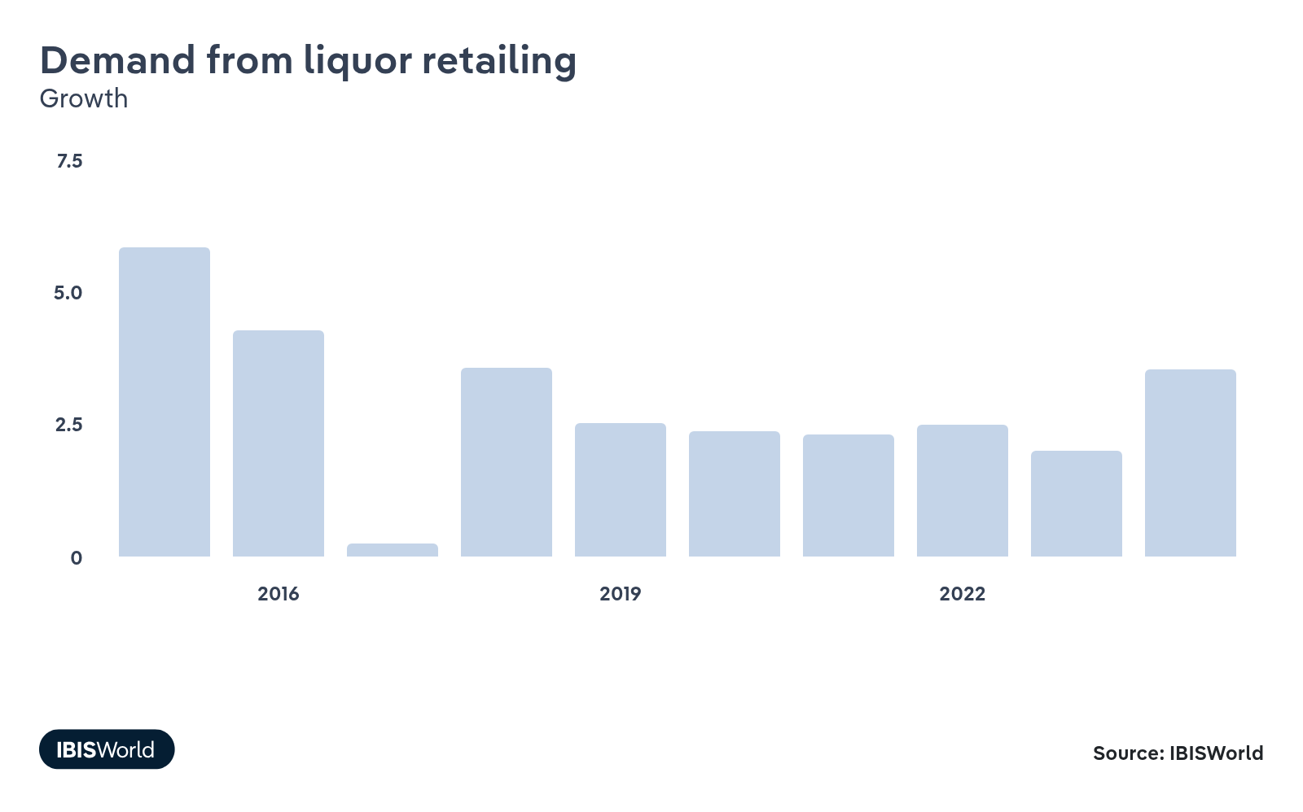
Liquor retailing plays a big part in downstream demand, as it accounts for the largest proportion of beer sold at the consumer level in Australia. Increases in demand from liquor retailing signify greater alcohol consumption, leading to retailers purchasing larger quantities of beer to meet demand. Growth in demand from liquor retailing represents an opportunity for the industry.
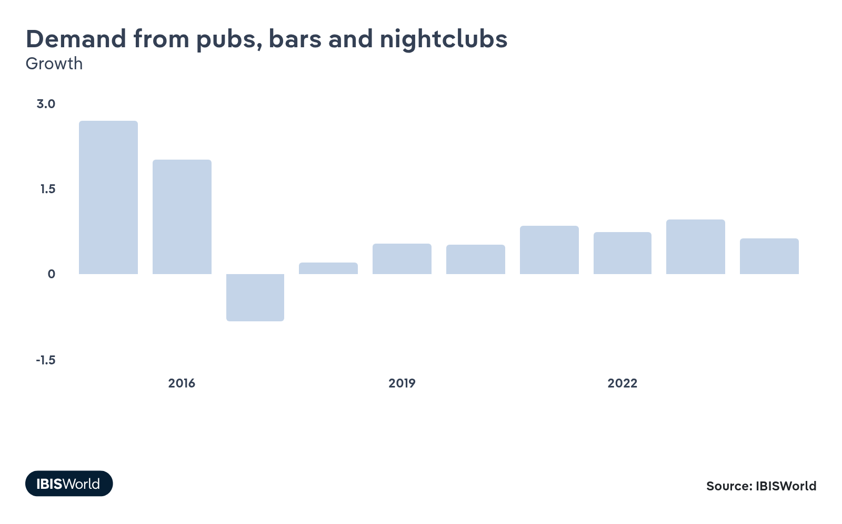
Pubs, bars, and nightclubs are a key market for beer, which they then sell to consumers for on-premises consumption. Rising demand from pubs, bars, and nightclubs would represent an increase in alcohol consumption, boosting sales and revenue for beer manufacturers as pubs, bars and nightclubs aim to meet consumer demand.
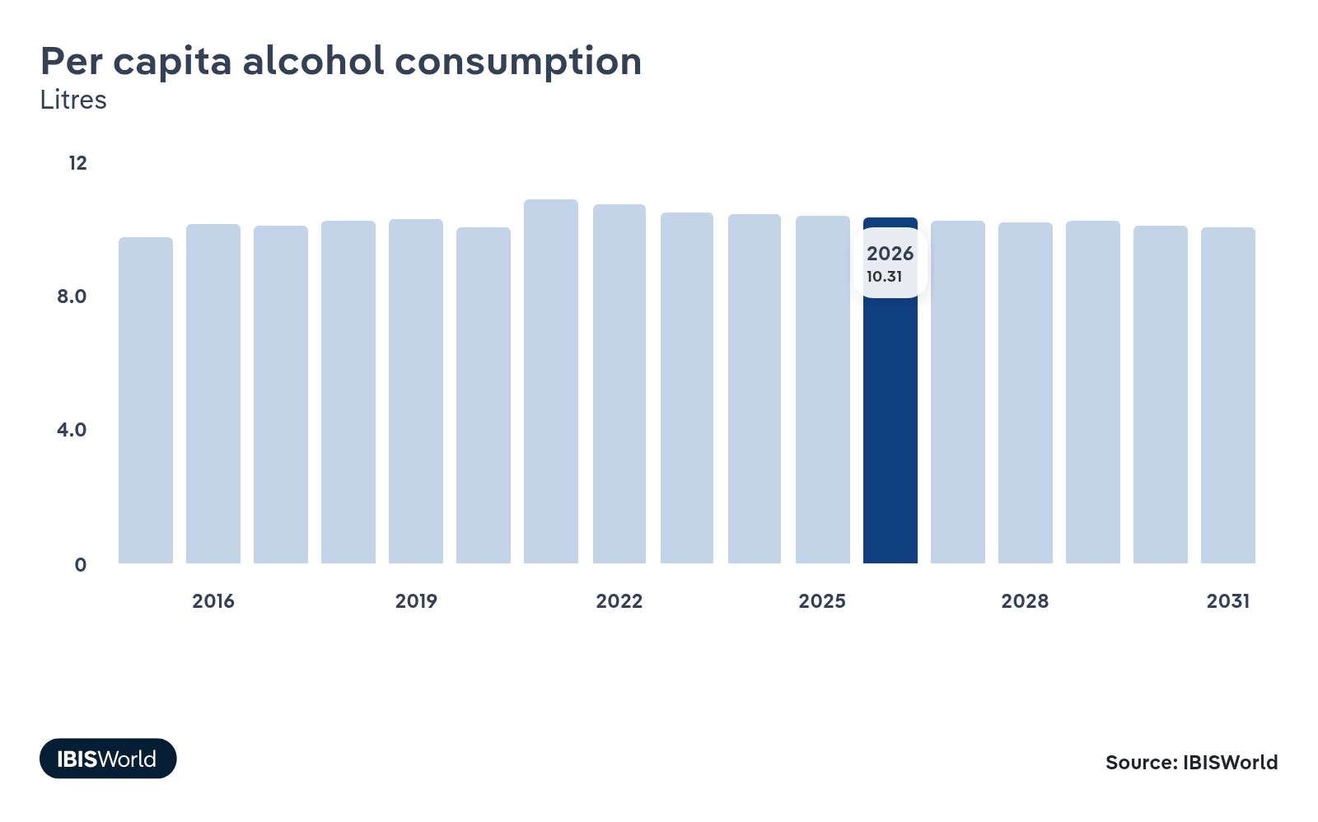
Per capita alcohol consumption is closely related to beer demand. As alcohol consumption grows, demand for beer tends to climb. Beer manufacturers compete with other alcoholic beverage manufacturers, like wineries and distilleries, so shifts in alcohol consumption don't solely reflect demand for the industry. Should demand for different alcoholic beverages like wine and spirits remain stagnant, increases in per capita alcohol consumption will result in greater demand for beer.
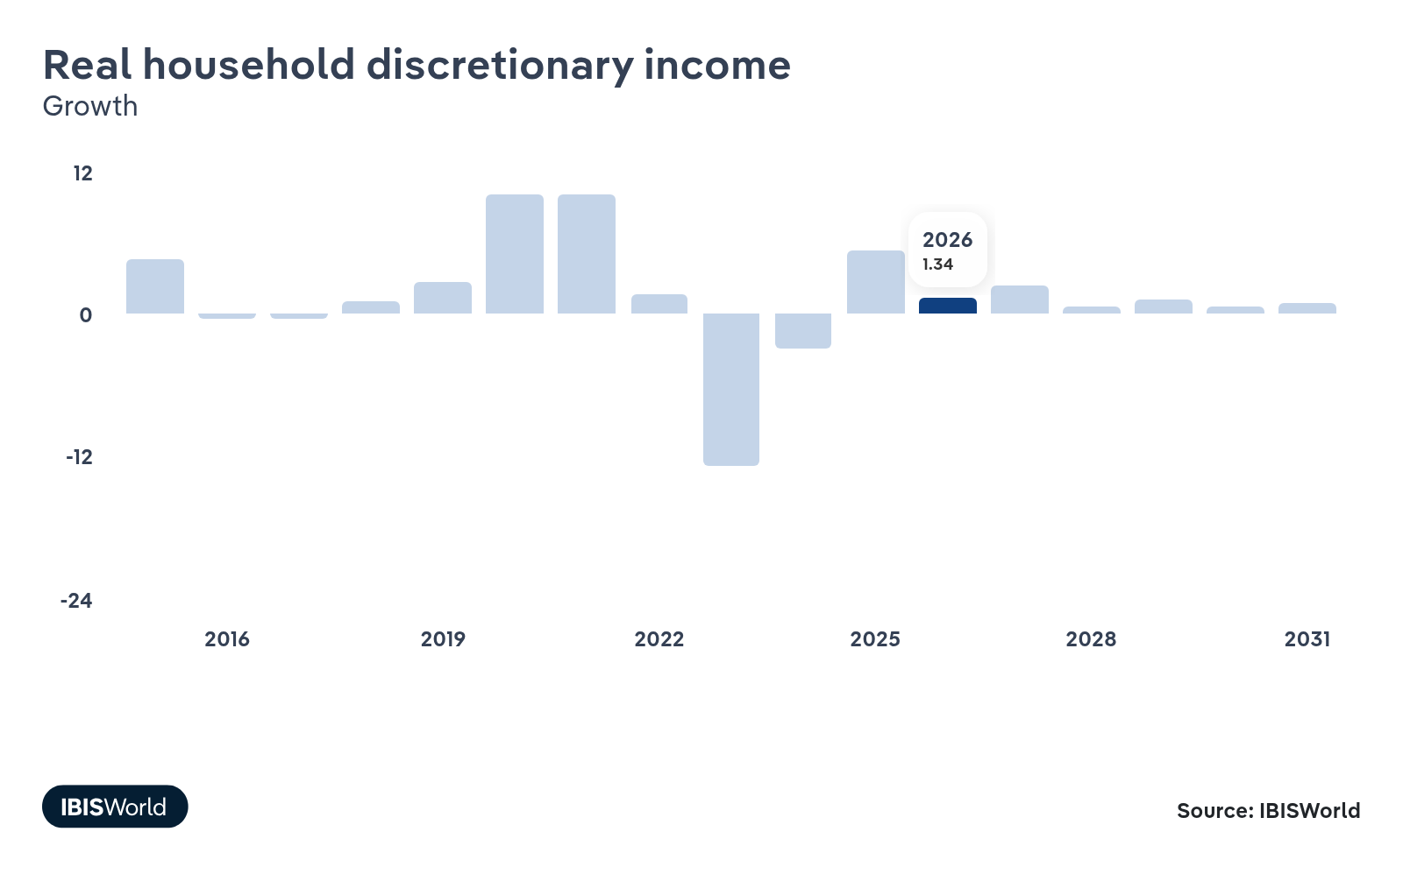
Trends in real household discretionary income have an influence on beer demand since it’s considered a non-essential commodity. Increases in real household discretionary income lead to greater spending on beer. In contrast, as discretionary income decreases, people tend to save more of their money for essential groceries and bills and spend less on nice-to-have items like beer.
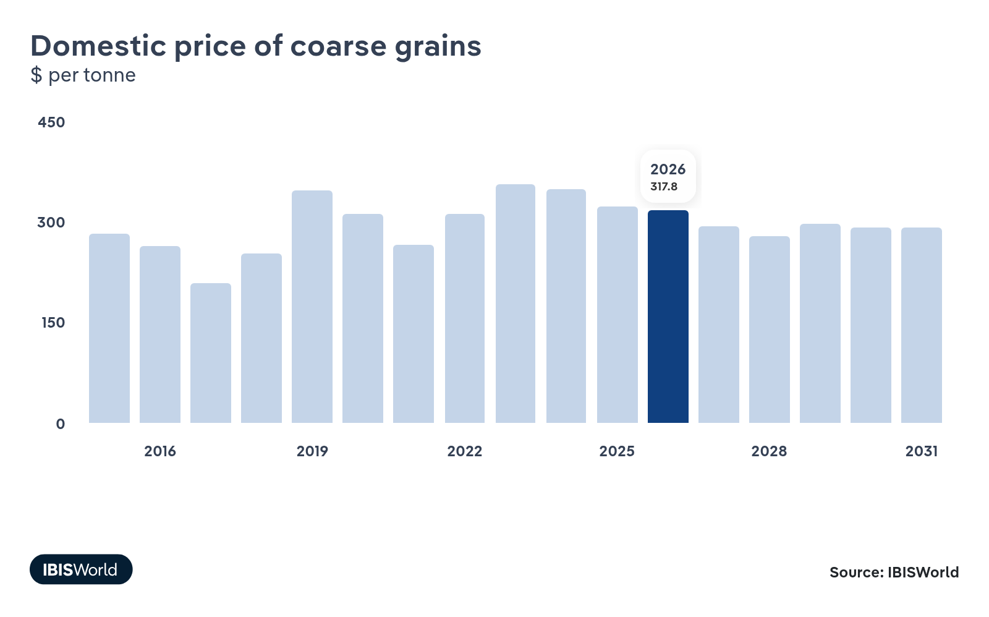
Coarse grains are a crucial ingredient in the beer manufacturing process. An increase in the price of coarse grains raises purchase costs, reducing profit margins. Brewers can try to pass these costs on to consumers, but this may result in less competitive pricing. Increases in the price of coarse grains represent a threat to the industry.

Regulation & Policy
High | Increasing

What regulations impact the industry?

Food Standards Australia New Zealand (FSANZ)
FSANZ enforces comprehensive labelling requirements for all alcoholic beverages, including beer. Labels must clearly state alcohol by volume (ABV), the number of standard drinks per serving and a pregnancy warning symbol. Noncompliance can result in product recalls that harm brand reputation. Low- and zero-alcohol beers are also subject to these rules, requiring accurate ABV disclosure. In August 2023, FSANZ introduced new labelling guidelines for pregnancy warnings, mandating consistent text and imagery across all beer packaging.

Excise Tax Compliance
Beer manufacturers in Australia are subject to excise duty. Businesses require an excise license to manufacture beer. The excise tax rate a business must pay depends on its beer's strength and the package's size. The regulations force companies to keep track of their beers’ alcoholic content, a register of raw materials, a recipe sheet and any other records for tax purposes. The excise tax is increased every six months to the consumer price index. Frequent seasonal changes in craft breweries’ recipes can complicate compliance, as each new batch must be accurately recorded for duty calculations. In August 2025, the Government introduced a two-year pause on increases to beer excise for draught beer served on tap, to run until August 2027. This follows on from a promise during the Albanese Governments campaign for the 2025 federal election.

Modern Slavery Act 2018
The act has a moderate effect on the Beer Manufacturing industry. It compels larger beer manufacturers with consolidated annual revenue of at least $100.0 million, including Asahi, Lion and Coopers, to report annually on the risks of modern slavery in their operations and supply chains and actions taken to address those risks. Smaller craft breweries below the $100 million threshold often escape these reporting obligations, although retailers and investors increasingly expect supply-chain transparency. In May 2023, the Attorney-General’s Department concluded a statutory review that recommended stronger enforcement powers, which may introduce penalties for non-compliant companies. In December 2024, the federal government responded to the review, indicating it would continue to consult with stakeholders to address the recommendations.

Liquor Control Reform Act
The Liquor Control Reform Act aims to minimise harm from misuse and abuse of alcohol, develop diversity among licensed facilities, contribute to responsible development of liquor and licensed hospitality industries and regulate licensed premises that provide sexually explicit entertainment. Regulations include minimum age requirements for purchasing alcohol and drink-driving policies. These regulations can make operating a licensed venue more complex, which may deter new entrants and shrink the hospitality market for beer manufacturers. Manufacturers running brewpubs must also comply with the Act, potentially increasing their operational challenges.

Container deposit schemes
Most states and territories in Australia operate a container deposit scheme. The scheme charges brewers around $0.12 per glass or aluminium container, while consumers typically receive a $0.10 refund upon return. However, rates vary among the states and territories. It aims to reduce the waste associated with beer sales and can potentially boost beer sales as drinkers can recoup part of the purchase price. Large brewers face higher cumulative fees because of their extensive output, whereas smaller craft brewers pay less but still incur administrative overheads for tracking container volumes.

Workplace laws
Beer manufacturers must comply with national workplace laws regarding employees' treatment. These cover minimum wages, safe working environments and licensing requirements, such as forklift licenses. Under the Work Health and Safety Act, employers are responsible for eliminating or minimising hazards like handling heavy brewing machinery or chemicals. Craft breweries often have smaller workforces but handle frequent, small-batch production, increasing the physical handling of raw materials and influencing WHS compliance needs.

Assistance
Low | Increasing

What assistance is available to this industry?

Energy Efficient Communities Program
This federal initiative awards grants of up to $25,000 to small and medium-size enterprises, including breweries, to reduce energy consumption and costs. Funding is often used to replace older equipment with more efficient machinery, like cooling or heating systems. The scheme has provided grants to numerous breweries across Australia, including Philter and Stomping Ground, which integrated solar energy technologies. Independent craft brewers typically benefit most, as they operate on tighter margins and face proportionally higher utility costs.

Manufacturing Modernisation Fund (MMF)
The MMF is an initiative to scale up local manufacturing, generate jobs and enhance global competitiveness. Since 2020, it has allocated over $5.0 million to breweries like Brick Lane, Moon Dog and Ballistic Beer Company Pty Ltd, enabling them to acquire advanced brewhouses and packaging lines. The initiative specifically benefits small to medium-size breweries, typically craft breweries, allowing them to improve efficiency through subsidised machinery upgrades they couldn’t otherwise afford.

Excise Remission Scheme
The Federal Government provides a tax-free threshold for beers containing less than 1.15% alcohol. The government also issues tax rebates through the Excise Remission Scheme for Alcohol Manufacturers, which gives breweries a full remission for their excise tax, up to an annual cap of $350,00. The government has announced that the excise remission cap will increase to $400,000 as of July 1, 2026, a change that was welcomed by the Independent Brewers Association. Innovative breweries can also access an R&D tax offset. This scheme significantly reduces operational costs and substantially improves the viability of smaller breweries, which often struggle to absorb excise taxes compared to larger competitors.

Western Australian Craft Beer Strategy 2024-2034
In August 2024, the WA Government introduced the Western Australian Craft Beer Strategy 2024-2034, a 10-year plan to promote craft brewing within the state. Developed in collaboration with key private industry bodies, the program aims to triple the volume or value of locally produced craft beer over the next decade. The strategy focuses on increasing brand awareness, expanding market access locally and globally, enhancing supply chain management and addressing regulatory barriers. By implementing a craft beer marketing plan and linking craft beer to Western Australia's tourism brand, the initiative seeks to attract more consumers and open new markets. This assistance specifically benefits the craft beer sector, boosting Western Australia's share of the industry and providing growth opportunities for local craft brewers, particularly small and medium-size enterprises looking to expand their reach. Other states like New South Wales operate similar programs.

Independent Brewers Association
The Independent Brewers Association is a private industry body that operates without direct government funding. It aims to support and give a voice to independently owned breweries, advocate for its members and facilitate training and development opportunities. The association does this by working with politicians, government departments and agencies, industry or trade associations and international counterparts. Smaller breweries, often lacking the capital of large multinational firms, benefit significantly from IBA resources that help them navigate regulatory complexities.

9. Financial Benchmarks
https://my.ibisworld.com/au/en/industry/C1212/financial-benchmarks
Profit Margin  3.3 %  ↓ Lower than sector | Average Wage  $70,489  ↓ Lower than sector | Largest Cost  Purchases  48.4% of Revenue

Key Takeaways
- Rising prices have increased purchase costs. Surging costs for malt, hops, aluminium and glass have pushed this trend, as brewers have struggled to pass these hikes on to consumers due to high competition.
- Intense price competition has eroded profit margins, as breweries keep prices low to maintain market share despite rising input costs. Economies of scale allow larger brewers to absorb these pressures better than smaller firms.
- Automation has reduced labour intensity, decreasing wages' share of revenue. As breweries invest in automation, they've lowered their reliance on manual labour, while upgrading equipment has also boosted depreciation expenses’ revenue share.

Cost Structure
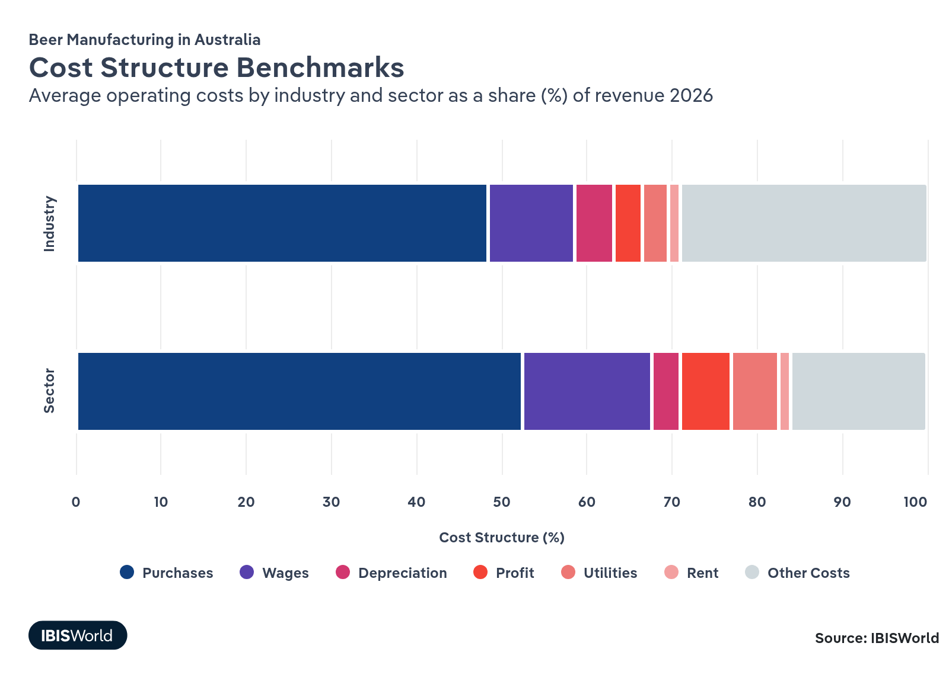
Chart displays current year only in the PDF version of this report. You can view and download chart for all other years associated with this industry on my.ibisworld.com.

What trends impact industry costs?

Profit margins have fallen because of intense competition and rising input costs
- An influx of new establishments has intensified price competition, limiting beer manufacturers' ability to pass on elevated input costs to consumers.
- Climbs in expenses like utilities and aluminium prices and twice-yearly increases in excise taxes have squeezed margins. Unlike other beverage sectors, where companies can pass on costs, the competitive beer market hampers this, reducing profitability from 10.7% in 2020-21 to 3.4% in 2025-26.
- A shift towards producing diverse products like low-carb and low-alcohol beers has required additional equipment, more intricate procedures and extra time, increasing manufacturing complexities and contributing to higher operational costs.
- Larger brewers with economies of scale have managed cost pressures more effectively, maintaining higher profitability than smaller independent breweries, which lack the scale to absorb increased expenses. This has led to the closures and restructuring of breweries like Red Lion Brewery and Hawkers.

Rising raw material and energy prices are driving an increase in purchase costs
- Purchases, beer manufacturers’ largest cost, have climbed from 42.5% of revenue in 2020-21 to 48.4% in 2025-26 because of surging raw material and packaging prices.
- Prices for key inputs like malt, hops, aluminium and glass have escalated over this period, and the beer market’s high level of competition has left producers struggling to pass on these increases in purchase costs onto consumers through increased selling prices.
- Smaller brewers, purchasing inputs in smaller quantities, face higher average per-unit production costs than larger beer manufacturers, amplifying the impact of rising input prices on smaller operators.

Automation reduces labour intensity, lowering wages' share of revenue
- Automation presents a way for brewers to reduce their reliance on manual labour and lower wage expenses. As brewers’ investment in automation has climbed, wages’ share of revenue has sunk, from 10.5% in 2020-21 to 10.1% in 2025-26, continuing a long-term downwards trend. This has been primarily driven by declines in the average industry wage.
- Smaller, labour-intensive craft breweries are adopting affordable automation technologies, following the lead of larger companies. For example, breweries like Bendigo Brewing and Big Shed Brewing have implemented Fermecraft's Brewtique, an automated fermentation system, to reduce wage expenses and improve efficiency.
- Despite adopting automation, wage expenses remain higher for smaller brewers than larger firms. Many lack the capital for extensive automation or prefer labour-intensive processes to differentiate their products from mass-produced beer, keeping wages elevated.

Investment in automation has elevated depreciation expenses
- Depreciation expenses have risen from 3.1% of revenue in 2020-21 to 4.7% in 2025-26 as breweries elevate investments in automation and machinery. Large beer manufacturers have upgraded their plants and equipment to enhance production efficiency and reduce labour costs, leading to higher depreciation costs relative to revenue as this capital expenditure is allocated over time through depreciation.
- While major brewers may have highly mechanised processes, craft beer manufacturers typically use less machinery, often performing tasks like bottling by hand. This has partially offset rising depreciation expenses. Less reliance on automated equipment results in lower depreciation costs for these firms than larger competitors and allows them to charge a premium for an artisanal touch.
- Compared to the broader beverage sector, the industry's depreciation costs are high because of significant investments in specialised brewing equipment, reflecting beer production’s capital-intensive nature.

Utility costs have remained steady despite fluctuating energy prices
- While utilities like water, electricity and gas are necessary for beer production, particularly in the fermentation process, they account for a small proportion of industry revenue. Despite fluctuating utility prices, their revenue share has remained steady in recent years.
- From 2020-21 to 2022-23, strong liquefied natural gas demand and the Russia-Ukraine conflict drove spikes in natural gas prices, raising utility costs per unit and hindering brewers’ profitability.
- Electricity and gas prices have since settled. New supplies from the United States have helped eased supply issues and stabilise utilities costs.
- Larger breweries have more resources to invest in energy-efficient technologies, mitigating the impact of fluctuating utility costs on their budgets.

Other costs have remained steady
- Other costs include rent, advertising, research and development (R&D), administration and distribution expenses. These expenses are viewed as necessary for brewers and have remained steady as a share of revenue over the past five years.
- Rent expenses especially impact brewers with hospitality venues, as they invest in pricey locations to attract customers.
- Advertising remains a significant cost, especially for major companies like Asahi and Lion, which produce numerous products. Promotional activities are elevated during warmer months when beer consumption peaks. Smaller companies often struggle to compete with larger brewers’ extensive marketing budgets, impacting their market visibility.
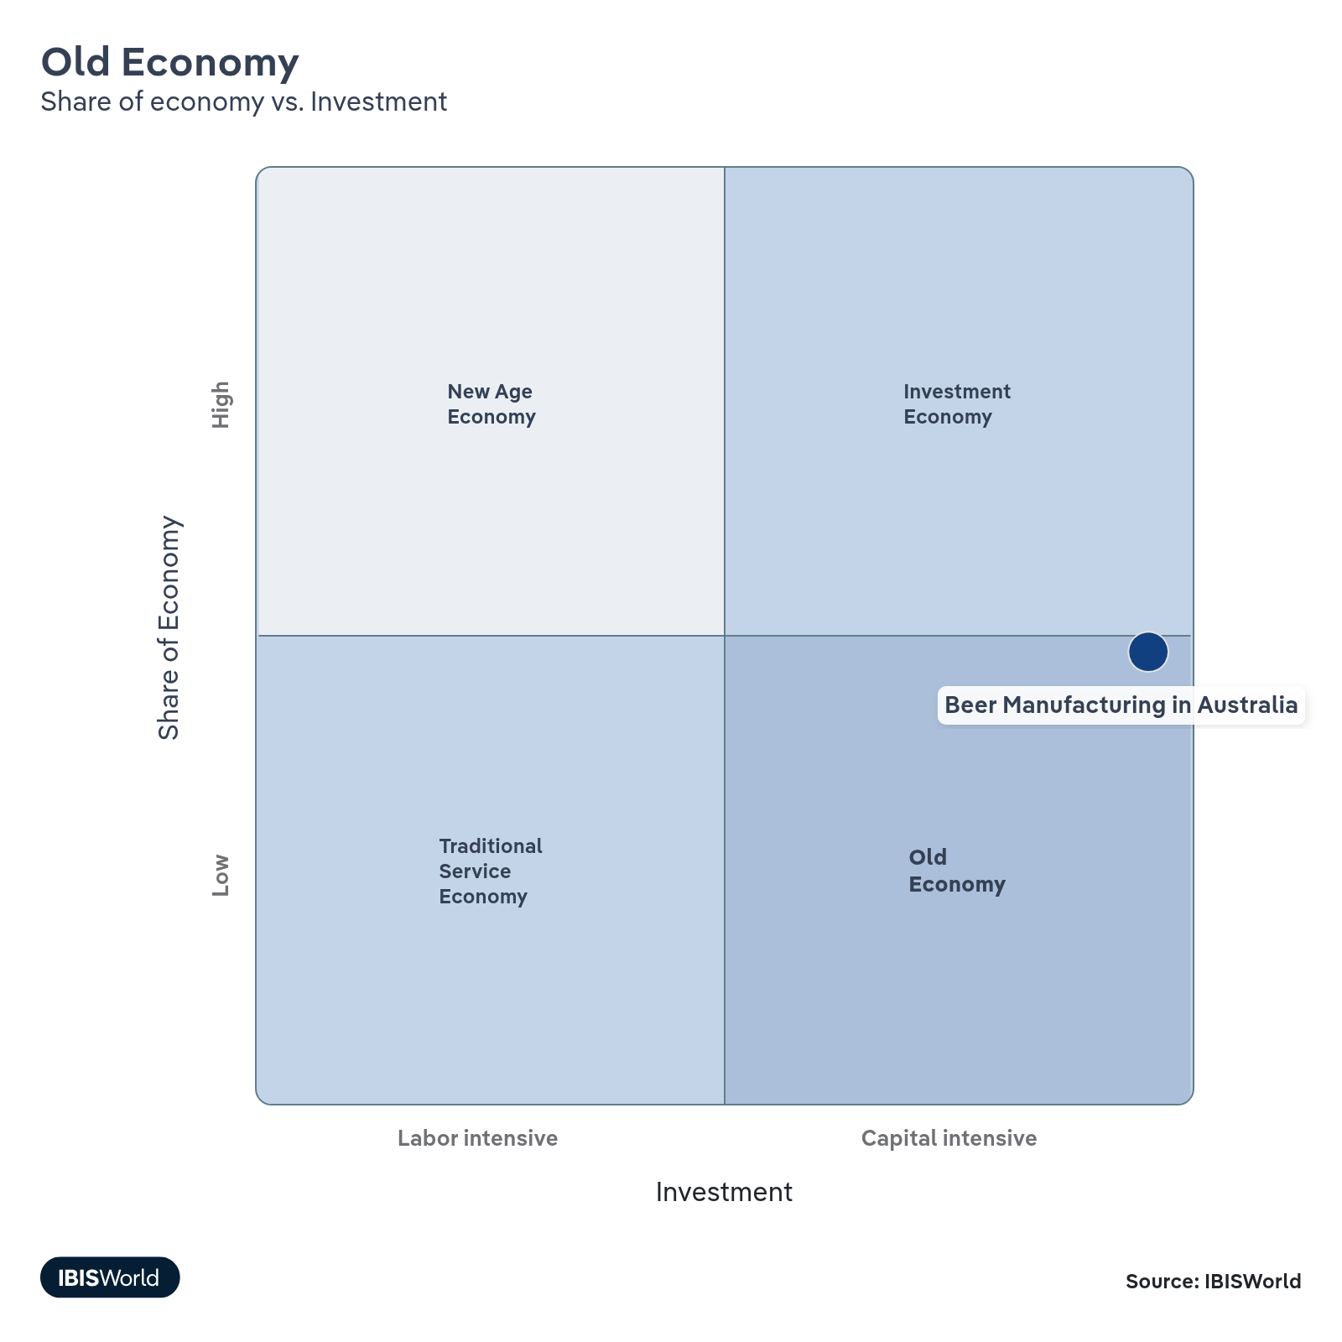

Financial Ratios

Liquidity Ratios
Ratio | 2019 | 2020 | 2021 | 2022 | 2023 | 3 Year Average | 5 Year Average
Cash Ratio | N/A | N/A | 0.2 | N/A | 0.1 | 0.1 | 0.1
Current Ratio | 1.0 | 0.8 | 1.5 | 0.7 | 1.0 | 1.1 | 1.0
Days' Payables | 165.0 | 122.2 | 20.6 | 53.7 | 47.9 | 40.7 | 81.9
Days’ Inventory | 34.6 | 40.7 | 36.8 | 64.5 | 76.8 | 59.4 | 50.7
Days’ Receivables | 104.4 | 67.1 | 26.5 | 58.0 | 50.8 | 45.1 | 61.4
Inventory Turnover | 10.6 | 9.0 | 9.9 | 5.7 | 4.8 | 6.8 | 8.0
Payables Turnover | 2.2 | 3.0 | 17.7 | 6.8 | 7.6 | 10.7 | 7.5
Quick Ratio | 0.8 | 0.6 | 1.3 | 0.5 | 0.7 | 0.8 | 0.8
Trade Receivables Turnover | 3.5 | 5.4 | 13.8 | 6.3 | 7.2 | 9.1 | 7.2
Working Capital Turnover | -62.6 | -11.4 | 8.6 | -6.7 | 86.1 | 29.3 | 2.8

Coverage Ratios
Ratio | 2019 | 2020 | 2021 | 2022 | 2023 | 3 Year Average | 5 Year Average
Cash Flow Coverage Ratio | N/A | N/A | 0.2 | N/A | N/A | 0.0 | 0.0
Cash Flow Margin Ratio | 0.1 | 0.1 | 0.3 | N/A | N/A | 0.1 | 0.1
Current Liability Coverage Ratio | 0.2 | 0.2 | 1.3 | -0.1 | -0.1 | 0.4 | 0.3
Interest Coverage | 1.7 | 2.7 | 4.5 | 2.1 | N/A | 2.2 | 2.2

Leverage Ratios
Ratio | 2019 | 2020 | 2021 | 2022 | 2023 | 3 Year Average | 5 Year Average
Debt / Net Worth | 2.1 | 1.5 | 1.8 | 0.7 | 0.7 | 1.1 | 1.4
Fixed Assets / Net Worth | 3.3 | 3.2 | 1.8 | 1.9 | 1.9 | 1.9 | 2.4
Net Worth ($ million) | 6771.1 | 7064.5 | 5201.8 | 5982.4 | 5715.1 | 5633.1 | 6147.0
Net Worth Ratio | 4.5 | 4.4 | 4.6 | 14.2 | 1081.4 | 366.7 | 221.8

Operating Ratios
Ratio | 2019 | 2020 | 2021 | 2022 | 2023 | 3 Year Average | 5 Year Average
Asset Turnover | 0.3 | 0.3 | 0.4 | 0.2 | 0.3 | 0.3 | 0.3
Cash & Equivalents (%) | 1.4 | 2.4 | 10.9 | 1.7 | 2.9 | 5.2 | 3.9
Fixed Asset Turnover | 0.3 | 0.3 | 0.5 | 0.2 | 0.3 | 0.4 | 0.3
Return on Total Assets (%) | 5.8 | 6.4 | 9.9 | 3.4 | N/A | 4.4 | 5.1

Assets
Ratio | 2019 | 2020 | 2021 | 2022 | 2023 | 3 Year Average | 5 Year Average
Fixed Assets (%) | 87.7 | 89.7 | 81.9 | 91.6 | 88.2 | 87.2 | 87.8
Inventory (%) | 1.5 | 1.6 | 1.7 | 2.1 | 3.1 | 2.3 | 2.0
Total Assets ($ million) | 25585.1 | 25207.2 | 11458.3 | 12525.7 | 12462.7 | 12148.9 | 17447.8
Total Current Assets (%) | 11.2 | 9.4 | 15.8 | 7.1 | 9.9 | 10.9 | 10.7
Trade Receivables (%) | 8.3 | 5.3 | 3.2 | 3.3 | 3.8 | 3.4 | 4.8

Liabilities
Ratio | 2019 | 2020 | 2021 | 2022 | 2023 | 3 Year Average | 5 Year Average
Long Term Debt (%) | 61.8 | 60.1 | 43.9 | 42.0 | 44.6 | 43.5 | 50.5
Short Term Debt (%) | 1.5 | 1.6 | 1.7 | 2.1 | 3.1 | 2.3 | 2.0
Total Current Liabilities (%) | 11.7 | 11.9 | 10.7 | 10.2 | 9.6 | 10.1 | 10.8
Total Liabilities & Net Worth ($ million) | 25585.1 | 25207.2 | 11458.3 | 12525.7 | 12462.7 | 12148.9 | 17447.8
Trade Payables (%) | 7.5 | 4.8 | 1.5 | 1.6 | 1.9 | 1.6 | 3.5

Profit Ratios
Ratio | 2019 | 2020 | 2021 | 2022 | 2023 | 3 Year Average | 5 Year Average
Expense / Income Ratio | 1.3 | 1.4 | 1.4 | 1.4 | 1.5 | 1.4 | 1.4
Gross Profit Margin (%) | 53.0 | 54.0 | 55.0 | 56.0 | 56.0 | 55.7 | 54.8
Mark Up (%) | 75.0 | 100.7 | 66.7 | 95.7 | 94.6 | 85.6 | 86.5
Net Profit (%) | -8.0 | -8.0 | -5.0 | -5.0 | -7.0 | -5.7 | -6.6
Return on Net Worth (%) | 9.6 | 14.7 | 17.1 | 3.7 | -5.2 | 5.2 | 8.0

Further Information
Ratio | 2019 | 2020 | 2021 | 2022 | 2023 | 3 Year Average | 5 Year Average
Cash & Equivalents ($ million) | 345.9 | 608.2 | 1246.9 | 216.0 | 367.6 | 610.2 | 556.9
EBIT ($ million) | 1490.0 | 1617.2 | 1137.4 | 420.2 | 5.3 | 521.0 | 934.0
Fixed Assets ($ million) | 22445.4 | 22601.9 | 9382.9 | 11468.0 | 10995.1 | 10615.3 | 15378.7
Operating Cashflow ($ million) | 633.8 | 490.1 | 1610.2 | -73.9 | -121.0 | 471.8 | 507.9

Valuation Multiples

Valuation Multiples
Ratio | 2019 | 2020 | 2021 | 2022 | 2023 | 3 Year Average | 5 Year Average
EV/Revenue | -0.9 | -0.5 | -0.6 | 0.6 | 0.4 | 0.1 | -0.2
EV/EBITDA | -9.6 | -3.3 | -4.0 | 5.6 | -10.0 | -2.8 | -4.3
EV/EBIT | -13.3 | -4.3 | -5.0 | 10.1 | -4.8 | 0.1 | -3.5

Key Ratios
Year | Revenue per Employee  ($) | Revenue per Enterprise  ($ Million) | Employees per Estab.  (Units) | Employees per Enterprise  (Units) | Average Wage  ($) | Wages/ Revenue  (%) | Estab. per Enterprise  (Units) | IVA/ Revenue  (%) | Imports/ Demand  (%) | Exports/ Revenue  (%)
2007-08 | 1,511,891 | 51.3 | 32.2 | 34.0 | 109,906 | 7.3 | 1.1 | 15.1 | 2.8 | 0.3
2008-09 | 1,616,580 | 60.6 | 34.0 | 37.5 | 122,258 | 7.6 | 1.1 | 15.2 | 3.7 | 0.3
2009-10 | 1,959,094 | 58.1 | 21.9 | 29.7 | 131,511 | 6.7 | 1.4 | 15.4 | 3.2 | 0.3
2010-11 | 1,655,187 | 45.1 | 21.9 | 27.2 | 120,501 | 7.3 | 1.2 | 16.4 | 3.0 | 0.4
2011-12 | 1,477,476 | 39.7 | 23.8 | 26.9 | 120,298 | 8.1 | 1.1 | 17.5 | 3.5 | 0.4
2012-13 | 1,798,216 | 49.9 | 25.5 | 27.8 | 125,068 | 7.0 | 1.1 | 15.4 | 3.9 | 0.3
2013-14 | 1,817,474 | 42.1 | 18.8 | 23.1 | 133,782 | 7.4 | 1.2 | 19.2 | 5.0 | 0.3
2014-15 | 1,569,408 | 31.6 | 18.7 | 20.1 | 145,764 | 9.3 | 1.1 | 22.0 | 5.4 | 0.4
2015-16 | 1,343,925 | 24.1 | 16.6 | 18.0 | 155,234 | 11.6 | 1.1 | 24.0 | 6.4 | 0.5
2016-17 | 1,119,110 | 18.5 | 15.5 | 16.5 | 143,698 | 12.8 | 1.1 | 24.9 | 6.7 | 0.6
2017-18 | 1,147,705 | 16.6 | 13.3 | 14.5 | 141,263 | 12.3 | 1.1 | 23.9 | 6.1 | 0.6
2018-19 | 1,068,713 | 15.6 | 13.0 | 14.6 | 124,197 | 11.6 | 1.1 | 21.8 | 6.0 | 0.6
2019-20 | 1,093,219 | 13.8 | 10.5 | 12.6 | 121,030 | 11.1 | 1.2 | 24.6 | 6.4 | 0.5
2020-21 | 861,530 | 11.5 | 12.1 | 13.3 | 90,122 | 10.5 | 1.1 | 24.3 | 5.8 | 0.4
2021-22 | 818,189 | 10.3 | 11.3 | 12.6 | 78,900 | 9.6 | 1.1 | 21.9 | 4.1 | 0.3
2022-23 | 736,217 | 10.8 | 12.4 | 14.6 | 73,309 | 10.0 | 1.2 | 20.1 | 3.2 | 0.4
2023-24 | 726,770 | 11.8 | 14.1 | 16.2 | 73,235 | 10.1 | 1.1 | 19.1 | 3.1 | 0.4
2024-25 | 717,447 | 11.4 | 13.9 | 15.9 | 71,929 | 10.0 | 1.1 | 18.5 | 2.6 | 0.4
2025-26 | 699,986 | 11.1 | 13.8 | 15.9 | 70,489 | 10.1 | 1.1 | 18.1 | 3.0 | 0.4
2026-27 | 684,802 | 10.9 | 13.8 | 15.9 | 68,805 | 10.0 | 1.2 | 18.0 | 2.9 | 0.4
2027-28 | 668,171 | 10.7 | 13.8 | 16.1 | 66,839 | 10.0 | 1.2 | 18.2 | 2.9 | 0.4
2028-29 | 655,291 | 10.6 | 13.8 | 16.2 | 64,664 | 9.9 | 1.2 | 18.2 | 3.0 | 0.4
2029-30 | 643,886 | 10.5 | 13.8 | 16.3 | 62,680 | 9.7 | 1.2 | 18.3 | 3.0 | 0.4
2030-31 | 634,778 | 10.5 | 14.0 | 16.5 | 60,712 | 9.6 | 1.2 | 18.3 | 3.0 | 0.4
2031-32 | 623,593 | 10.5 | 14.1 | 16.8 | 59,042 | 9.5 | 1.2 | 18.4 | 3.0 | 0.4
*Figures are inflation adjusted to 2025-2026
*Figures are inflation adjusted to 2025-2026

10. Key Statistics
https://my.ibisworld.com/au/en/industry/C1212/key-statistics

Industry Data

Values
Year | Revenue  ($ Million) | IVA  ($ Million) | Estab.  (Units) | Enterprises  (Units) | Employment  (Units) | Exports  ($ Million) | Imports  ($ Million) | Wages  ($ Million)
2007-08 | 8,623.8 | 1,302.3 | 177 | 168 | 5,704 | 29.3 | 251.9 | 626.9
2008-09 | 8,913.8 | 1,354.9 | 162 | 147 | 5,514 | 30.0 | 337.8 | 674.1
2009-10 | 9,529.0 | 1,467.5 | 222 | 164 | 4,864 | 29.6 | 309.0 | 639.7
2010-11 | 8,838.7 | 1,449.5 | 244 | 196 | 5,340 | 31.8 | 273.0 | 643.5
2011-12 | 8,299.0 | 1,452.4 | 236 | 209 | 5,617 | 30.5 | 301.2 | 675.7
2012-13 | 9,438.8 | 1,453.5 | 206 | 189 | 5,249 | 30.3 | 385.1 | 656.5
2013-14 | 9,420.0 | 1,808.7 | 276 | 224 | 5,183 | 31.8 | 493.6 | 693.4
2014-15 | 9,295.6 | 2,045.1 | 317 | 294 | 5,923 | 33.0 | 529.6 | 863.4
2015-16 | 8,955.9 | 2,149.4 | 401 | 371 | 6,664 | 43.5 | 607.2 | 1,034.5
2016-17 | 8,142.6 | 2,027.5 | 468 | 441 | 7,276 | 50.6 | 580.3 | 1,045.5
2017-18 | 8,351.8 | 1,996.1 | 547 | 503 | 7,277 | 51.8 | 543.6 | 1,028.0
2018-19 | 8,719.6 | 1,900.9 | 629 | 560 | 8,159 | 49.4 | 553.9 | 1,013.3
2019-20 | 8,306.3 | 2,043.3 | 723 | 601 | 7,598 | 41.4 | 564.5 | 919.6
2020-21 | 7,669.3 | 1,863.6 | 736 | 668 | 8,902 | 26.9 | 467.8 | 802.3
2021-22 | 8,011.7 | 1,754.6 | 866 | 775 | 9,792 | 27.4 | 344.7 | 772.6
2022-23 | 8,638.0 | 1,736.2 | 946 | 803 | 11,733 | 34.6 | 287.6 | 860.1
2023-24 | 9,578.8 | 1,829.5 | 934 | 814 | 13,180 | 35.7 | 303.3 | 965.2
2024-25 | 9,740.8 | 1,802.1 | 977 | 856 | 13,577 | 37.0 | 256.0 | 976.6
2025-26 | 9,841.1 | 1,781.2 | 1,019 | 887 | 14,059 | 37.2 | 304.5 | 991.0
2026-27 | 9,957.7 | 1,792.4 | 1,056 | 913 | 14,541 | 36.8 | 300.6 | 1,000.5
2027-28 | 10,080.7 | 1,834.7 | 1,095 | 938 | 15,087 | 37.1 | 299.6 | 1,008.4
2028-29 | 10,242.2 | 1,864.1 | 1,136 | 965 | 15,630 | 37.4 | 315.8 | 1,010.7
2029-30 | 10,356.9 | 1,895.3 | 1,165 | 984 | 16,085 | 37.8 | 316.1 | 1,008.2
2030-31 | 10,515.1 | 1,924.3 | 1,185 | 1,002 | 16,565 | 37.9 | 323.9 | 1,005.7
2031-32 | 10,672.8 | 1,963.8 | 1,211 | 1,016 | 17,115 | 38.2 | 333.1 | 1,010.5

*Figures are inflation adjusted to 2025-2026

Annual Change
Year | Revenue  % | IVA  % | Estab.  % | Enterprises  % | Employment  % | Exports  % | Imports  % | Wages  %
2007-08 | N/A | N/A | N/A | N/A | N/A | N/A | N/A | N/A
2008-09 | 3.4 | 4.0 | -8.5 | -12.5 | -3.3 | 2.1 | 34.1 | 7.5
2009-10 | 6.9 | 8.3 | 37.0 | 11.6 | -11.8 | -1.1 | -8.5 | -5.1
2010-11 | -7.2 | -1.2 | 9.9 | 19.5 | 9.8 | 7.2 | -11.6 | 0.6
2011-12 | -6.1 | 0.2 | -3.3 | 6.6 | 5.2 | -3.9 | 10.3 | 5.0
2012-13 | 13.7 | 0.1 | -12.7 | -9.6 | -6.6 | -0.9 | 27.8 | -2.8
2013-14 | -0.2 | 24.4 | 34.0 | 18.5 | -1.3 | 5.0 | 28.2 | 5.6
2014-15 | -1.3 | 13.1 | 14.9 | 31.3 | 14.3 | 3.8 | 7.3 | 24.5
2015-16 | -3.7 | 5.1 | 26.5 | 26.2 | 12.5 | 31.9 | 14.7 | 19.8
2016-17 | -9.1 | -5.7 | 16.7 | 18.9 | 9.2 | 16.2 | -4.4 | 1.1
2017-18 | 2.6 | -1.6 | 16.9 | 14.1 | 0.0 | 2.4 | -6.3 | -1.7
2018-19 | 4.4 | -4.8 | 15.0 | 11.3 | 12.1 | -4.6 | 1.9 | -1.4
2019-20 | -4.7 | 7.5 | 14.9 | 7.3 | -6.9 | -16.2 | 1.9 | -9.3
2020-21 | -7.7 | -8.8 | 1.8 | 11.1 | 17.2 | -35.1 | -17.1 | -12.8
2021-22 | 4.5 | -5.9 | 17.7 | 16.0 | 10.0 | 2.2 | -26.3 | -3.7
2022-23 | 7.8 | -1.0 | 9.2 | 3.6 | 19.8 | 26.3 | -16.6 | 11.3
2023-24 | 10.9 | 5.4 | -1.3 | 1.4 | 12.3 | 3.1 | 5.5 | 12.2
2024-25 | 1.7 | -1.5 | 4.6 | 5.2 | 3.0 | 3.5 | -15.6 | 1.2
2025-26 | 1.0 | -1.2 | 4.3 | 3.6 | 3.6 | 0.6 | 18.9 | 1.5
2026-27 | 1.2 | 0.6 | 3.6 | 2.9 | 3.4 | -1.1 | -1.3 | 1.0
2027-28 | 1.2 | 2.4 | 3.7 | 2.7 | 3.8 | 0.8 | -0.3 | 0.8
2028-29 | 1.6 | 1.6 | 3.7 | 2.9 | 3.6 | 0.8 | 5.4 | 0.2
2029-30 | 1.1 | 1.7 | 2.6 | 2.0 | 2.9 | 1.1 | 0.1 | -0.2
2030-31 | 1.5 | 1.5 | 1.7 | 1.8 | 3.0 | 0.3 | 2.5 | -0.2
2031-32 | 1.5 | 2.1 | 2.2 | 1.4 | 3.3 | 0.8 | 2.8 | 0.5

*Figures are inflation adjusted to 2025-2026

DISCLAIMER
This product has been supplied by IBISWorld Pty Ltd. (‘IBISWorld’) solely for use by its authorised licensees strictly in accordance with their license agreements with IBISWorld. IBISWorld makes no representation to any other person with regard to the completeness or accuracy of the data or information contained herein, and it accepts no responsibility and disclaims all liability (save for liability which cannot be lawfully disclaimed) for loss or damage whatsoever suffered or incurred by any other person resulting from the use of, or reliance upon, the data or information contained herein. Copyright in this publication is owned by IBISWorld Pty Ltd. The publication is sold on the basis that the purchaser agrees not to copy the material contained within it for other than the purchasers own purposes.In the event that the purchaser uses or quotes from the material in this publication – in papers, reports, or opinions prepared for any other person – it is agreed that it will be sourced to: IBISWorld Pty Ltd

